# IGNOU

##### Project Proposal (Synopsis) + Project Report

**BACHELOR IN COMPUTER APPLICATION (BCA) (Program code)**

**On**

*Institute Management System*

*or*

*Java Based User-Faculty Institute Workspace*

*(Web Application)*

Submitted By

**Name: - Ujjwal Pandey**

**Enrollment No: - 185512614**

**Course Code: - BCSP64**

**Regional Center: - Delhi RC-01**

**Contact: - +91 8375990500, ujjwalpandey.aps@gmail.com**

INDIRA GANDHI NATIONAL OPEN UNIVERSITY

(SCHOOL OF COMPUTER AND INFORMATION SCIENCE **(SOCIS),**

(IST FLOOR, DEC BUILDING, **IGNOU,** MAIDAN GARHI, New Delhi – 110068.)

Synopsis after corrections

Sequence of documents in it

1. Original copy of Approved Project Proposal Proforma,
2. Certificate of Originality,
3. Guide’s Resume,
4. Synopsis, and
5. Project Report

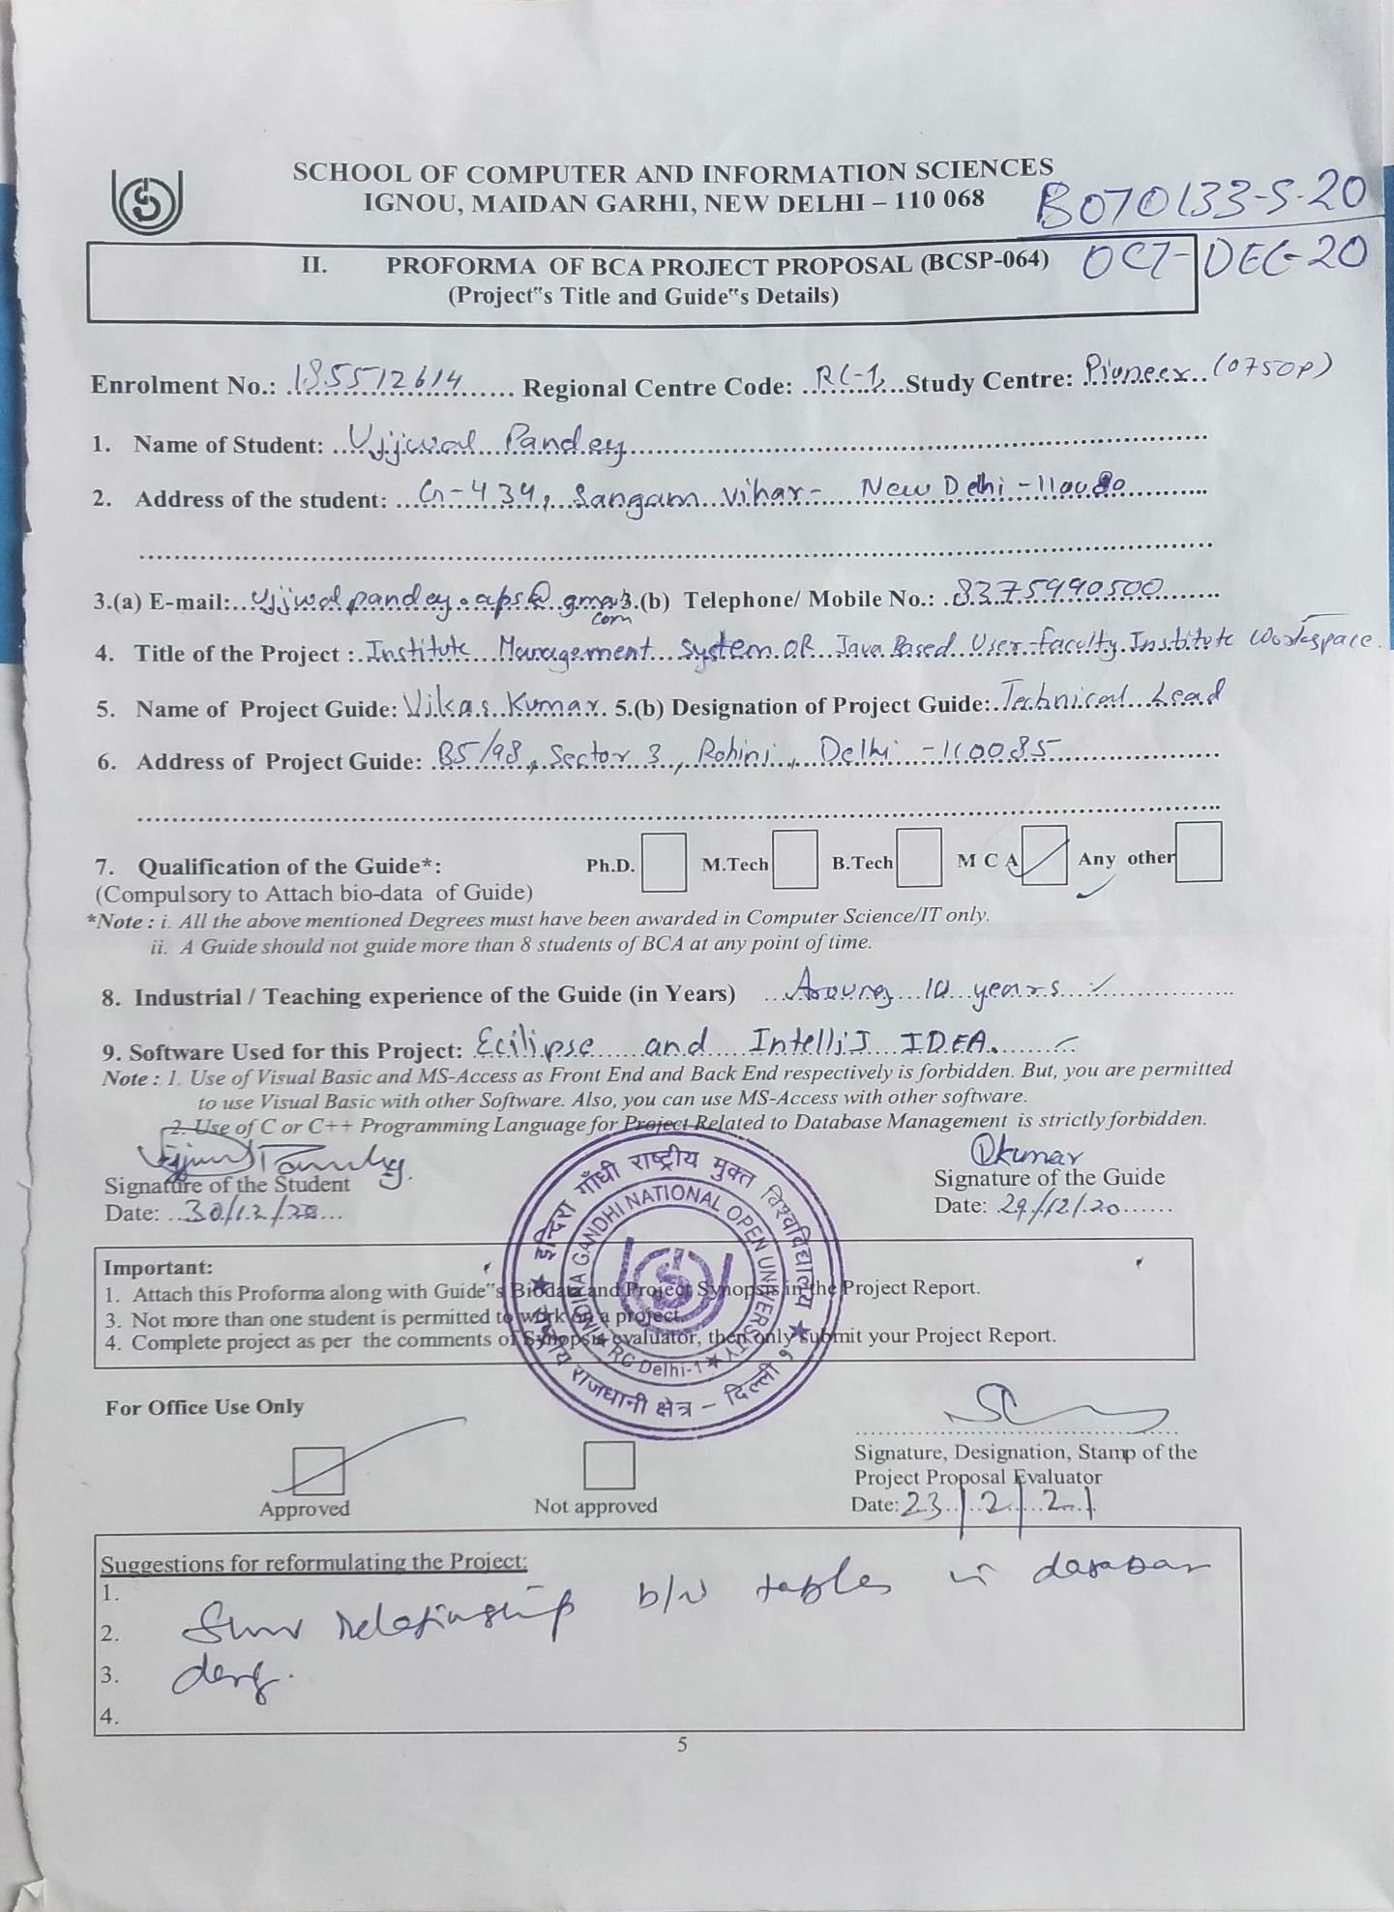

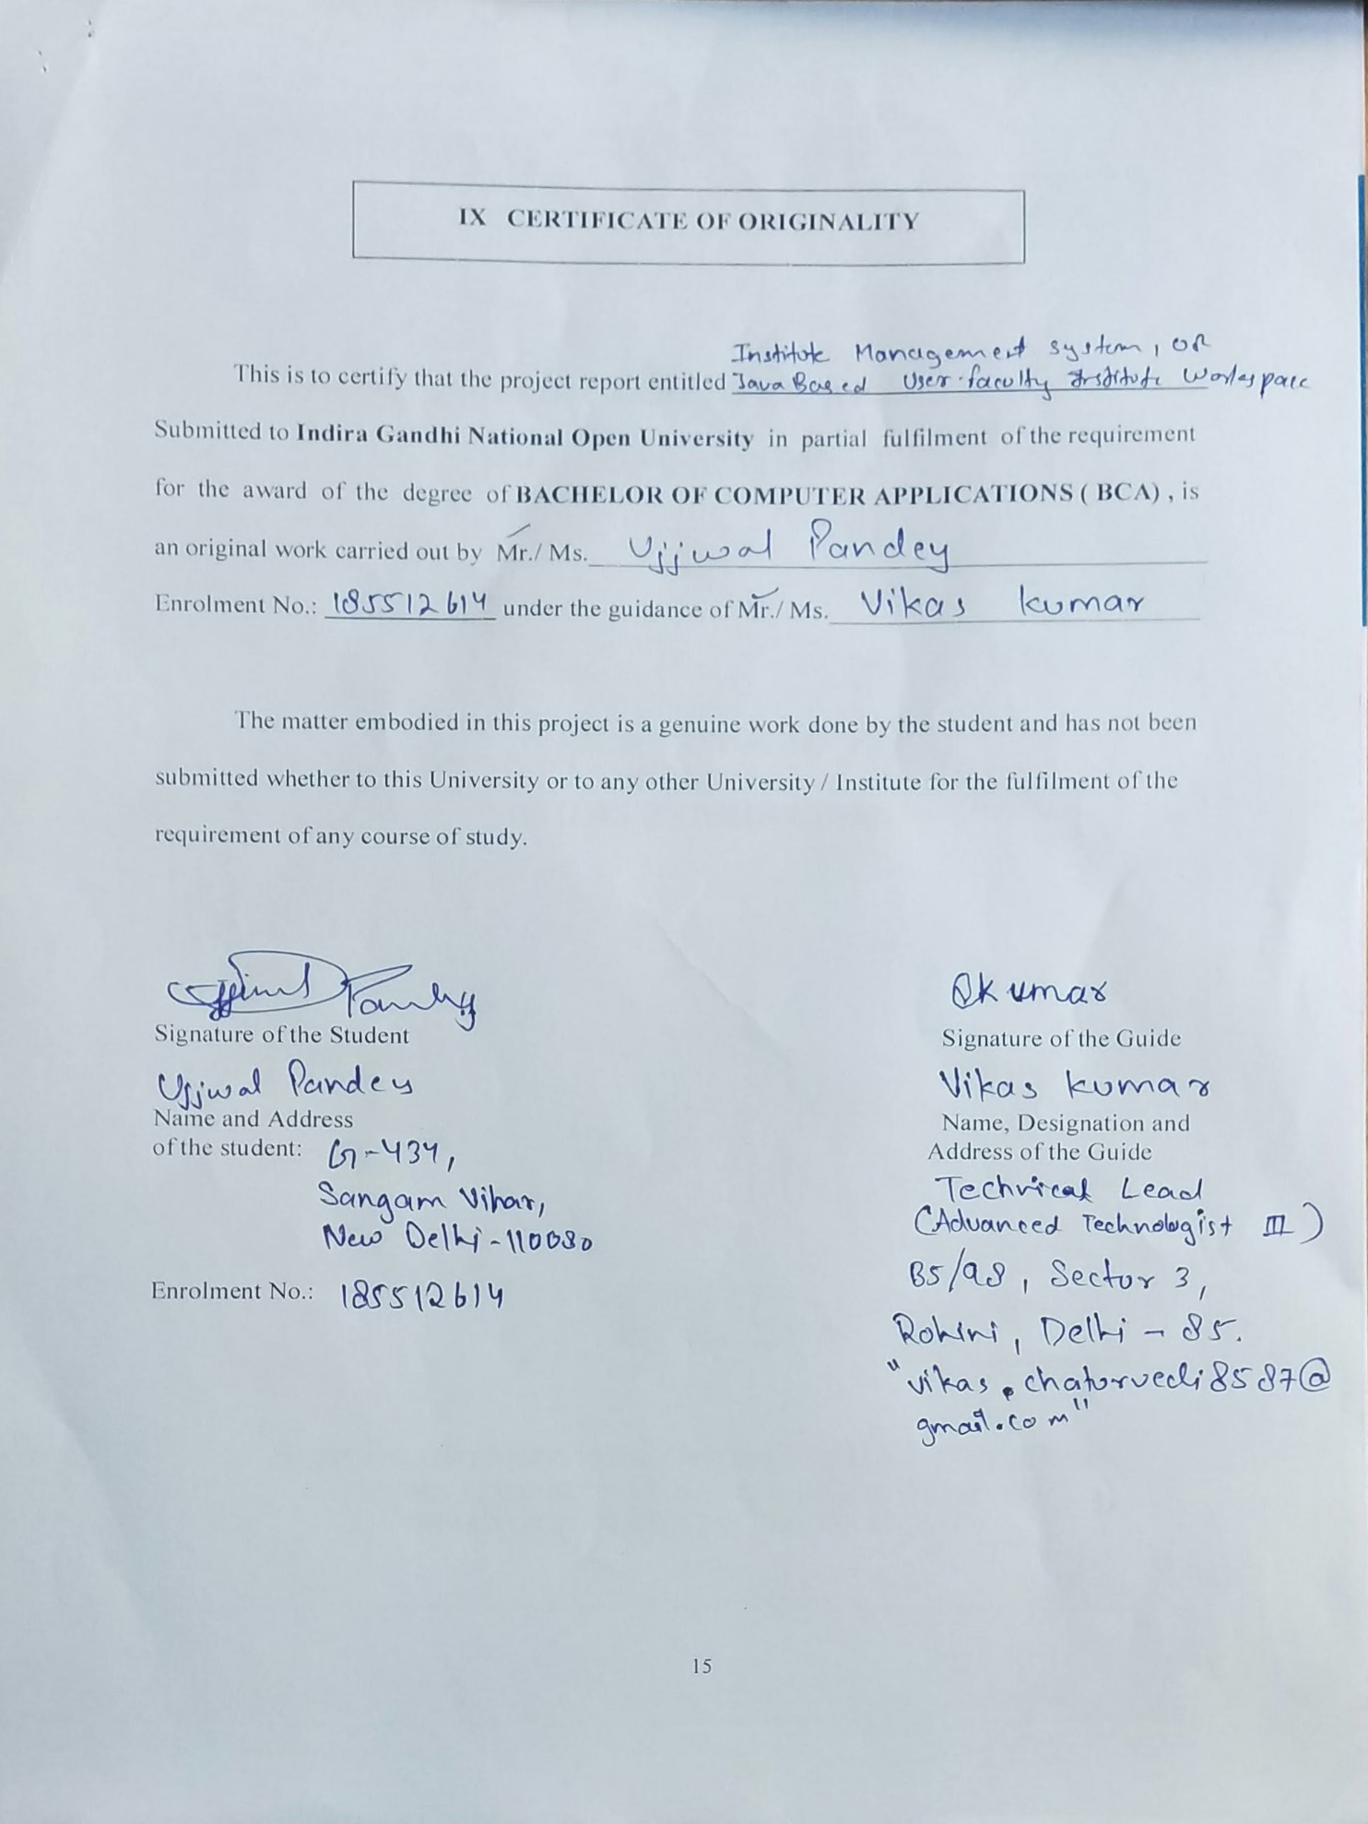

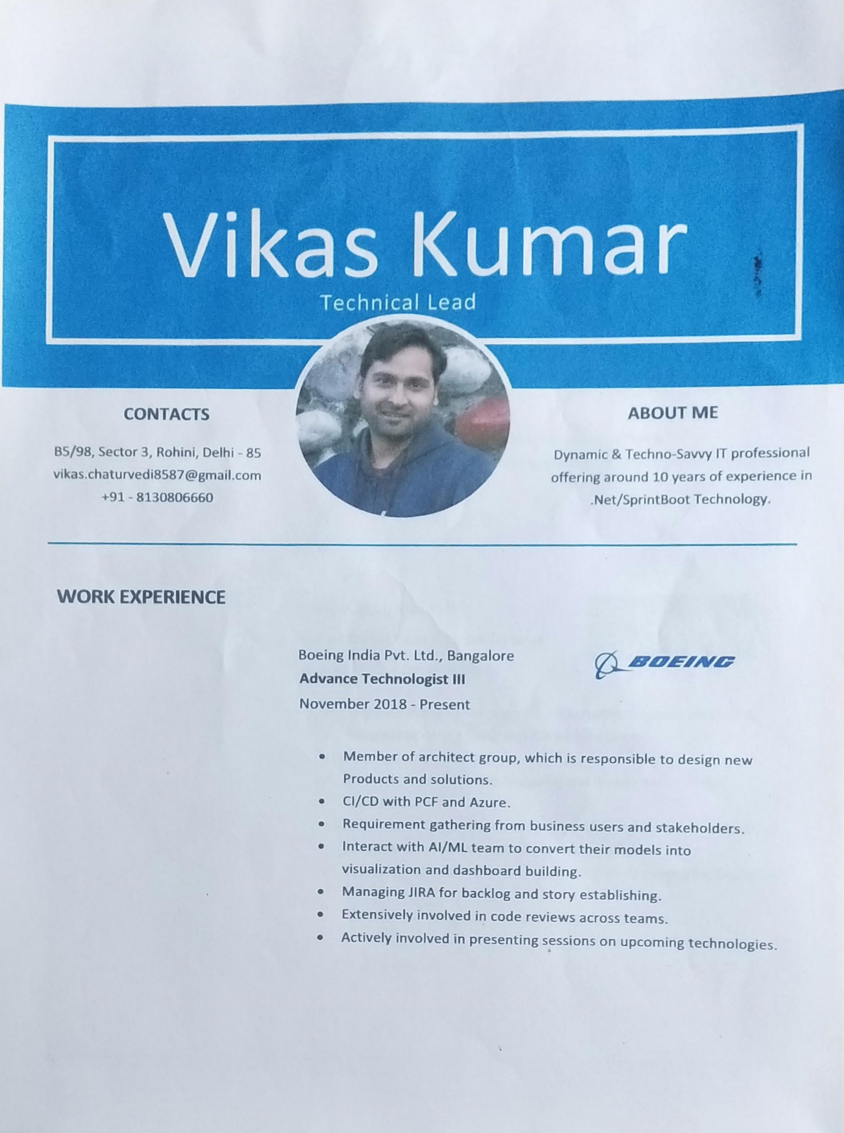

Guid Resume





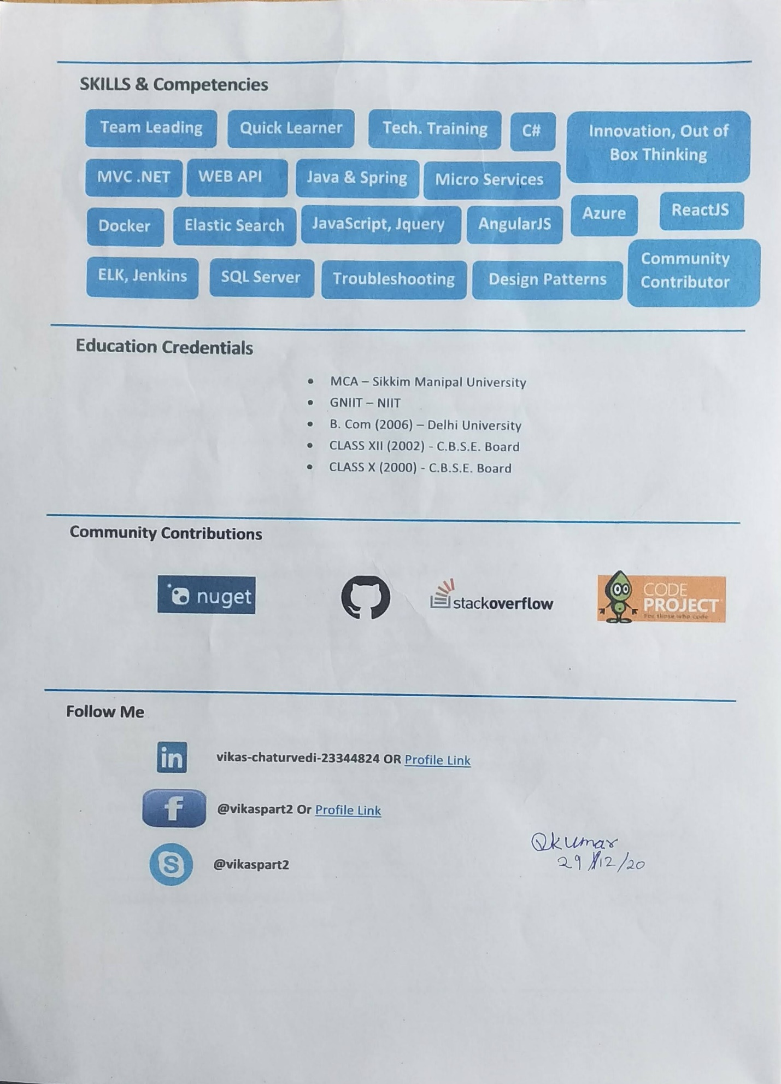

**TABLE OF CONTENTS**

**Page No.**

1. Introduction of Project ….09
2. Objectives of Project ….10
3. Project category ….11
4. Tools/Platform of Project – H/W and S/W ….15
5. Design of Project
   1. DFD ….17
   2. ER DIAGRAM ….20
   3. DATA STRUCTURE ….21
   4. Summarizing tables Relationship ….23
   5. Number of Modules & Their Description ….24
   6. Process Logic of Modules ….25
6. Limitation of the Projects ….28
7. Future Scope of Project ….28
8. Bibliography ….29

**INTRODUCTION**

**Institute Management System**

**Institute Management System** is the software made for the user and faculty to find, manage, and perform a maximum of functions. Many modules are included in the software to perform full operation like, For user student: - searching courses, getting full details about the respective course, getting enrolled in the respective course by full-filling a form with required detail which on completion provide a pdf file having all submitted details with a unique enrolment no, find details about the institute, get details to connect with the institute in different ways, For faculty: - they can see no. of students in the institute in a list and details of a student with their specific enrollment number, list of faculties in the institute and their detail, with all these only the owner will be able to add and delete new faculty in the list of the institute having real-time all data visible to him/her.

At very first when a user will open the institute site, the site will open its home page which will contain a nice image with a logo and inspiring line at the center nothing else, but on scrolling it will show other content like achievements, few courses, hyperlink to all the courses page, about the institute and few location contactable details with a hyperlink containing full contact page which will have a form for user or guardian to contact online through an online form, mail, and mobile numbers to contact in the institute to clear all the query.

**OBJECTIVE OF THE PROJECT**

As the title of the project suggests, the objective of this software (web application) is to automate all the works (excluding teaching) of the Institute related to the management of admission getting details etc. Some of the features of this software would be: -

* Creating a system to automate the services offered by the Institute, it would be more flexible than human to human contact as of today’s corona situation.
* It allows a user search for their loved and required course within the institute and get enrolled in it without coming in contact with other humans, and reduce the spread of COVID-19.
* It keeps track of the students enrolled to date and faculty in the institute.

**PROJECT CATEGORY**

* The project is based on a **three-tier architecture.** The three-tier architecture where the application is divided into three logical constituents
* User tier – Provide services such as user interface. (JSP, CSS, JavaScript, etc.) also known as **View**.
* Business tier – Implement business rules which will control how our web app will work (Java and JavaScript) also known as **Controller**.
* Data tier – Provide handling and validation of data getting and saving data in the database. (MySQL in this case) also known as **Model**.
* Why three-tier not two-tier model or Disadvantages of two-tier architecture model**.**
* Two-tier puts extra load on the server
* Difficult to implement incremental improvements.
* Applications are bound to the data source.

**REASONS FOR USING Eclipse**

Eclipse is a powerful Java project management and build management IDE. That means we can manage java project builds very easily using eclipse IDE. Eclipse can help us to minimize our project and build management time and efforts as comparison to any other non-ide code editor. It Is fine to manage the project manually if it is small. But If the project Is huge like our and future project or there are many, then It Is very hard for a developer to manage each of them manually.

Advantages of Eclipse IDE project

* It makes the project build process easy.
* It provides an easy and uniform build system.
* It provides quality project document Information.
* Managing project dependencies.
* Provides guild lines for better project management practices.
* Facilitate easy and transparent migration to new features.
* It allows to building projects using project object model (POM).
* It downloads required dependency's jar files automatically from Maven central repositories.
* Gives auto-correction and suggestions for code completion.

**THE ADVANTAGES OF RDBMS** (in my case- **MySQL**)

A database system is essentially a sophisticated, computerized record-keeping system, a repository for a collection of computerized data files. A database system maintains information and makes that information available on-demand, for this purpose a database system provides a set of facilities to perform such operations.

The benefits of a database system over any traditional system are obvious as the database is integrated as well as shared, thus a database eliminates redundancy, and also as a consequence, the database lets multiple users access the same piece of data.

The most important advantage of the database is to maintain integrity, i.e.; it ensures that the change made to the database by authorized users does not result in a loss of data consistency and guard against accidental damage to the database.

**RDBMS has the following facilities**

* Creation of files, Addition of data, Deletion of data, Modification of data.
* Retrieving data collectively or selectively.
* The data stored can be sorted or indexed at the user’s discretion or direction.
* Various reports can be produced from the system. These may either be standardized reports or that may be specifically generated according to specific user definition.
* The mathematical function can be performed and the data stored in the database can be manipulated with functions to perform the desired calculations.
* To maintain data integrity and database use.
* Data integrity for multiple users.
* Providing a form-based interface for easy accessibility and data entry.

# Major Advantages of Using MySQL (and why not any other RDBMS tech)

MySQL is a free-to-use, open-source database that facilitates effective management of databases by connecting them to the software. It is a stable, reliable and powerful solution with advanced features like the following:

## **Data Security**

MySQL is globally renowned for being the most secure and reliable database management system used in popular web applications like WordPress, Facebook and Twitter.

## **On-Demand Scalability**

MySQL offers unmatched scalability to facilitate the management of deeply embedded apps using a smaller footprint even in massive warehouses that stack terabytes of data. On-demand flexibility is the star feature of MySQL.

## **High Performance**

MySQL features a distinct storage-engine framework that facilitates system administrators to configure the MySQL database server for a flawless performance. Whether it is an eCommerce website that receives a million queries every single day or a high-speed transactional processing system, MySQL is designed to meet even the most demanding applications while ensuring optimum speed, full-text indexes, and unique memory caches for enhanced performance.

## **Round-the-clock Uptime**

MySQL comes with the assurance of 24X7 uptime and offers a wide range of high availability solutions like specialized cluster servers and master/slave replication configurations.

## **Comprehensive Transactional Support**

MySQL tops the list of robust transactional database engines available on the market. With features like complete atomic, consistent, isolated, durable transaction support, multi-version transaction support, and unrestricted row-level locking, it is the go-to solution for full data integrity. It guarantees instant deadlock identification through server-enforced referential integrity.

## **Complete Workflow Control**

With the average download and installation time being less than 30 minutes, MySQL means usability from day one. Whether your platform is Linux, Microsoft, Macintosh, or UNIX, MySQL is a comprehensive solution with self-management features that automate everything.

## **Reduced Total Cost of Ownership**

By migrating current database apps to MySQL, enterprises are enjoying significant cost savings on new projects.

## **The Flexibility of Open Source**

All the fears and worries that arise in an open-source solution can be brought to an end with My SQL’s round-the-clock support and enterprise indemnification. The secure processing and trusted software of MySQL combine to provide effective transactions for large volume projects. It makes maintenance, debugging and upgrades fast and easy while enhancing the end-user experience.

**TOOLS/PLATFORM, HARDWARE, AND SOFTWARE REQUIREMENT SPECIFICATION**

**Tools/Platform**

Project is developed using **Eclipse & MySQL 2017 command line** for storing data.

**🡪Use of Technologies/Tools**

*It is going to be a java web application.*

1. Unconditionally java
2. JSP
3. CSS
4. JavaScript
5. MySQL
6. Hibernate

**🡪Project type**

Java-based web application

**🡪Use of IDE**

Eclipse

**🡪Use of Browser**

Google Chrome, and

Microsoft Edge

**Hardware requirement Specification**

Altogether a Personal Computer with following components**:**

To use Browser on Windows®, you'll need:

* Windows 7, Windows 8, Windows 8.1, Windows 10 or later
* An Intel Pentium 4 processor or later that's SSE3 capable (as we need only a browser)
* 2 GB Memory (RAM)
* Hard Disk 125 GB
* Color Monitor
* Keyboard
* Mouse
* Printer

**Software requirement Specification**

The software which was required for using the software is a new advanced **web browser** like Google Chrome, Microsoft Edge, Opera, mac Safari.

**CONTEXT LEVEL DFD**

**Created on www.app.creately.com**

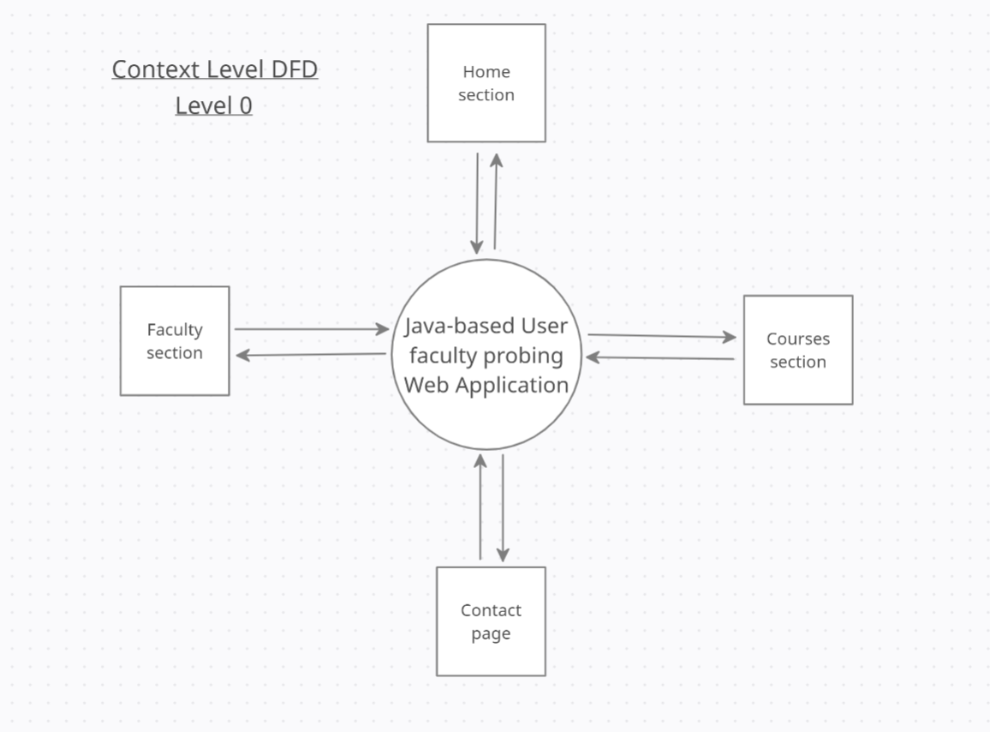

*DFD level 0*

**CONTEXT LEVEL DFD**

**Created on www.app.creately.com**

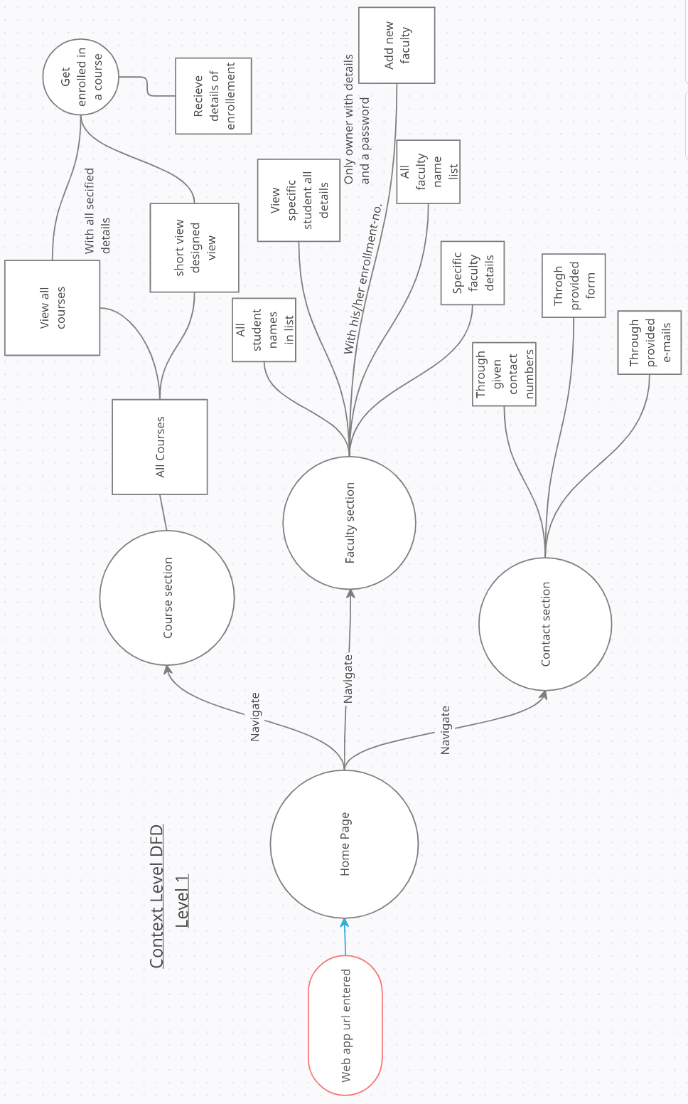

*DFD level 1*

**CONTEXT LEVEL DFD**

**Created on www.lucid.app**

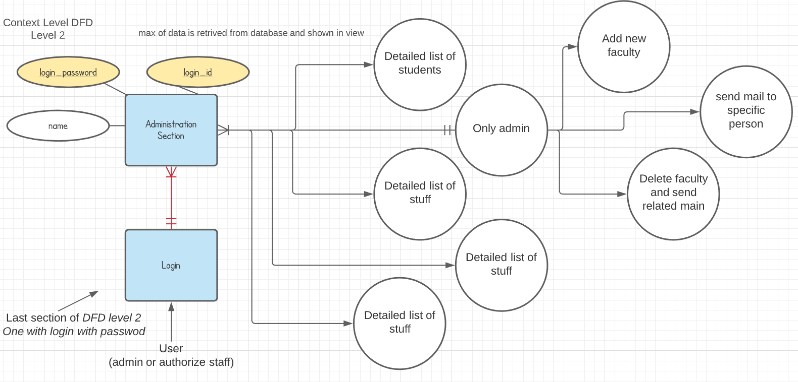

*DFD level-2*

**ER-Diagram**

**Created on www.lucid.app**

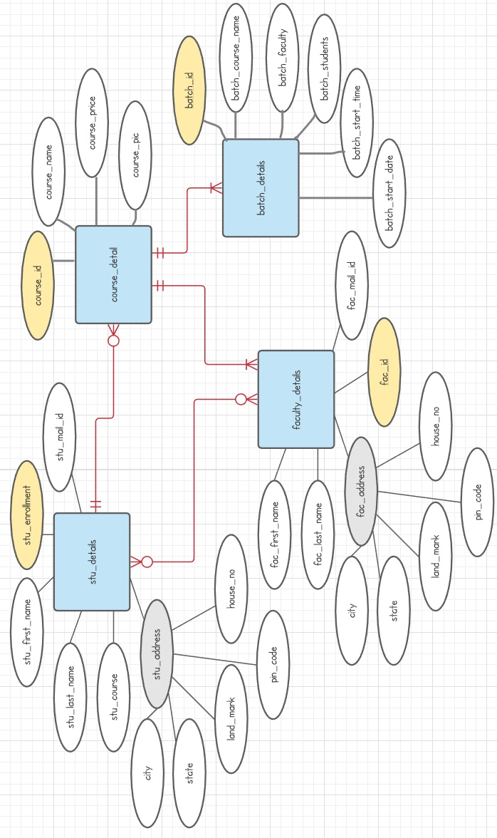

**DATA-STRUCTURES**

🡪 Tables are subject to be increased or decreased while code developement.

Table Name: userdetails

|  |  |  |  |
| --- | --- | --- | --- |
| **Column Name** | **Data Type** | **Constraints** | **Description** |
| Email | VARCHAR (255) | primary key  NOT NULL | unique identity of each user |
| city | VARCHAR (35) |  | City where user lives |
| contactNumber | VARCHAR (15) |  | User contact number |
| firstName | VARCHAR (20) |  | User’s first name |
| houseNo | VARCHAR (15) |  | House number of the user |
| landMark | VARCHAR (255) |  | Landmark of use address |
| lastName | VARCHAR (20) |  | User’s last name |
| password | VARCHAR (255) |  | User’s password |
| pinCode | VARCHAR (255) |  | Pin code |
| registrationDate | VARCHAR (255) |  | Date when user registered |
| state | VARCHAR (255) |  | User’s address state |
| userType | VARCHAR (255) |  | What type of user is Admin/Student/Faculty |

Table Name: queryfromform

|  |  |  |  |
| --- | --- | --- | --- |
| **Column Name** | **Data Type** | **Constraint** | **Description** |
| qSoNo | Int | PRIMARY KEY  NOT NULL | Unique id of query |
| qContact | VARCHAR (255) |  | Contact details given by person submitting query |
| qEmail | VARCHAR (255) |  | Email id provided by the person querying |
| qName | VARCHAR (255) |  | Name of querier |
| qQueryExplained | VARCHAR (255) |  | Brief of what they want to know |
| qQueryHead | VARCHAR (255) |  | Title of the query |

Table Name: hibernate_sequence

|  |  |  |  |
| --- | --- | --- | --- |
| **Column Name** | **Data Type** | **Constraints** | **Description** |
| next_val | bigint | Not null | Used to number other tables unique id automatically |
|  |  |  |  |

Table Name: courselist

|  |  |  |  |
| --- | --- | --- | --- |
| **Column Name** | **Data Type** | **Constraints** | **Description** |
| courseId | INT | Primary key | Unique identity of the course |
| courseAddedDate | DATE |  | Course added date |
| courseImage | VARCHAR (255) |  | Path of image |
| courseName | VARCHAR (255) |  | Title of course |
| coursePrice | INT |  | Course price |
| courseDescription | VARCHAR (1000) |  | Detail to show on same card of course detail |

Table Name: boughtcourses

|  |  |  |  |
| --- | --- | --- | --- |
| **Column Name** | **Data Type** | **Constraints** | **Description** |
| buyingID | INT | Primary key  NOT NULL | Unique identity of the course bought |
| courseID | int | NOT NULL | Unique identity no of the course |
| courseImage | VARCHAR (255) |  | Path of image |
| courseName | VARCHAR (255) |  | Title of course |
| coursePrice | Int |  | At what price it was bought |
| courseDescription | VARCHAR (255) |  | Detail of particular course |
| userEmail | VARCHAR (255) |  | Who bought the course |

**Summarizing tables Relationship**

**User Details table:** It’s contains all the basic details of all 3 types of users, its most important details are email, password and user-Type.

**QueryFromForm Table:** It contains the query asked by any user related to any suspicion curiosity, etc. they got while surfing site, finding course, login, logout, batch detail, faculty detail, if they want to post some suggestion, problem related to anything, etc.

This table’s form is accessible to all the users and table can only be seen and edited by the admin.

hibernate_sequence: This is auto access table which is accessed by the other table sequence columns on every new entry, and all this is done by hibernate automatically. This table is related to all other tables.

**courselist:** This table is used to store the data related to the courses and accessed by the jsp pages and course buying servlet to fetch and store data in the table of *‘bought courses table’,* this table works on some of the conditional based codes also in jsp. This table relation with bought courses is dependent on time – mean the data at that time is save for the particular user and if changed will not affect the user saved data.

**Boughtcourses:** This table is used by faculty and student these two users get their bought courses from this table and shows in the jsp respective pages.

**NUMBER OF MODULES AND THEIR DESCRIPTION**

1. **List of courses with details**
2. **Admission**
3. **Any user view list of teachers with their respective subjects**
4. **List of batches**
5. **Viewing basic student and students’ details**
6. **Viewing the basic details of teacher and teachers**
7. **Viewing batch details**
8. **Secure Login**
9. **Viewing advanced detail of student and all students**
10. **Viewing advanced detail of teacher and all faculties**
11. **Adding more faculty with administration login**
12. **Deleting resigned faculty and sending mail to them by admin**
13. **Update staff and student data**

**PROCESS LOGIC OF EACH MODULE**

The project will be based on a Multi-User approach, which means that multiple users can use the application simultaneously. Each user will be assigned a specific role and will have limited permissions to operate the web application. User details are as below: –

**Administrator** – He will have full privilege to operate the entire system as per the requirements of the system. Only he/she will have permission to add new Login IDs (staffs) to the system, change passwords, change connection settings, and perform any other administrative functions which will be provided by the application.

**Staff** – He/she can view any details with few limitations desired by them regarding students or teacher (other staff) details. They don’t have any power to change any data.

**Secure Login**

This module of this Project will authorize users and block any unauthorized users after checking. With this, we can maintain only authorized login. This will help to maintain the security of the system and institute data.

**List of courses with details**

This module’s business logic takes data from the model and shows it on view on a specified JSP page. It comprises of query language of MySQL with java (used hibernate framework which makes work easier with HQL).

**Admission**

This module consists of a form on the view page through which the user will interact and fill in all the given details and submit it online with just a single click. Then details will be added to the database is provided to the admission-taking student.

**Any user view list of teachers with their respective subjects**

This module is interactable through a single button and the data will be visible on the screen with the help of java, hibernate extracting data from database and showing on the JSP page.

**List of batches**

This module is as simple as other view lists the same process but the query used and data extracted is changed. The most visible change is in their way of presentation.

**Viewing basic student and students’ details**

This module consists of extracting and presenting on the page. It does not have the authority to show all the details of a student like a fee, address, etc.

**Viewing basic teacher and teachers’ details**

This module consists of extracting and presenting on the page. It does not have the authority to show all the details of a faculty like a salary, date of joining, address, etc.

**Secure Login**

This module is used while login in by authorities and is properly secure, all the data used to check login details are fetched from the database which can’t be changed by any unauthorized person. Only the admin or owner of the institute can do so.

**Viewing advanced detail of student and all students**

This is used by only the owner/admin of the institute. It is different from all other list presenting modules as it fetches all the student detail available in the database without hiding anything from the owner.

**Viewing advanced detail of teacher and all faculties**

This is used by only the owner/admin of the institute. It is different from all other list presenting modules as it fetches all the student detail available in the database without hiding anything from the owner.

**Adding more faculty with administration login**

This is used by the owner only. He/she can add new faculty after confirming they're joining in institute. When he/she adds their details in the database, a mail is sent to them as congratulation.

**Deleting resigned or left faculty and sending mail to them**

Same as adding the only difference is that it gives a warning before deleting the data and then on confirmation it deletes the data with a mail to left faculty. The mail received by the leaving faculty contains ‘Thanks for being with us’

**Updating staff and student data**

This module performs more than one work. First, it takes the enrollment id or any unique id filled in the section and then fetches their data from the database which after successful fetching presents on the screen, and gets an update after editing by the owner.

**LIMITATION OF THE PROJECT**

* Needs internet connection
* Needs advanced browser which supports new functions added after 2005

**FUTURE SCOPE OF THE PROJECT**

This project is designed and developed in such a manner that it provides maximum efficiency & speed and has a vast scope for further development. A number of modules can be added without any modifications in the database and with a minimum modification in its code. It is armed with a powerful query support system and is capable of supporting advanced and complex queries for much more advanced processes and reports.

This application fits into the current scenario, which is the Coronavirus and information age. This application with some modifications can be used by other institutes to automate their services, increase their efficiency, and to make their presence felt in the present fast online world.

In the future, I have decided to add more features like a login system for students too, online classes, live chat with teachers, performance, progress, and so on.

All the present and addable features will definitely help the world to run faster and give a better of teaching with data saving.

**BIBLIOGRAPHY**

# *WEBSITEs* used to get help while creating projects –

1. [www.google.com](http://www.google.com)
2. <http://www.microsoft.com/en-in/download/>
3. <https://www.javatpoint.com/mysql-tutorial>
4. <https://app.creately.com/diagram/IZYu0470DJu/edit>
5. [https://lucid.app/lucidchart/9e136d93-4545-4cd1-b26f-8bb69ac6484d/edit?beaconFlowId=E7D9D2D1265439AA&page=0_0#](https://lucid.app/lucidchart/9e136d93-4545-4cd1-b26f-8bb69ac6484d/edit?beaconFlowId=E7D9D2D1265439AA&page=0_0)
6. Many channels and videos from youtube.

**Referenced Books**

1. All books of NIIT (I am a student of NIIT). They taught me:
   1. Core java
   2. Advanced java
   3. RWD
   4. RDBMS
   5. MYSQL
   6. JSP
   7. HIBERNATE
2. IGNOU Blocks

referenced books (SQL Server 2005)–

1. Leonard Lobal, *Andrew J. Brust, Stephen Forte, Programming Microsoft SQL Server 2005 (Pro Developer),* 29 Oct 2008
2. Robert Vieira, *Professional Microsoft SQL Server 2005 Programming,* 23 Aug 2009
3. IGNOU Blocks

***Main Functions my project have:***

1. Login and Register Separate Page
2. Home page
   1. Introduction to the site, login and register button
   2. Top rankers
   3. Achievements
   4. Hyperlink for new courses
   5. Register and login button on top right corner
3. Admin home page
   1. Add new faculty
   2. View all User details,
   3. View all student details,
   4. View all faculty,

Update data of any user

* 1. Deleting any type of user details

1. Course page (explore and buy course of your likened)
   1. List of courses *(in card view)*
   2. With click on more detail button it will transfer the user to the new jsp page
      1. With full detail page of course, we can take it.
2. Admission page
   1. User gets his/her admission in the online courses for free while creatin an account on the site.
3. Check your courses
   1. In the home page of student (loads automatic on page load)
   2. Also, in the home page of faculty.
4. Faculty page
   1. Check student details *(can’t edit any detail*)
   2. Check faculty details *(can’t edit any detail)*
   3. *Update own detail*

# IGNOU Project Report

**On**

*Institute Management System*

*or*

*Java Based User-Faculty Institute Workspace*

*(Web Application)*

**BY**

**UJJWAL PANDEY**

**TABLE OF CONTENT of PROJECT REPORT**

1. Introduction …33
2. Objectives …34
3. Tools/Environment Used …35
4. Analysis Document …36
5. Program Code …39
6. Tables used (screenshots) …133
7. Output screens …138
8. Testing …154
9. Input-Output …156
10. Security implementation …157
11. Limitations of the Project …158
12. Future Application of the Project …158
13. Bibliography …159
14. **INRODUCTION:**

Java based user faculty workspace is developed in favor of the Institute management team, which will help them to save, keep and manage the records of the students and faculty about their personal details, courses and other things. It helps them to switch from the manual work to automatic work, which was very difficult to save, keep, maintain, retrieve and update data of student, faculty and administration.

This solution is developed on the plight of the institute management and student data, through this software they can see and update their data whenever they want without visiting to anyone and waiting to be acquaintance by them.

For example, ‘’IGNOU” has 1,00,000+ students and faculty which are doing their courses and jobs respectively from ‘IGNOU’ but what when they want to check some of their details for any reason? What they find something outdated? What when they want to update some details? What if they want to take admission in new course?

The answer of all this question is before this web app they have to do all these things with the help management team, by visiting personally and then go for all the process one by one which was time taking on repeat, and hence there is a lot of strain on the person/team who were running the management to work with papers.

Thus, there are a lot of repetitions which can be easily avoided with the help of my project. This particular project deals with the problems on managing a specific institute works and avoids the problems which occur when carried manually

Identification of the drawbacks of the existing system leads to the designing of computerized system that will be compatible to the existing system with the system which is more user friendly and more GUI oriented. We can improve the efficiency of the system, thus overcome the drawbacks of the existing system.

1. **Objective:**

This system is designed for managing various activities in the Institute. For the past few years, the number of educational institutes are increasing rapidly, therefore the number of persons and team are also increasing which have to undergo the manual process of storing, retrieving, and updating data creating a lot of strain on them plus taking much time and wasting it.

So, my software (with high security) can help the in different ways,

* By adding the user through internet without sharing detail with anyone,
* Increase efficiency of students, faculty and admin.
* Strength and strain of manual Laboure can be reduced,
* Backup data can be easily generated,
* Data consistency,
* Easy data updating,
* Easy record keeping,
* If the visitor is satisfied with the course they can enroll,
* Search their likely course whenever they want,
* Contact institute faculty without visiting them in personal,
* Easy keep tracking of every user by admin, and
* Bring several functional and non-functional work with site

1. **Tools/Environment Used to create project**
2. Hardware used to create this project
   1. Laptop
   2. Books
3. Software Configuration
   1. Eclipse 2020-03
   2. **Maven project** (help in managing dependencies efficiently)
   3. Font-awesome
   4. Hibernate
   5. MySQL 8.0
   6. Java
   7. Advanced Java
   8. CSS
   9. JavaScript
   10. Browsers (Edge and Firefox)

(These are Tools/ Environment used in project)

1. **Analysis Document**

The function and performance allocated to software as part of system engineering are refined by establishing a complete information description, a detailed functional and behavioral description, an indication of performance requirements and design constraints, appropriate validation criteria, and other data pertinent to requirements.

The proposed system has the following requirements:

* System needs store information about new User.
* System needs to maintain quantity record
* System needs to keep the record of Courses
* System needs to update the record of Courses
* System needs to update the user type
* System needs to be conte ted with internet and database in order to work
* System needs secured network to work without interruptions.

**Scope**

It may help collecting perfect user and course details. In a very short time, the collection will be obvious, simple and suitable. It will help a new admin person to know the management and work of passed year perfectly and vividly. It will help new and current management system in managing the details of everything perfectly and easily just with the help of browser and internet. It will be also reducing the cost of collecting the data, collecting procedure time and give ability to handle more and more courses and user at time. It will go on smoothly.

* The system generates types of information that can be used for various purposes.
* Easy to operate
* Easy to understand by user and operator.

**Data Dictionary:**

This is normally represented as the data about data. It is also termed as metadata some times which gives the data about the data stored in the database. It defines each data term encountered during the analysis and design of a new system. Data elements can describe files or the processes.

Data dictionary entries:

* Words should be defined to understand for what they need and not the variable need by which they may be described in the program.
* Each word must be unique. We cannot have two definition of the same client.
* Aliases or synonyms are allowed when two or more enters shows the same meaning. For example, a vendor number may also be called as customer number.
* A self-defining word should not be decomposed. It means that the reduction of any information in to subpart should be done only if it is really required that is it is not easy to understand directly.

**User Interface Design**

User Interface Design is concerned with the dialogue between a user and the computer. It is concerned with everything from starting the system or logging into the system to the eventually presentation of desired inputs and outputs. *The overall flow of screens and messages is called a dialogue.*

The following steps are various *guidelines for User Interface Design:*

* 1. The system user should always be aware of what to do next.
* 2. The screen should be formatted so that various types of information, instructions and messages always appear in the same general display area.
* 3. Message, instructions or information should be displayed long enough to allow
* the system user to read them.
* 4. Use display attributes sparingly.
* 5. Default values for fields and answers to be entered by the user should be specified.
* 6. A user should not be allowed to proceed without correcting an error

1. **Program Code**

**Basic Structure of my project**

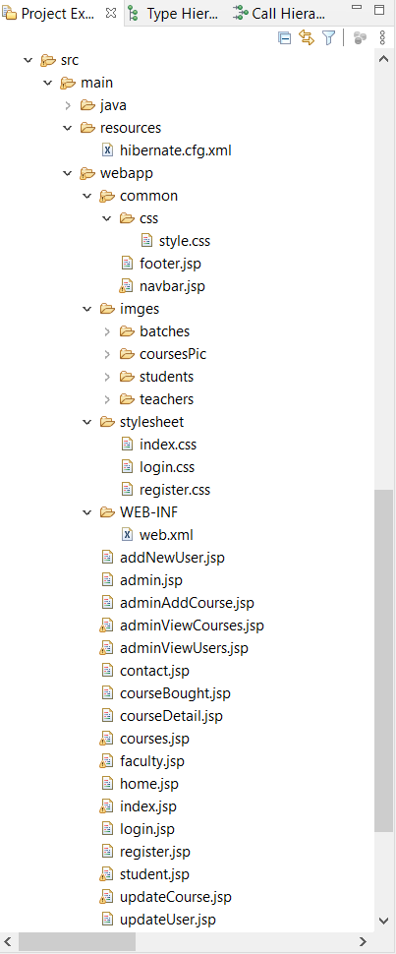

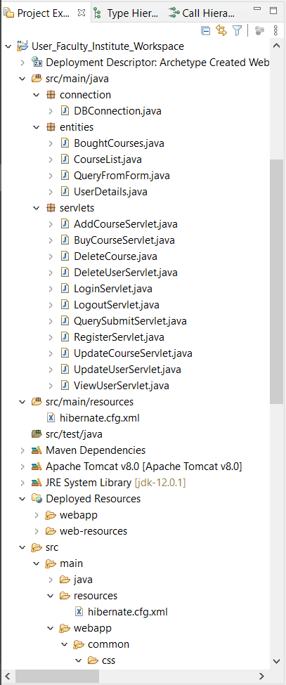

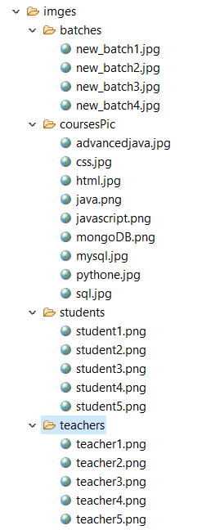

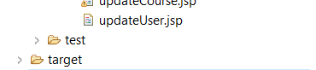



**Codes of *‘connection’* package**

**DBConnection.java**

package connection;

import org.hibernate.SessionFactory;

import org.hibernate.cfg.Configuration;

public class DBConnection {

//default Constructor

public DBConnection() {

}

// I used static so that I can call this function without making an object

// and calling this method like an function

public static SessionFactory factory;

public static SessionFactory getFactory() {

if (factory == null) {

factory = new Configuration().configure().buildSessionFactory();

}

return factory;

}

public void closeFactory() {

if (factory.isOpen())

factory.close();

}

}

**Codes of *‘entities’* package**

**BoughtCourses.java**

package entities;

import javax.persistence.Entity;

import javax.persistence.GeneratedValue;

import javax.persistence.GenerationType;

import javax.persistence.Id;

@Entity

public class BoughtCourses {

@Id

@GeneratedValue(strategy = GenerationType.IDENTITY)

private int buyingID;

private int courseID;

private String courseName;

private String couseDescription;

private String courseImage;

private int coursePrice = 2999;

private String userEmail;

public int getBuyingID() {

return buyingID;

}

public void setBuyingID(int buyingID) {

this.buyingID = buyingID;

}

public int getCourseID() {

return courseID;

}

public void setCourseID(int courseID) {

this.courseID = courseID;

}

public String getCourseName() {

return courseName;

}

public void setCourseName(String courseName) {

this.courseName = courseName;

}

public int getCoursePrice() {

return coursePrice;

}

public void setCoursePrice(int coursePrice) {

this.coursePrice = coursePrice;

}

public String getCouseDescription() {

return couseDescription;

}

public void setCouseDescription(String couseDescription) {

this.couseDescription = couseDescription;

}

public BoughtCourses() {

}

public String getCourseImage() {

return courseImage;

}

public void setCourseImage(String courseImage) {

this.courseImage = courseImage;

}

public String getUserEmail() {

return userEmail;

}

public void setUserEmail(String userEmail) {

this.userEmail = userEmail;

}

public BoughtCourses(int courseID, String courseName,

String couseDescription, String courseImage, int coursePrice,

String userEmail) {

super();

this.courseID = courseID;

this.courseName = courseName;

this.couseDescription = couseDescription;

this.courseImage = courseImage;

this.coursePrice = coursePrice;

this.userEmail = userEmail;

}

}

**CourseList.java**

package entities;

import javax.persistence.*;

import java.util.Date;

@Entity

@Table

public class CourseList {

@Id

@GeneratedValue(strategy = GenerationType.AUTO)

@Column(unique = true)

private int courseID;

private String courseName;

private String couseDescription;

private String courseImage;

private int coursePrice = 2999;

@Temporal(TemporalType.DATE)

@Column(name = "courseAddedDate")

private Date courseAddedDate;

public int getCourseID() {

return courseID;

}

public void setCourseID(int courseID) {

this.courseID = courseID;

}

public String getCourseName() {

return courseName;

}

public void setCourseName(String courseName) {

this.courseName = courseName;

}

public String getCouseDescription() {

return couseDescription;

}

public void setCouseDescription(String couseDescription) {

this.couseDescription = couseDescription;

}

public String getCourseImage() {

return courseImage;

}

public void setCourseImage(String courseImagePath) {

this.courseImage = courseImagePath;

}

public int getCoursePrice() {

return coursePrice;

}

public void setCoursePrice(int coursePrice) {

this.coursePrice = coursePrice;

}

public Date getCourseAddedDate() {

return courseAddedDate;

}

public void setCourseAddedDate(Date courseAddedDate) {

this.courseAddedDate = courseAddedDate;

}

public CourseList() {

}

public CourseList(String courseName, String couseDescription,

String courseImage, int coursePrice, Date courseAddedDate) {

super();

this.courseName = courseName;

this.couseDescription = couseDescription;

this.courseImage = courseImage;

this.coursePrice = coursePrice;

this.courseAddedDate = courseAddedDate;

}

public CourseList(String courseName, String couseDescription, int coursePrice) {

super();

this.courseName = courseName;

this.couseDescription = couseDescription;

this.coursePrice = coursePrice;

}

@Override

public String toString() {

return "CourseList [courseID=" + courseID + ", courseName=" + courseName

+ ", couseDescription=" + couseDescription + ", courseImage="

+ courseImage + ", coursePrice=" + coursePrice + "]";

}

}

**QueryFromQuery.java**

**package** entities;

**import** javax.persistence.*;

@Entity

@Table

**public** **class** QueryFromForm {

@Id

@GeneratedValue(strategy = GenerationType.***AUTO***)

@Column(nullable = **false**)

**private** **int** qSoNo;

**private** String qName;

**private** String qEmail;

**private** String qContact;

**private** String qQueryHead;

@Column(columnDefinition = "TEXT")

**private** String qQueryExplained;

**public** **int** getqSoNo() {

**return** qSoNo;

}

**public** **void** setqSoNo(**int** qSoNo) {

**this**.qSoNo = qSoNo;

}

**public** String getqName() {

**return** qName;

}

**public** **void** setqName(String qName) {

**this**.qName = qName;

}

**public** String getqEmail() {

**return** qEmail;

}

**public** **void** setqEmail(String qEmail) {

**this**.qEmail = qEmail;

}

**public** String getqContact() {

**return** qContact;

}

**public** **void** setqContact(String qContact) {

**this**.qContact = qContact;

}

**public** String getqQueryHead() {

**return** qQueryHead;

}

**public** **void** setqQueryHead(String qQueryHead) {

**this**.qQueryHead = qQueryHead;

}

**public** String getqQueryExplained() {

**return** qQueryExplained;

}

**public** **void** setqQueryExplained(String qQueryExplained) {

**this**.qQueryExplained = qQueryExplained;

}

**public** QueryFromForm() {

**super**();

}

**public** QueryFromForm(String qName, String qEmail, String qContact,

String qQueryHead, String qQueryExplained) {

**super**();

**this**.qName = qName;

**this**.qEmail = qEmail;

**this**.qContact = qContact;

**this**.qQueryHead = qQueryHead;

**this**.qQueryExplained = qQueryExplained;

}

@Override

**public** String toString() {

**return** "QueryFromForm [qSoNo=" + qSoNo + ", qName=" + qName

+ ", qEmail=" + qEmail + ", qContact=" + qContact

+ ", qQueryHead=" + qQueryHead + ", qQueryExplained="

+ qQueryExplained + "]";

}

}

**UserDetails.java**

package entities;

import javax.persistence.Column;

import javax.persistence.Entity;

import javax.persistence.Id;

import javax.persistence.Table;

import java.text.SimpleDateFormat;

import java.util.Date;

@Entity

@Table

public class UserDetails {

@Id

@Column(nullable = false, unique = true)

private String email;

@Column(nullable = false, length = 20)

private String firstName;

@Column(nullable = true, length = 20)

private String lastName;

@Column(nullable = false)

private String password;

@Column(nullable = true)

private String contactNumber;

@Column(nullable = false)

private String registraionDate;

@Column(nullable = false)

private String userType;

@Column(nullable = true, length = 15)

private String houseNo;

@Column(nullable = true)

private String landMark;

@Column(nullable = true, length = 35)

private String city;

@Column(nullable = true)

private String state;

@Column(nullable = true)

private String pinCode;

public UserDetails() {

super();

}

public String getHouseNo() {

return houseNo;

}

public void setHouseNo(String houseNo) {

this.houseNo = houseNo;

}

public String getLandMark() {

return landMark;

}

public void setLandMark(String landMark) {

this.landMark = landMark;

}

public String getCity() {

return city;

}

public void setCity(String city) {

this.city = city;

}

public String getState() {

return state;

}

public void setState(String state) {

this.state = state;

}

public String getPinCode() {

return pinCode;

}

public void setPinCode(String pinCode) {

this.pinCode = pinCode;

}

public String getFirstName() {

return firstName;

}

public void setFirstName(String firstName) {

this.firstName = firstName;

}

public String getLastName() {

return lastName;

}

public void setLastName(String lastName) {

this.lastName = lastName;

}

public String getEmail() {

return email;

}

public void setEmail(String email) {

this.email = email;

}

public String getPassword() {

return password;

}

public void setPassword(String password) {

this.password = password;

}

public String getContactNumber() {

return contactNumber;

}

public void setContactNumber(String contactNumber) {

this.contactNumber = contactNumber;

}

public String getUserType() {

return userType;

}

public void setUserType(String userType) {

this.userType = userType;

}

public String getRegistraionDate() {

return registraionDate;

}

public void setRegistraionDate(Date registerDate) {

SimpleDateFormat formatter = new SimpleDateFormat(

"dd-MM-yyyy, HH:mm:ss");

this.registraionDate = formatter.format(registerDate);

}

public UserDetails(String firstName, String lastName, String email,

String password, Date registraionDate, String userType) {

super();

this.firstName = firstName;

this.lastName = lastName;

this.email = email;

this.password = password;

this.userType = userType;

this.setRegistraionDate(registraionDate);

this.registraionDate = this.getRegistraionDate();

}

public UserDetails(String email, String firstName, String lastName,

String password, String contactNumber, String userType, String houseNo,

String landMark, String city, String state, String pinCode) {

super();

this.email = email;

this.firstName = firstName;

this.lastName = lastName;

this.password = password;

this.contactNumber = contactNumber;

this.userType = userType;

this.houseNo = houseNo;

this.landMark = landMark;

this.city = city;

this.state = state;

this.pinCode = pinCode;

}

public String getFullName() {

return firstName + " " + lastName;

}

public String toStringFullAddress() {

return "Address:- " + getHouseNo() + ", " + getLandMark() + ", "

+ getCity() + ", " + getState() + " " + getPinCode();

}

@Override

public String toString() {

return "UserDetails [email=" + email + ", firstName=" + firstName

+ ", lastName=" + lastName + ", password=" + password

+ ", contactNumber=" + contactNumber + ", registraionDate="

+ registraionDate + ", userType=" + userType + ", houseNo="

+ houseNo + ", landMark=" + landMark + ", city=" + city

+ ", state=" + state + ", pinCode=" + pinCode + "]";

}

}

**Codes of *‘servlets’* package**

**AddCourseServlet.java**

package servlets;

import connection.DBConnection;

import entities.CourseList;

import org.hibernate.Session;

import javax.servlet.ServletException;

import javax.servlet.http.HttpServlet;

import javax.servlet.http.HttpServletRequest;

import javax.servlet.http.HttpServletResponse;

import javax.servlet.http.HttpSession;

import java.io.IOException;

import java.util.Date;

public class AddCourseServlet extends HttpServlet {

private static final long serialVersionUID = 1L;

public AddCourseServlet() {

super();

}

protected void doPost(HttpServletRequest request,

HttpServletResponse response) throws ServletException, IOException {

String title = (String) request.getParameter("cTitle");

String description = (String) request.getParameter("cExplination");

String image = (String) request.getParameter("subjectImage");

int price = Integer.parseInt(request.getParameter("cPrice"));

CourseList cl;

cl = new CourseList(title, description, image, price, new Date());

//System.out.println(cl.toString());

Session sess = DBConnection.getFactory().openSession();

sess.beginTransaction();

sess.save(cl);

sess.getTransaction().commit();

sess.close();

HttpSession session = null;

session = request.getSession();

session.setAttribute("course-added", "New courese " + title + " added");

response.sendRedirect("admin.jsp");

}

}

**BuyCourseServlet.java**

package servlets;

import java.io.IOException;

import javax.servlet.ServletException;

import javax.servlet.http.HttpServlet;

import javax.servlet.http.HttpServletRequest;

import javax.servlet.http.HttpServletResponse;

import javax.servlet.http.HttpSession;

import org.hibernate.Session;

import org.hibernate.Transaction;

import connection.DBConnection;

import entities.BoughtCourses;

import entities.CourseList;

public class BuyCourseServlet extends HttpServlet {

private static final long serialVersionUID = 1L;

public BuyCourseServlet() {

super();

}

protected void doPost(HttpServletRequest request,

HttpServletResponse response) throws ServletException, IOException {

doGet(request, response);

}

protected void doGet(HttpServletRequest request,

HttpServletResponse response) throws ServletException, IOException {

String userId = request.getParameter("userId");

HttpSession session = null;

session = request.getSession();

CourseList cl = (CourseList) session.getAttribute("courseDetails");

try {

Session sess = DBConnection.getFactory().openSession();

Transaction tr = sess.beginTransaction();

BoughtCourses bcCourse = new BoughtCourses(cl.getCourseID(),

cl.getCourseName(), cl.getCouseDescription(),

cl.getCourseImage(), cl.getCoursePrice(), userId);

sess.save(bcCourse);

tr.commit();

sess.close();

} catch (Exception e) {

e.printStackTrace();

}

session.setAttribute("CourseBought",

"Course '" + cl.getCourseName() + "' bought successfully.");

response.sendRedirect("courses.jsp");

}

}

**DeleteCourse.java**

package servlets;

import java.io.IOException;

import javax.servlet.ServletException;

import javax.servlet.http.HttpServlet;

import javax.servlet.http.HttpServletRequest;

import javax.servlet.http.HttpServletResponse;

import javax.servlet.http.HttpSession;

import org.hibernate.Session;

import connection.DBConnection;

import entities.CourseList;

public class DeleteCourse extends HttpServlet {

private static final long serialVersionUID = 1L;

public DeleteCourse() {

super();

}

protected void doGet(HttpServletRequest request,

HttpServletResponse response) throws ServletException, IOException {

Session sess = DBConnection.getFactory().openSession();

int cId = Integer.parseInt(request.getParameter("courseID"));

sess.beginTransaction();

CourseList cl = new CourseList();

cl.setCourseID(cId);

sess.delete(cl);

sess.getTransaction().commit();

sess.close();

HttpSession session = null;

session = request.getSession();

session.setAttribute("course-delete-success",

"Course with course id - " + cId + " deleted successfuly");

response.sendRedirect("adminViewCourses.jsp");

}

}

**DeleteUserServlet.java**

package servlets;

import connection.DBConnection;

import entities.UserDetails;

import org.hibernate.Session;

import org.hibernate.Transaction;

import javax.servlet.ServletException;

import javax.servlet.http.HttpServlet;

import javax.servlet.http.HttpServletRequest;

import javax.servlet.http.HttpServletResponse;

import javax.servlet.http.HttpSession;

import java.io.IOException;

public class DeleteUserServlet extends HttpServlet {

private static final long serialVersionUID = 1L;

public DeleteUserServlet() {

super();

}

protected void doGet(HttpServletRequest request,

HttpServletResponse response) throws ServletException, IOException {

try {

String email = request.getParameter("courseID");

Session sess = DBConnection.getFactory().openSession();

Transaction tr = sess.beginTransaction();

UserDetails userDelete = new UserDetails();

userDelete.setEmail(email);

int check = 10;

UserDetails persist = sess.load(UserDetails.class, email);

String utype2 = persist.getUserType();

if (persist != null) {

sess.delete(persist);

check = 1;

}

tr.commit();

sess.close();

HttpSession session = null;

if (check == 1) {

session = request.getSession();

session.setAttribute("Users-Success", "User with email: '"

+ email + "' deleted successfully!");

} else {

session = request.getSession();

session.setAttribute("Users-Success", "User with email: '"

+ email + "' not deleted successfully!");

}

response.sendRedirect("adminViewUsers.jsp?whoUser=" + utype2 + "");

// response.sendRedirect("adminViewCourses.jsp");

System.out.println("Redirected succes.");

} catch (Exception e) {

e.printStackTrace();

}

}

}

**LoginServlet.java**

package servlets;

import connection.DBConnection;

import entities.UserDetails;

import org.hibernate.Session;

import javax.servlet.ServletException;

import javax.servlet.annotation.WebServlet;

import javax.servlet.http.HttpServlet;

import javax.servlet.http.HttpServletRequest;

import javax.servlet.http.HttpServletResponse;

import javax.servlet.http.HttpSession;

import java.io.IOException;

@WebServlet

public class LoginServlet extends HttpServlet {

private static final long serialVersionUID = 1L;

public LoginServlet() {

super();

}

protected void doPost(HttpServletRequest request,

HttpServletResponse response) throws ServletException, IOException {

String email = request.getParameter("uEmail");

String password = request.getParameter("uPassword");

// no need of transaction as we are not saving anything.

Session sess = DBConnection.getFactory().openSession();

UserDetails userDetails = (UserDetails) sess.get(UserDetails.class,

email);

HttpSession logedInDetails = null;

if (userDetails != null) {

if (userDetails.getPassword().equals(password)) {

logedInDetails = request.getSession();

logedInDetails.setAttribute("logedInUser", userDetails);

if (userDetails.getUserType().equals("student")) {

response.sendRedirect("student.jsp");

} else if (userDetails.getUserType().equals("faculty"))

response.sendRedirect("faculty.jsp");

else if (userDetails.getUserType().equals("admin"))

response.sendRedirect("admin.jsp");

} else {

sess.getTransaction().rollback();

logedInDetails = request.getSession();

logedInDetails.setAttribute("login-failed",

"Wronge Password try again...");

response.sendRedirect("login.jsp");

}

} else {

logedInDetails = request.getSession();

logedInDetails.setAttribute("login-failed",

"This user does not exists!!!");

response.sendRedirect("login.jsp");

System.out.println(

"Database returned object is empty\n Now we need to create a temp session and send use it to show an alert in the login page that the details does not match. wrong mail id password.");

}

}

}

**LogoutServlet.java**

package servlets;

import javax.servlet.ServletException;

import javax.servlet.http.HttpServlet;

import javax.servlet.http.HttpServletRequest;

import javax.servlet.http.HttpServletResponse;

import javax.servlet.http.HttpSession;

import java.io.IOException;

public class LogoutServlet extends HttpServlet {

private static final long serialVersionUID = 1L;

public LogoutServlet() {

super();

}

protected void doPost(HttpServletRequest request,

HttpServletResponse response) throws ServletException, IOException {

try {

HttpSession session = request.getSession();

session.removeAttribute("logedInUser");

session.setAttribute("logout-msg", "Logout sucessfull...");

response.sendRedirect("login.jsp");

} catch (Exception e) {

e.printStackTrace();

}

}

protected void doGet(HttpServletRequest request,

HttpServletResponse response) throws ServletException, IOException {

try {

HttpSession session = request.getSession();

session.removeAttribute("logedInUser");

session.setAttribute("logout-msg", "Logout sucessfull...");

response.sendRedirect("login.jsp");

} catch (Exception e) {

e.printStackTrace();

}

}

}

**QuerySubmitServlet.java**

package servlets;

import connection.DBConnection;

import entities.QueryFromForm;

import org.hibernate.Session;

import org.hibernate.Transaction;

import javax.servlet.ServletException;

import javax.servlet.http.HttpServlet;

import javax.servlet.http.HttpServletRequest;

import javax.servlet.http.HttpServletResponse;

import javax.servlet.http.HttpSession;

import java.io.IOException;

public class QuerySubmitServlet extends HttpServlet {

private static final long serialVersionUID = 1L;

public QuerySubmitServlet() {

super();

}

protected void doPost(HttpServletRequest request,

HttpServletResponse response) throws ServletException, IOException {

String name = request.getParameter("name");

String email = request.getParameter("email");

String contact = request.getParameter("contact");

String queryHeading = request.getParameter("queryHead");

String query = request.getParameter("queryExplained");

QueryFromForm q = new QueryFromForm(name, email, contact, queryHeading,

query);

Session session = DBConnection.getFactory().openSession();

Transaction tr = session.beginTransaction();

session.save(q);

HttpSession sessionh = request.getSession();

sessionh.setAttribute("querySubmited",

"Query submitted we will reach you soon.");

response.sendRedirect("contact.jsp");

tr.commit();

session.close();

}

}

**RegisterServlet.java**

package servlets;

import connection.DBConnection;

import entities.UserDetails;

import org.hibernate.Session;

import org.hibernate.Transaction;

import org.hibernate.exception.ConstraintViolationException;

import javax.servlet.ServletException;

import javax.servlet.http.HttpServlet;

import javax.servlet.http.HttpServletRequest;

import javax.servlet.http.HttpServletResponse;

import javax.servlet.http.HttpSession;

import java.io.IOException;

import java.io.Serializable;

import java.util.Date;

public class RegisterServlet extends HttpServlet {

private static final long serialVersionUID = 1L;

public RegisterServlet() {

super();

}

protected void doPost(HttpServletRequest request,

HttpServletResponse response) throws ServletException, IOException {

HttpSession session = null;

try {

String uFirstName = request.getParameter("uFirstName");

String uLastName = request.getParameter("uLastName");

String uEmail = request.getParameter("uEmail");

String uPassword = request.getParameter("uPassword");

String uType = request.getParameter("uType");

Session sess = DBConnection.getFactory().openSession();

UserDetails userDetails = (UserDetails) sess.get(UserDetails.class,

uEmail);

if (userDetails != null) {

session = request.getSession();

// Will execute when connection with database is failed due to

// various reason.

session.setAttribute("reg-failed", "This user email '" + uEmail

+ "' is already in use take something else.");

response.sendRedirect("register.jsp");

} else {

UserDetails uDetails;

if (uType != null) {

uDetails = new UserDetails(uFirstName, uLastName, uEmail,

uPassword, new Date(), uType);

// DBConnection gives the factory.

// Create session from the factory.

// Create a transaction from the session.

Transaction tr = sess.beginTransaction();

// or sess.beginTransaction();

Serializable iddd = sess.save(uDetails);

System.out.println(iddd);

tr.commit();

// or sess.getTransaction().commit();

sess.close();

session = request.getSession();

session.setAttribute("reg-sucess",

"New '" + uType + "' Registered Sucesfull");

response.sendRedirect("admin.jsp");

} else {

uDetails = new UserDetails(uFirstName, uLastName, uEmail,

uPassword, new Date(), "student");

// Create a transaction from the session.

Transaction tr = sess.beginTransaction();

// or sess.beginTransaction();

Serializable iddd = sess.save(uDetails);

System.out.println(iddd);

tr.commit(); // or sess.getTransaction().commit();

sess.close();

session = request.getSession();

session.setAttribute("reg-sucess",

"Registration Sucesfull");

response.sendRedirect("register.jsp");

}

}

} catch (ConstraintViolationException cve) {

System.out.println("Duplicate maal");

} catch (Exception e) {

System.out.println("2nd exception is thrown\n");

e.printStackTrace();

session = request.getSession();

// Will execute when connection with database is failed due to

// various reason.

session.setAttribute("reg-failed",

"Registration Unsucessful, Something went wrong with server!! Come back in 10 min....");

response.sendRedirect("register.jsp");

}

}

}

**UpdateCourseServlet.java**

package servlets;

import connection.DBConnection;

import entities.CourseList;

import org.hibernate.Session;

import org.hibernate.Transaction;

import javax.servlet.ServletException;

import javax.servlet.http.HttpServlet;

import javax.servlet.http.HttpServletRequest;

import javax.servlet.http.HttpServletResponse;

import javax.servlet.http.HttpSession;

import java.io.IOException;

public class UpdateCourseServlet extends HttpServlet {

private static final long serialVersionUID = 1L;

public UpdateCourseServlet() {

super();

// TODO Auto-generated constructor stub

}

protected void doPost(HttpServletRequest request,

HttpServletResponse response) throws ServletException, IOException {

String title = request.getParameter("cTitle");

String descr = request.getParameter("cExplination");

int price = Integer.parseInt(request.getParameter("cPrice"));

int id = Integer.parseInt(request.getParameter("couresID"));

// CourseList todo = new CourseList(title, descr, price);

Session sess = DBConnection.getFactory().openSession();

Transaction tr = sess.beginTransaction();

CourseList updateIt = sess.get(CourseList.class, id);

updateIt.setCourseName(title);

updateIt.setCouseDescription(descr);

updateIt.setCoursePrice(price);

tr.commit();

sess.close();

HttpSession session = request.getSession();

session.setAttribute("course-delete-success",

"Course with id: " + id + " updated successfully.");

response.sendRedirect("adminViewCourses.jsp");

}

}

**UpdateUserServlet.java**

package servlets;

import java.io.IOException;

import javax.servlet.ServletException;

import javax.servlet.http.HttpServlet;

import javax.servlet.http.HttpServletRequest;

import javax.servlet.http.HttpServletResponse;

import org.hibernate.Session;

import org.hibernate.Transaction;

import connection.DBConnection;

import entities.UserDetails;

public class UpdateUserServlet extends HttpServlet {

private static final long serialVersionUID = 1L;

public UpdateUserServlet() {

super();

}

protected void doPost(HttpServletRequest request,

HttpServletResponse response) throws ServletException, IOException {

String fName = request.getParameter("uFirstName");

String lName = request.getParameter("uLastName");

String uEmail = request.getParameter("uEmail");

String password = request.getParameter("uPassword");

String uType = request.getParameter("uType");

String uContact = request.getParameter("uContact");

String uHouse = request.getParameter("uHouse");

String uLandMark = request.getParameter("uLandmark");

String uCity = request.getParameter("uCity");

String uState = request.getParameter("uState");

String uPinCode = request.getParameter("uPinCode");

try {

Session sess = DBConnection.getFactory().openSession();

Transaction tr = sess.beginTransaction();

UserDetails udu = new UserDetails();

udu = (UserDetails) sess.get(UserDetails.class, uEmail);

udu.setEmail(uEmail);

udu.setFirstName(fName);

udu.setLastName(lName);

udu.setPassword(password);

udu.setContactNumber(uContact);

udu.setUserType(uType);

udu.setHouseNo(uHouse);

udu.setLandMark(uLandMark);

udu.setCity(uCity);

udu.setState(uState);

udu.setPinCode(uPinCode);

sess.update(udu);

System.out.println("updated");

tr.commit();

sess.close();

String previousPageUrl = request.getParameter("previousPageUrl");

response.sendRedirect(previousPageUrl);

//System.out.println(previousPageUrl);

} catch (Exception e) {

e.printStackTrace();

}

}

}

**ViewUserServlet.java**

package servlets;

import javax.servlet.ServletException;

import javax.servlet.http.HttpServlet;

import javax.servlet.http.HttpServletRequest;

import javax.servlet.http.HttpServletResponse;

import java.io.IOException;

public class ViewUserServlet extends HttpServlet {

private static final long serialVersionUID = 1L;

public ViewUserServlet() {

super();

}

protected void doGet(HttpServletRequest request,

HttpServletResponse response) throws ServletException, IOException {

System.out.println("Inside doGet");

String whoUser = request.getParameter("whoUser");

// Data from UserDetail.java

if (whoUser.equals("student")) {

response.sendRedirect("student.jsp");

} else if (whoUser.equals("faculty")) {

response.sendRedirect("faculty.jsp");

} else {

response.sendRedirect("admin.jsp");

}

}

}

**Codes of *‘main/resources’* folder**

**hibernate.cfg.xml**

<?xml version=*'1.0'* encoding=*'utf-8'*?>

<!DOCTYPE hibernate-configuration PUBLIC

"-//Hibernate/Hibernate Configuration DTD//EN"

"http://hibernate.sourceforge.net/hibernate-configuration-3.0.dtd">

<hibernate-configuration>

<session-factory>

<property name=*"connection.driver_class"*>com.mysql.jdbc.Driver</property>

<property name=*"connection.url"*>jdbc:mysql://localhost:3306/institute_workspace</property>

<!-- Table Name (Create yourself) -->

<property name=*"connection.username"*>root</property>

<property name=*"connection.password"*>Goldenstar@1234</property>

<property name=*"dialect"*>org.hibernate.dialect.MySQL8Dialect</property>

<property name=*"hbm2ddl.auto"*>update</property>

<!-- <property name="show_sql">true</property> -->

<property name=*"format_sql"*>true</property>

<!-- POJO to create classes -->

<mapping class=*"entities.UserDetails"*/>

<mapping class=*"entities.CourseList"*/>

<mapping class=*"entities.BoughtCourses"*/>

<mapping class=*"entities.QueryFromForm"*/>

<!-- File where annotation is performed. -->

<!-- <mapping resource = "hibernate.student"/> -->

<!-- !IMPORTANT:- resource attribute is used in mapping option when using

hibernate.hbm.xml file form mapping. class attribute is used in mapping option

when using annotation for mapping. -->

</session-factory>

</hibernate-configuration>

**Codes of *‘webapp/common’* folder**

**CSS/style.css**

@charset *"ISO-8859-1"*;

/*

Navigation bar and Footer Styling.

*/

* {

box-sizing: *border-box*;

margin: *0px*;

}

**form** {

width: *100%*;

padding: *1rem* *3rem*;

}

**form** *.form-group* {

padding: *2rem* *0rem*;

}

*.add-shadow*>**div** {

box-shadow: *1px* *1px* *3px* *black*;

}

*.bg-custom* {

background: *#a446d7*;

}

*.btn-custom* {

/*background: #ef3bef;*/

background: *white*;

}

*.navbar* *.nav-item* *.nav-link* {

font-size: *1rem*;

color: *white*;

}

**body** {

font-family: *sans-serif*;

margin: *0*;

background: *#fbfbfb*;

}

**h1** {

text-align: *center*;

margin-top: *50px*;

}

**p** {

text-align: *center*;

margin-bottom: *60px*;

}

**h4** {

text-align: *center*;

line-height: *80px*;

font-weight: *normal*;

}

*.masonry* { /* Masonry container */

-webkit-column-count: *4*;

-moz-column-count: *4*;

column-count: *4*;

margin: *1.5em*;

padding: *0*;

-moz-column-gap: *1.5em*;

-webkit-column-gap: *1.5em*;

column-gap: *1.5em*;

font-size: *.85em*;

}

*.item* {

display: *inline-table*;

background: *#fff*;

padding: *1em*;

margin: *0* *0* *1.5em*;

width: *100%*;

transition: *1s* *ease* *all*;

-webkit-transition: *1s* *ease* *all*;

box-sizing: *border-box*;

-moz-box-sizing: *border-box*;

-webkit-box-sizing: *border-box*;

box-shadow: *2px* *2px* *4px* *0* *#ccc*;

}

*.item* **img** {

max-width: *100%*;

height: *auto*;

}

*.down* {

}

@media only screen and (max-width: 320px) {

*.masonry* {

-moz-column-count: *1*;

-webkit-column-count: *1*;

column-count: *1*;

}

}

@media only screen and (min-width: 321px) and (max-width: 768px) {

*.masonry* {

-moz-column-count: *2*;

-webkit-column-count: *2*;

column-count: *2*;

}

}

@media only screen and (min-width: 769px) and (max-width: 1200px) {

*.masonry* {

-moz-column-count: *3*;

-webkit-column-count: *3*;

column-count: *3*;

}

}

@media only screen and (min-width: 1201px) {

*.masonry* {

-moz-column-count: *4*;

-webkit-column-count: *4*;

column-count: *4*;

}

}

**footer.jsp**

<style>

*.down* {

transition: *all .35s ease*;

}

*.down:hover* {

margin-bottom: *-10px*;

box-shadow:*1px 2px 2px black*;

transform: *scale(1.2)*;

}

</style>

<!-- Footer -->

<footer class=*"bg-light text-center text-lg-start"*>

<div class=*"text-center p-3"*

style="background-color: *rgba(0, 0, 0, 0.2)*;">

<!-- Facebook -->

<a class=*"down btn btn-primary rounded-circle"*

style="background-color: *#3b5998*" href=*"https://www.facebook.com/ujjwal.pandey.1656/"* target=*"_blank"* role=*"button"*><i

class=*"fab fa-facebook"*></i></a>

<!-- Twitter -->

<a class=*"down btn btn-primary rounded-circle"*

style="background-color: *#55acee*" href=*"https://twitter.com/Ujjwalp13341664"* target=*"_blank"* role=*"button"*><i

class=*"fab fa-twitter"*></i></a>

<!-- Instagram -->

<a class=*"down btn btn-primary rounded-circle"*

style="background-color: *#ac2bac*" href=*"https://www.instagram.com/pandey.ujjwalpandey/"* target=*"_blank"* role=*"button"*><i

class=*"fab fa-instagram"*></i></a>

<!-- Linkedin -->

<a class=*"down btn btn-primary rounded-circle"*

style="background-color: *#0082ca*" href=*"https://www.linkedin.com/in/ujjwal-pandey-8bb562138/"* target=*"_blank"* role=*"button"*><i

class=*"fab fa-linkedin-in"*></i></a>

<!-- Stack overflow -->

<a class=*"down btn btn-primary rounded-circle"*

style="background-color: *#ffac44*" href=*"https://stackoverflow.com/users/12213190/ujjwal-pandey"* target=*"_blank"* role=*"button"*><i

class=*"fab fa-stack-overflow"*></i></a>

<!-- Github -->

<a class=*"down btn btn-primary rounded-circle"*

style="background-color: *#333333*" href=*"https://github.com/ujjwalpandeyjava"* target=*"_blank"* role=*"button"*><i

class=*"fab fa-github"*></i></a><br> <br> © 2020 Copyright: <span

class=*"text-dark"*>Developers Point </span>

</div>

</footer>

<!-- Footer ends here -->

<!-- Bootstrap 5 JavaScript and PopperJs -->

<script src=*"webjars/bootstrap/5.0.0-beta3/js/bootstrap.min.js"*></script>

<script src=*"webjars/popper.js/2.5.4/umd/popper.min.js"*></script>

**navbar.jsp**

<!-- Bootstrap 5 CDN Dependencies -->

<%@page import=*"entities.UserDetails"*%>

<link href=*"webjars/bootstrap/5.0.0-beta3/css/bootstrap.min.css"*

rel=*"stylesheet"*>

<!-- Font-awesome CDN Dependencies -->

<link href=*"webjars/font-awesome/5.15.2/css/all.min.css"*

rel=*"stylesheet"*>

<!--

<link

href="https://stackpath.bootstrapcdn.com/font-awesome/4.7.0/css/font-awesome.min.css"

rel="stylesheet">-->

<!-- Custom -->

<link rel=*"stylesheet"* href=*"common/css/style.css"*>

<link rel=*"image/x-icon"* href=*"fa fa-icon"*>

<!-- Navigation Bar starts here -->

<nav class=*"px-3 navbar navbar-expand-lg navbar-dark bg-custom"*>

<div class=*"container-fluid"*>

<a class=*"navbar-brand fst-italic"* href=*"index.jsp"*><i

class=*"fa fa-bookmark"*> Developers' Point</i></a>

<button class=*"navbar-toggler"* type=*"button"* data-bs-toggle=*"collapse"*

data-bs-target=*"#navbarSupportedContent"*

aria-controls=*"navbarSupportedContent"* aria-expanded=*"false"*

aria-label=*"Toggle navigation"*>

<span class=*"navbar-toggler-icon"*></span>

</button>

<div class=*"collapse navbar-collapse"* id=*"navbarSupportedContent"*>

<ul class=*"navbar-nav me-auto mb-2 mb-lg-0"*>

<%

UserDetails userDetails = (UserDetails) session.getAttribute("logedInUser");

**if** (userDetails != **null**) {

%>

<li class=*"nav-item"*><a class=*"nav-link"* href=*"home.jsp"*> <i

class=*"fa fa-home"* aria-hidden=*"true"*> Home</i>

</a></li>

<%

}

%>

<li class=*"nav-item"*><a class=*"nav-link"* aria-current=*"page"*

href=*"courses.jsp"*><i class=*"fa fa-user-graduate"*> Courses</i></a></li>

<!-- <li class="nav-item"><a class="nav-link" href="newBatches.jsp">

<i class="fa fa-plus" aria-hidden="true"> New Batches</i> -->

</a>

</li>

<li class=*"nav-item"*><a class=*"nav-link"* href=*"contact.jsp"*>

<i class=*"fa fa-shopping-basket"*> Contact</i>

</a></li>

</ul>

<%

**if** (userDetails != **null**) {

%>

<div class=*"d-flex"*>

<a class=*"btn btn-custom btn-outline-dark mx-1"*

data-bs-toggle=*"modal"* data-bs-target=*"#exampleModal"*><i

class=*"fa fa-user-circle"*> <%=userDetails.getFullName()%></i> </a> <a

href=*"LogoutServlet"* class=*"btn btn-custom btn-oFutline-dark mx-1"*><i

class=*"fa fa-sign-out-alt"*> logout</i> </a>

</div>

<!-- Modal -->

<div class=*"modal fade"* id=*"exampleModal"* tabindex=*"-1"*

aria-labelledby=*"exampleModalLabel"* aria-hidden=*"true"*>

<div class=*"modal-dialog"*>

<div class=*"modal-content"*>

<div class=*"modal-header"*>

<h5 class=*"modal-title text-center fs-2"* id=*"exampleModalLabel"*>Profile

Details</h5>

<button type=*"button"* class=*"btn-close"* data-bs-dismiss=*"modal"*

aria-label=*"Close"*></button>

</div>

<div class=*"modal-body"*>

<table class=*"table table-striped text-center"*>

<thead>

<tr>

<th scope=*"col"* colspan=*"2"*><i

class=*"fa fa-user-circle fs-4"*> DETAILS</i></th>

</tr>

</thead>

<tbody>

<tr>

<th scope=*"row"*>Email ID:</th>

<td><%=userDetails.getEmail()%></td>

</tr>

<tr>

<th scope=*"row"*>Name:</th>

<td><%=userDetails.getFirstName()%></td>

</tr>

<tr>

<th scope=*"row"*>User since:</th>

<td><%=userDetails.getRegistraionDate()%></td>

</tr>

<!--<tr>

<th scope="row">Password</th>

<td colspan="2">

/*

String passStar = "";

String pass = userDetails.getPassword();

char[] ch = new char[pass.length()];

for (int i = 0; i < pass.length(); i++) {

passStar += "*";

}*/ %></td>

</tr>-->

</tbody>

</table>

</div>

<div class=*"modal-footer"*>

<button type=*"button"* class=*"btn btn-secondary"*

data-bs-dismiss=*"modal"*>Close</button>

<a class=*"btn btn-info px-3 w-100"* role=*"button"*

href=*"updateUser.jsp?userId=*<%=userDetails.getEmail()%>*"*>Edit</a>

</div>

</div>

</div>

</div>

<%

} **else** {

%>

<div class=*"d-flex"*>

<a href=*"register.jsp"* class=*"btn btn-custom btn-outline-dark mx-1"*><i

class=*"fa fa-user-plus"*> Register</i> </a> <a href=*"login.jsp"*

class=*"btn btn-custom btn-outline-dark mx-1"*><i

class=*"fa fa-user-circle"*> login</i> </a>

</div>

<%

}

%>

</div>

</div>

</nav>

<!-- Navigation Bar ends here -->

**Codes of *‘webapp/stylesheet’* folder**

**Index.css**

/*Font */

@import

*url("https://fonts.googleapis.com/css2?family=Belleza&display=swap")*;

/*

font-family: 'Belleza', sans-serif;

*/

* {

margin: *0*;

padding: *0*;

box-sizing: *border-box*;

}

*.primary-container* {

width: *100%*;

min-height: *80vh*;

padding: *7px*;

background-color: *aqua*;

}

*.primary-container*>*.section* {

margin: *30px* *3px*;

padding: *15px*;

border-radius: *9px*;

display: *flex*;

flex-direction: *column*;

align-items: *center*;

}

*.primary-container*>*.section-1* {

background-color: *white*;

}

*.rows* {

display: *flex*;

flex-wrap: *wrap*;

margin: *12px* *16px*;

border-radius: *3px*;

padding: *9px* *10px*;

background-color: *#8ddfc8*;

justify-content: *space-around*;

width: *100%*;

}

*.imagediv* {

height: *180px*;

padding: *10px*;

width: *auto*;

}

*.imagediv*>**img** {

height: *100%*;

width: *auto*;

border-radius: *3px*;

transition: *all* *0.7s* *ease*;

}

**img***:hover* {

transform: *scale(1.1)*;

}

*.of1***,** *.of2* {

max-width: *40%*;

margin-top: *6px*;

justify-content: *center*;

}

*.of1* {

display: *flex*;

flex-direction: *row*;

flex-wrap: *wrap*;

}

*.of2*>**div**>**p** {

text-align: *left* *!important*;

}

*.of1*>**div***:nth-child*(*2*) {

padding: *40px*;

}

*.of1*>**div***:nth-child*(*2*)**,** *.of2*>**div***:nth-child*(*2*) {

padding: *8px*;

}

*.primary-container*>*.section-2* {

background-color: *#f4ebeb*;

}

*.glow* {

color: *#e8ffde*;

}

*.section-2*>**div** {

background-color: *#0097a7*;

margin: *4px*;

color: *white*;

font-weight: *600*;

padding: *12px* *4px*;

border-radius: *4px*;

width: *100%*;

}

*.teachers*>**div**>**img** {

margin-left: *-14px*;

width: *70px*;

height: *auto*;

border-radius: *50%*;

}

@media only screen and (max-width: 375px) {

*.teachers*>**div**>**img** {

width: *60px*;

}

}

@media only screen and (min-width: 768px) {

*.teachers*>**div**>**img** {

width: *100px*;

}

}

*.students* **div**>**div**>**img** {

max-width: *300px*;

height: *auto*;

padding: *9px*;

box-shadow: *0px* *0px* *5px* *black*;;

background-color: *white*;

}

*.size-Custome* {

font-size: *x-large*;

}

*.primary-container*>*.section-3* {

background-color: *white*;

}

*.primary-container*>*.section-4* {

background-color: *#f4ebeb*;

}

*.primary-container*>*.section-5* {

background-color: *white*;

}

*.primary-container*>*.section-6* {

background-color: *#f4ebeb*;

}

**Login.css**

*.main-data* {

height: *85vh*;

width: *100%*;

background-image: *linear-gradient(111deg,* *rgb(64,* *151,* *147),*

*rgb(164,* *70,* *215),* *rgb(64,* *151,* *147))*;

box-shadow: *inset* *0px* *0px* *10px* *-3px* *black*;

}

*.form-outter* {

min-height: *70%*;

height: *auto*;

min-width: *300px*;

width: *60%*;

max-width: *70%*;

padding: *10px*;

background-image: *linear-gradient(252deg,* *rgb(218* *172* *243),*

*rgb(113,* *223,* *218))*;

box-shadow: *inset* *0px* *0px* *10px* *-3px* *black*;

/*border: 1px solid black;*/

display: *flex*;

flex-direction: *column*;

justify-content: *center*;

min-width: *300px*;

}

**section** {

display: *block*;

width: *100%*;

padding: *13px* *35px*;

}

**section**>**label** {

max-width: *40%*;

font-weight: *normal*;

font-size: *x-large*;

/*margin-left: 20px;*/

font-style: *oblique*;

}

**section**>**input** {

width: *100%*;

border: *none*;

outline: *none*;

padding: *3px* *13px*;

border-bottom: *1px* *solid* *blue*;

}

**section**>**input***:focus* {

border-bottom: *2px* *solid* *blue*

}

**input**[type="submit"] {

background-color: *#c9d0fc*;

width: *40%*;

border: *1px* *solid* *lime*;

box-shadow: *0* *0* *4px* *lime*;

padding: *4px* *15px*;

font-size: *1.25rem*;

border-radius: *20px*;

margin-left: *50%*;

transform: *translate(-50%,* *-50%)*;

border: *1px* *solid* *lime*;

outline: *none*;

}

**input**[type="submit"]*:hover* {

background-color: *lime*;

color: *black*;

}

**form**>**h2** {

font-weight: *500*;

text-align: *center*;

}

+

**register.css**

*.main-data* {

height: *81vh*;

width: *100%*;

box-shadow: *inset* *0px* *0px* *10px* *-3px* *black*;

background: *linear-gradient(to* *right,* *rgb(0,* *159,* *255),* *rgb(236,* *47,* *75))*;

background: *linear-gradient(to* *right,* *rgb(43* *164* *236),* *#ee2b46cf)*;

}

*.form-outter* {

max-width: *70%*;

width: *60%*;

min-height: *70%*;

min-width: *300px*;

padding: *10px*;

background-image: *linear-gradient(252deg,* *rgb(218* *172* *243),*

*rgb(113,* *223,* *218))*;

box-shadow: *inset* *0px* *0px* *10px* *-3px* *black*;

/*border: 1px solid black;*/

display: *flex*;

flex-direction: *column*;

justify-content: *center*;

}

*.form-outter*>**h2** {

font-weight: *300*;

text-align: *center*;

}

**section** {

display: *block*;

width: *100%*;

}

**section**>**label** {

max-width: *40%*;

font-weight: *lighter*;

margin-left: *20px*;

font-style: *oblique*;

}

**section**>**input** {

width: *100%*;

border: *none*;

outline: *none*;

padding: *3px* *13px*;

border-bottom: *1px* *solid* *blue*;

}

**section**>**input***:focus* {

border-bottom: *2px* *solid* *blue*

}

**input**[type="submit"] {

text-align: *center*;

align-self: *center*;

width: *40%*;

background-color: *#c9d0fc*;

/*border: 1px solid lime;*/

box-shadow: *0* *0* *4px* *lime*;

padding: *4px* *15px*;

font-size: *1.15rem*;

border-radius: *20px*;

margin-left: *50%*;

transform: *translate(-50%,* *-50%)*;

}

**input**[type="submit"]*:hover* {

background-color: *lime*;

color: *black*;

}

**input**[type="submit"]*:focu* {

background-color: *#00ff0075*;

}

*.hidden* {

display: *none*;

}

*.mustFill* {

color: *red*;

}

**Codes of *‘webapp/WEB-INF’* folder**

**Web.xml**

<!DOCTYPE web-app PUBLIC

"-//Sun Microsystems, Inc.//DTD Web Application 2.3//EN"

"http://java.sun.com/dtd/web-app_2_3.dtd" >

<web-app>

<display-name>Archetype Created Web Application</display-name>

<servlet>

<servlet-name>RegisterServlet</servlet-name>

<display-name>RegisterServlet</display-name>

<description />

<servlet-class>servlets.RegisterServlet</servlet-class>

</servlet>

<servlet>

<servlet-name>LoginServlet</servlet-name>

<display-name>LoginServlet</display-name>

<description />

<servlet-class>servlets.LoginServlet</servlet-class>

</servlet>

<servlet>

<servlet-name>LogoutServlet</servlet-name>

<display-name>LogoutServlet</display-name>

<description />

<servlet-class>servlets.LogoutServlet</servlet-class>

</servlet>

<servlet>

<servlet-name>QuerySubmitServlet</servlet-name>

<display-name>QuerySubmitServlet</display-name>

<description />

<servlet-class>servlets.QuerySubmitServlet</servlet-class>

</servlet>

<servlet>

<servlet-name>ViewUserServlet</servlet-name>

<display-name>ViewUserServlet</display-name>

<description />

<servlet-class>servlets.ViewUserServlet</servlet-class>

</servlet>

<servlet>

<servlet-name>AddCourse</servlet-name>

<display-name>AddCourse</display-name>

<description />

<servlet-class>servlets.AddCourse</servlet-class>

</servlet>

<servlet>

<servlet-name>AddCourseServlet</servlet-name>

<display-name>AddCourseServlet</display-name>

<description />

<servlet-class>servlets.AddCourseServlet</servlet-class>

</servlet>

<servlet>

<servlet-name>DeleteCourse</servlet-name>

<display-name>DeleteCourse</display-name>

<description />

<servlet-class>servlets.DeleteCourse</servlet-class>

</servlet>

<servlet>

<servlet-name>UpdateCourse</servlet-name>

<display-name>UpdateCourse</display-name>

<description />

<servlet-class>servlets.UpdateCourse</servlet-class>

</servlet>

<servlet>

<servlet-name>UpdateCourseServlet</servlet-name>

<display-name>UpdateCourseServlet</display-name>

<description />

<servlet-class>servlets.UpdateCourseServlet</servlet-class>

</servlet>

<servlet>

<servlet-name>DeleteUser</servlet-name>

<display-name>DeleteUser</display-name>

<description />

<servlet-class>servlets.DeleteUser</servlet-class>

</servlet>

<servlet>

<servlet-name>DeleteUserServlet</servlet-name>

<description />

<servlet-class>servlets.DeleteUserServlet</servlet-class>

</servlet>

<servlet>

<servlet-name>UpdateUserServlet</servlet-name>

<servlet-class>servlets.UpdateUserServlet</servlet-class>

</servlet>

<servlet>

<servlet-name>BuyCourseServlet</servlet-name>

<servlet-class>servlets.BuyCourseServlet</servlet-class>

</servlet>

<servlet-mapping>

<servlet-name>RegisterServlet</servlet-name>

<url-pattern>/RegisterServlet</url-pattern>

</servlet-mapping>

<servlet-mapping>

<servlet-name>LoginServlet</servlet-name>

<url-pattern>/LoginServlet</url-pattern>

</servlet-mapping>

<servlet-mapping>

<servlet-name>LogoutServlet</servlet-name>

<url-pattern>/LogoutServlet</url-pattern>

</servlet-mapping>

<servlet-mapping>

<servlet-name>QuerySubmitServlet</servlet-name>

<url-pattern>/QuerySubmitServlet</url-pattern>

</servlet-mapping>

<servlet-mapping>

<servlet-name>ViewUserServlet</servlet-name>

<url-pattern>/ViewUserServlet</url-pattern>

</servlet-mapping>

<servlet-mapping>

<servlet-name>AddCourse</servlet-name>

<url-pattern>/AddCourse</url-pattern>

</servlet-mapping>

<servlet-mapping>

<servlet-name>AddCourseServlet</servlet-name>

<url-pattern>/AddCourseServlet</url-pattern>

</servlet-mapping>

<servlet-mapping>

<servlet-name>DeleteCourse</servlet-name>

<url-pattern>/DeleteCourse</url-pattern>

</servlet-mapping>

<servlet-mapping>

<servlet-name>UpdateCourse</servlet-name>

<url-pattern>/UpdateCourse</url-pattern>

</servlet-mapping>

<servlet-mapping>

<servlet-name>UpdateCourseServlet</servlet-name>

<url-pattern>/UpdateCourseServlet</url-pattern>

</servlet-mapping>

<servlet-mapping>

<servlet-name>DeleteUser</servlet-name>

<url-pattern>/DeleteUser</url-pattern>

</servlet-mapping>

<servlet-mapping>

<servlet-name>DeleteUserServlet</servlet-name>

<url-pattern>/DeleteUserServlet</url-pattern>

</servlet-mapping>

<servlet-mapping>

<servlet-name>BuyCourseServlet</servlet-name>

<url-pattern>/BuyCourseServlet</url-pattern>

</servlet-mapping>

<servlet-mapping>

<servlet-name>UpdateUserServlet</servlet-name>

<url-pattern>/UpdateUserServlet</url-pattern>

</servlet-mapping>

</web-app>

**Codes of *‘webapp’* folder**

**addNewUser.jsp**

<%

UserDetails userDetails1 = (UserDetails) session.getAttribute("logedInUser");

**if** ((userDetails1 == **null**) || (!userDetails1.getUserType().equals("admin"))) {

session.setAttribute("login-failed",

"Only Admin can acess this page. Login as admin");

response.sendRedirect("LogoutServlet");

//response.sendRedirect("login.jsp");

}

%><%@ page language=*"java"* contentType=*"text/html; charset=ISO-8859-1"*

pageEncoding=*"ISO-8859-1"*%>

<!DOCTYPE html>

<html>

<head>

<meta charset=*"ISO-8859-1"*>

<link rel=*"stylesheet"* type=*"text/css"* href=*"stylesheet/register.css"*>

<style type=*"text/css"*>

*.mustFill* {

color: *red*;

}

</style>

<title>Admin add user | DevelpersPoint</title>

</head>

<body>

<%@include file=*"common/navbar.jsp"*%>

<div class=*"container"*>

<!-- Form begins here -->

<form method=*"post"* action=*"RegisterServlet"*>

<h2 class=*"text-center"*>Add new user with respective details</h2>

<section>

<label>First Name:<span class=*"mustFill"*>*</span></label> <br>

<input type=*"text"* placeholder=*"First name"* required

name=*"uFirstName"*>

</section>

<br>

<section>

<label>Last Name:</label> <br> <input type=*"text"*

placeholder=*"Last name"* name=*"uLastName"*>

</section>

<br>

<section>

<label>E-mail:</label><span class=*"mustFill"*>*</span> <br> <input

type=*"email"* placeholder=*"E-mail Address"* required name=*"uEmail"*>

</section>

<br>

<section>

<label>Password:</label><span class=*"mustFill"*>*</span> <br> <input

type=*"password"* min=*"8"* max=*"16"* required

placeholder=*"8-16 character long"* name=*"uPassword"*

onkeyup="CheckCount()"> <label class=*"hidden"*

id=*"alert_custom"* style="color: *orange*;">The password must

be between 8-16 character long!!</label>

</section>

<br>

<section>

<label>Type of user:-</label><span class=*"mustFill"*>*</span> <br>

<select class=*"form-select"* name=*"uType"*

aria-label=*"Default select example"*>

<option selected>Select user type</option>

<option value=*"student"*>Student</option>

<option value=*"faculty"*>Faculty</option>

<option value=*"admin"*>Admin</option>

</select>

</section>

<br> <br> <input type=*"submit"*

class=*"btn btn-pill text-center vw-20"* value=*"Submit"* id=*"submitMe"*>

</form>

</div>

<%@include file=*"common/footer.jsp"*%>

</body>

</html>

**admin.jsp**

<%

UserDetails userDetails1 = (UserDetails) session.getAttribute("logedInUser");

**if** ((userDetails1 == **null**) || (!userDetails1.getUserType().equals("admin"))) {

session.setAttribute("login-failed",

"Only Admin can acess this page. Login as admin");

response.sendRedirect("LogoutServlet");

//response.sendRedirect("login.jsp");

}

%>

<%@ page language=*"java"* contentType=*"text/html; charset=ISO-8859-1"*

pageEncoding=*"ISO-8859-1"*%>

<!DOCTYPE html>

<html>

<head>

<meta charset=*"ISO-8859-1"*>

<style type=*"text/css"*>

*.courses***,** *.user* {

background-color: *#bfd4ec*;

margin: *10px*;

display: *flex*;

flex-wrap: *wrap*;

justify-content: *space-around*;

border-radius: *5px*;

text-align: *center*;

}

*.customFlexCard* {

min-width: *200px*;

text-align: *center*;

margin: *4px 7px*;

}

*.card* {

padding: *0px*;

}

</style>

<title>Admin | DevellpersPoint</title>

</head>

<body style="background-color: *rgb(186, 226, 238)*;">

<%@include file=*"common/navbar.jsp"*%>

<hr>

<h2 class=*"display-3 text-center m-1"*>Courses</h2>

<hr>

<%

String courseAddedSuccesful = (String) session.getAttribute("course-added");

**if** (courseAddedSuccesful != **null**) {

%>

<div class=*"alert alert-success text-center fs-3 mx-2"* role=*"alert"*><%=courseAddedSuccesful%></div>

<%

session.removeAttribute("course-added");

}

%>

<div class=*"courses"*>

<div class=*"p-2 customFlexCard"*>

<div class=*"card border-secondary mb-3 col"* style="max-width: *18rem*;">

<div class=*"card-header"*>

<b>View List of All courses</b>

</div>

<div class=*"card-body text-secondary"*>

<h5 class=*"card-title"*>A list of all courses available</h5>

<p class=*"card-text"*>

Will show a list of courses with details and 'Two buttons' <br>&bull;

One to do editing to the course <br> &bull; Another to delete

the course

</p>

<a class=*"btn btn-info"* href=*"adminViewCourses.jsp"*>View all

courses</a>

</div>

</div>

</div>

<div class=*"p-2 customFlexCard"*>

<div class=*"card border-secondary mb-3 col"* style="max-width: *18rem*;">

<div class=*"card-header"*>

<b>Add new course</b>

</div>

<div class=*"card-body text-secondary"*>

<h5 class=*"card-title"*>Add more courses</h5>

<p class=*"card-text"*>

Contains a form with input fields:- <br> &bull; Course title

<br> &bull; Price of course<br> &bull; Description<br>

&bull; For which subject it is for<br>

</p>

<a class=*"btn btn-info"* href=*"adminAddCourse.jsp"*>Add new

course</a>

</div>

</div>

</div>

</div>

<hr>

<h2 class=*"display-3 text-center m-1"*>User</h2>

<hr>

<%

String added = (String) session.getAttribute("reg-sucess");

**if** (added != **null**) {

%>

<div class=*"alert alert-success text-center fs-2"* role=*"alert"*><%=added%></div>

<%

}

session.removeAttribute("reg-sucess");

%>

<div class=*"user"*>

<div class=*"p-2 customFlexCard"*>

<div class=*"card border-secondary mb-3 col"* style="max-width: *18rem*;">

<div class=*"card-header"*>

<b>All users</b>

</div>

<div class=*"card-body text-secondary"*>

<h5 class=*"card-title"*>List of current user</h5>

<p class=*"card-text"*>

Will show a list of users with details with 'Two buttons' <br>&bull;

One to do editing of that user <br> &bull; Another to delete

the course

</p>

<a class=*"btn btn-info"* href=*"adminViewUsers.jsp?whoUser=all"*>View

all users</a>

</div>

</div>

</div>

<div class=*"p-2 customFlexCard"*>

<div class=*"card border-secondary mb-3 col"* style="max-width: *18rem*;">

<div class=*"card-header"*>

<b>All faculty</b>

</div>

<div class=*"card-body text-secondary"*>

<h5 class=*"card-title"*>List of Faculties</h5>

<p class=*"card-text"*>

Shows a list of faculty in details with 'Two buttons' <br>&bull;

Edit that user <br>&bull; Delete the user

</p>

<a class=*"btn btn-info"* href=*"adminViewUsers.jsp?whoUser=faculty"*>View

all faculty</a>

</div>

</div>

</div>

<div class=*"p-2 customFlexCard"*>

<div class=*"card border-secondary mb-3 col"* style="max-width: *18rem*;">

<div class=*"card-header"*>

<b>All student</b>

</div>

<div class=*"card-body text-secondary"*>

<h5 class=*"card-title"*>List of Students</h5>

<p class=*"card-text"*>

Shows a list of students in details with 'Two buttons' <br>&bull;

Edit that user <br>&bull; Delete the user

</p>

<a class=*"btn btn-info"* href=*"adminViewUsers.jsp?whoUser=student"*>View

all student</a>

</div>

</div>

</div>

<div class=*"p-2 customFlexCard"*>

<div class=*"card border-secondary mb-3 col"* style="max-width: *18rem*;">

<div class=*"card-header"*>

<b>Add User</b>

</div>

<div class=*"card-body text-secondary"*>

<h5 class=*"card-title"*>Add a User</h5>

<p class=*"card-text"*>

To add a new user fill: <br>&bull; First and Last Name of

user <br>&bull; Email, Password of user <br>&bull; Type

of user

</p>

<a class=*"btn btn-info"* href=*"addNewUser.jsp"*>Add new user</a>

</div>

</div>

</div>

</div>

<hr>

<%@include file=*"common/footer.jsp"*%>

</body>

</html>

**adminAddCourse.jsp**

<%

UserDetails userDetails1 = (UserDetails) session.getAttribute("logedInUser");

**if** ((userDetails1 == **null**) || (!userDetails1.getUserType().equals("admin"))) {

session.setAttribute("login-failed",

"Only Admin can acess this page. Login as admin");

response.sendRedirect("LogoutServlet");

//response.sendRedirect("login.jsp");

}

%>

<!DOCTYPE html>

<html>

<head>

<meta charset=*"ISO-8859-1"*>

<link rel=*"stylesheet"* type=*"text/css"* href=*"stylesheet/register.css"*>

<style type=*"text/css"*>

*.mustFill* {

color: *red*;

}

</style>

<title>Admin Add course | DevelpersPoint</title>

</head>

<body>

<%@include file=*"common/navbar.jsp"*%>

<!-- Form to add new Course -->

<div class=*"container"*>

<!-- Form begins here -->

<form method=*"post"* action=*"AddCourseServlet"*>

<h2 class=*"text-center"*>Add new Course with respective details</h2>

<section>

<label>Course Title:<span class=*"mustFill"*>*</span></label> <br>

<input type=*"text"* placeholder=*"Title to show on course"* required

name=*"cTitle"*>

</section>

<br>

<section>

<label>Course Description:</label> <span class=*"mustFill"*>*</span><br>

<input type=*"text"*

placeholder=*"Little explanation oF learning material"* required

name=*"cExplination"*>

</section>

<br>

<section>

<label>Price (in rs):</label><span class=*"mustFill"*>*</span> <br>

<input type=*"number"* placeholder=*"Course price without any discount"*

required name=*"cPrice"*>

</section>

<br>

<section>

<label>Subject it is related to:</label><span class=*"mustFill"*>*</span>

<br> <select class=*"form-select"* name=*"subjectImage"* required

aria-label=*"Default select example"*>

<option selected>Select Course Subject</option>

<option value=*"java.png"*>Java</option>

<option value=*"mongoDB.png"*>MongoDB</option>

<option value=*"python.jpg"*>Python</option>

<option value=*"sql.jpg"*>SQl</option>

<option value=*"advancedjava.jpg"*>Advanced Java</option>

<option value=*"mysql.jpg"*>MYSQl</option>

<option value=*"html.jpg"*>HTML</option>

<option value=*"css.jpg"*>CSS</option>

<option value=*"javascript.png"*>JavaScript</option>

</select>

</section>

<br> <br> <input type=*"submit"*

class=*"btn btn-pill text-center vw-20"* value=*"Submit"* id=*"submitMe"*>

</form>

</div>

<%@include file=*"common/footer.jsp"*%>

</body>

</html>

**adminViewCourses.jsp**

<%@page import=*"org.hibernate.internal.build.AllowSysOut"*%>

<%@page import=*"org.hibernate.Query"*%>

<%@page import=*"java.util.Iterator"*%>

<%@page import=*"org.hibernate.Criteria"*%>

<%@page import=*"java.util.List"*%>

<%@page import=*"entities.CourseList"*%>

<%@page import=*"org.hibernate.Session"*%>

<%@page import=*"connection.DBConnection"*%>

<%

UserDetails userDetails1 = (UserDetails) session.getAttribute("logedInUser");

**if** ((userDetails1 == **null**) || (!userDetails1.getUserType().equals("admin"))) {

session.setAttribute("login-failed",

"Only Admins can access this page.\n Login as admin");

response.sendRedirect("LogoutServlet");

//response.sendRedirect("login.jsp");

}

%><%@ page language=*"java"* contentType=*"text/html; charset=ISO-8859-1"*

pageEncoding=*"ISO-8859-1"*%>

<!DOCTYPE html>

<html>

<head>

<meta charset=*"ISO-8859-1"*>

<title>Courses | DevelpersPoint</title>

</head>

<body>

<%@include file=*"common/navbar.jsp"*%>

<%

Session sess = DBConnection.getFactory().openSession();

sess.beginTransaction();

Criteria criteria = sess.createCriteria(CourseList.**class**);

List<CourseList> col = criteria.list();

%>

<div class=*"container-fluid my-4 overflow-auto"*>

<table class=*"table table-hover"*>

<thead class=*"thead-light"*>

<h2 class=*"display-4 text-center"*>Course</h2>

<%

String st = (String) session.getAttribute("course-delete-success");

**if** (st != **null**) {

%>

<div class=*"alert alert-info text-center fade show"*

style="cursor: *grab*;">

<%=st%>

<span class=*"closebtn text-right float-right"*

style="right: *10px*; cursor: *pointer*; background-color: *white*; padding: *2px 8px*; border-radius: *3px*; margin-left: *30px*;"

onclick="this.parentElement.style.display='none';">×</span>

</div>

<%

session.removeAttribute("course-delete-success");

}

%>

<tr>

<th scope=*"col"*>Id</th>

<th scope=*"col"*>Title</th>

<th scope=*"col"*>Description</th>

<th scope=*"col"*>Added on</th>

<th scope=*"col"*>Price</th>

<th scope=*"col"*>Edit</th>

<th scope=*"col"*>Delete</th>

</tr>

</thead>

<tbody>

<%

Iterator<CourseList> itr = col.iterator();

**while** (itr.hasNext()) {

CourseList cl = itr.next();

%>

<tr>

<th scope=*"row"*><%=cl.getCourseID()%></th>

<td style="word-break: *break-all*;"><%=cl.getCourseName()%></td>

<td style="word-break: *break-all*;"><%=cl.getCouseDescription()%></td>

<td><%=cl.getCourseAddedDate()%></td>

<td><%=cl.getCoursePrice()%></td>

<td><a type=*"button"* class=*"btn btn-primary"*

href=*"updateCourse.jsp?courseID=*<%=cl.getCourseID()%>*"*>Update</a></td>

<td><a type=*"button"* class=*"btn btn-danger"*

href=*"DeleteCourse?courseID=*<%=cl.getCourseID()%>*"*>Delete</a></td>

</tr>

<%

}

%>

</tbody>

</table>

</div>

<!-- Closing the page data loading-->

<%

sess.getTransaction().commit();

sess.close();

%>

<%@include file=*"common/footer.jsp"*%>

</body>

</html>

**adminViewUsers.jsp**

<%@page import=*"org.hibernate.internal.build.AllowSysOut"*%>

<%@page import=*"java.util.List"*%>

<%@page import=*"org.hibernate.Query"*%>

<%@page import=*"entities.CourseList"*%>

<%@page import=*"connection.DBConnection"*%>

<%@page import=*"org.hibernate.Session"*%>

<%

UserDetails userDetails1 = (UserDetails) session.getAttribute("logedInUser");

**if** ((userDetails1 == **null**) || (userDetails1.getUserType().equals("student"))) {

session.setAttribute("login-failed",

"Only Admins can access this page.\n Login as admin");

response.sendRedirect("LogoutServlet");

}

%><%@ page language=*"java"* contentType=*"text/html; charset=ISO-8859-1"*

pageEncoding=*"ISO-8859-1"*%>

<!DOCTYPE html>

<html>

<head>

<meta charset=*"ISO-8859-1"*>

<link rel=*"stylesheet"* type=*"text/css"* href=*"stylesheet/register.css"*>

<title>Admin View users | DevelpersPoint</title>

</head>

<body>

<%@include file=*"common/navbar.jsp"*%>

<%

String userType = request.getParameter("whoUser");

//System.out.println(userType);

Session sess = DBConnection.getFactory().openSession();

sess.beginTransaction();

String hql = **null**;

**if** (userType.equals("all")) {

hql = "From UserDetails";

} **else** **if** (userType.equals("faculty")) {

hql = "From UserDetails where userType = 'faculty'";

} **else** **if** (userType.equals("student")) {

hql = "From UserDetails where userType = 'student'";

}

Query<UserDetails> query = sess.createQuery(hql);

List<UserDetails> userList = query.list();

%>

<!-- Table -->

<div class=*"container-fluid my-4 overflow-auto"*>

<%

String succ = (String) session.getAttribute("Users-Success");

**if** (succ != **null**) {

%>

<div class=*"alert alert-info text-center fade show"*

style="cursor: *grab*;">

<%=succ%>

<span class=*"closebtn text-right float-right"*

style="right: *10px*; cursor: *pointer*; background-color: *white*; padding: *2px 8px*; border-radius: *3px*; margin-left: *30px*;"

onclick="this.parentElement.style.display='none';">×</span>

</div>

<%

session.removeAttribute("Users-Success");

}

%>

<table class=*"table table-hover"*>

<thead class=*"thead-light"*>

<h2 class=*"display-4 text-center"*>Users</h2>

<%

String st = (String) session.getAttribute("user-change-success");

**if** (st != **null**) {

%>

<div class=*"alert alert-info text-center fade show"*

style="cursor: *grab*;">

<%=st%>

<span class=*"closebtn text-right float-right"*

style="right: *10px*; cursor: *pointer*; background-color: *white*; padding: *2px 8px*; border-radius: *3px*; margin-left: *30px*;"

onclick="this.parentElement.style.display='none';">×</span>

</div>

<%

session.removeAttribute("course-delete-success");

}

%>

<tr>

<th scope=*"col"*>Name</th>

<th scope=*"col"*>Email</th>

<th scope=*"col"*>User Type</th>

<th scope=*"col"*>Contact</th>

<th scope=*"col"*>Address</th>

<th scope=*"col"*>With us from</th>

<%

**if** (userDetails.getUserType().equals("admin")) {

%>

<th scope=*"col"*>Edit</th>

<th scope=*"col"*>Delete</th>

<%

}

%>

</tr>

</thead>

<tbody>

<%

**for** (UserDetails element : userList) {

%>

<tr>

<th scope=*"row"*><%=element.getFullName()%></th>

<td style="word-break: *break-all*;"><%=element.getEmail()%></td>

<td style="word-break: *break-all*;"><%=element.getUserType()%></td>

<td><%=element.getContactNumber()%></td>

<td><%=element.toStringFullAddress()%></td>

<td><%=element.getRegistraionDate()%></td>

<%

**if** (userDetails.getUserType().equals("admin")) {

%>

<td><a type=*"button"* class=*"btn btn-primary"*

href=*"updateUser.jsp?userId=*<%=element.getEmail()%>*"*>Update</a></td>

<td><a type=*"button"* class=*"btn btn-danger"*

href=*"DeleteUserServlet?courseID=*<%=element.getEmail()%>*"*>Delete</a></td>

<%

}

%>

</tr>

<%

}

%>

</tbody>

</table>

</div>

<%

sess.getTransaction().commit();

sess.close();

%>

<%@include file=*"common/footer.jsp"*%>

</body>

</html>

**contact.jsp**

<%@ page language=*"java"* contentType=*"text/html; charset=ISO-8859-1"*

pageEncoding=*"ISO-8859-1"*%>

<!DOCTYPE html>

<html>

<head>

<meta charset=*"ISO-8859-1"*>

<title>Contact | Developers Point</title>

<style type=*"text/css"*>

*.mustFill* {

color: *red*;

}

</style>

</head>

<body>

<%@include file=*"common/navbar.jsp"*%>

<div class=*"jumbotron jumbotron-fluid"*>

<div class=*"container my-3"*>

<%

String querySubmited = (String) session.getAttribute("querySubmited");

**if** (querySubmited != **null**) {

%>

<div class=*"alert alert-success"* role=*"alert"*><%=querySubmited%></div>

<%

session.removeAttribute("querySubmited");

}

%>

<h2>Fill form no login required</h2>

<form action=*"QuerySubmitServlet"* method=*"post"*>

<section class=*"my-3"*>

<label for=*"name"*> Name<span class=*"mustFill"*>*</span></label> <input

type=*"text"* class=*"form-control"* name=*"name"*

placeholder=*"Your name"* required>

</section>

<section class=*"my-3"*>

<label for=*"email"*> Email-id<span class=*"mustFill"*>*</span></label>

<input type=*"email"* class=*"form-control"* name=*"email"*

placeholder=*"Email id to contact you"* required>

</section>

<section class=*"my-3"*>

<label for=*"contact"*> Reachable number</label> <input type=*"text"*

class=*"form-control"* name=*"contact"* placeholder=*"Contact number"*>

</section>

<section class=*"my-3"*>

<label for=*"contact"*> Type of query</label><input type=*"text"*

class=*"form-control"* name=*"queryHead"*

placeholder=*"A heading for your query"*>

</section>

<section class=*"my-3"*>

<label for=*"contact"*> Query<span class=*"mustFill"*>*</span><sub>in

details</sub>

</label>

<textarea class=*"form-control"* name=*"queryExplained"* rows=*"7"*

placeholder=*"Explain properly in details we will reach as soon as possible to solve"*

required></textarea>

</section>

<br> <input type=*"submit"* value=*"Submit"*>

</form>

<hr>

<div class=*"text-center"*>

<h2>

<strong>Some other ways to contact us</strong>

</h2>

<b>Number:</b> <i>+91-9876-5432-89, +91-8375-9905-00</i> <br> <b>Mail-name:</b>

<i>support@developerspoint.com</i> <br> <b>Visit:</b> <i>36,

Ground floor, near bank of baroda, Sankat Vihar, New Delhi, Delhi

110067</i>

</div>

</div>

</div>

<%@include file=*"common/footer.jsp"*%>

</body>

</html>

**coursesBought.jsp**

<%@page import=*"entities.CourseList"*%>

<%@page import=*"org.hibernate.Criteria"*%>

<%@page import=*"connection.DBConnection"*%>

<%@page import=*"org.hibernate.Session"*%>

<%@ page language=*"java"* contentType=*"text/html; charset=ISO-8859-1"*

pageEncoding=*"ISO-8859-1"*%>

<!DOCTYPE html>

<html>

<head>

<meta charset=*"ISO-8859-1"*>

<style type=*"text/css"*>

*.bg-cus* {

background-color: *#f5eaf7*;

}

</style>

<title>Course detail | DevelpersPoint</title>

</head>

<body>

<%@include file=*"common/navbar.jsp"*%>

<%

**int** id = Integer.parseInt(request.getParameter("courseId"));

Session sess = DBConnection.getFactory().openSession();

sess.beginTransaction();

CourseList specific = (CourseList) sess.get(CourseList.**class**, id);

%>

<div class=*"row"* style="min-height: *78vh*; width: *100vw*;">

<div class=*"col-xs-12 p-5 col-md-6"*>

<img class=*"card-img-top shadow-sm p-3 mb-5 bg-body rounded"*

src=*"imges/coursesPic/*<%=specific.getCourseImage()%>*"*

alt=*"Card image cap"*><br> <br> <span class=*"fs-3"*><strong>Topic:

</strong><%=specific.getCourseName()%></span>

<div>

<strong>Launch Date: </strong><%=specific.getCourseAddedDate()%></div>

</div>

<div class=*"col-xs-12 p-5 col-md-6 bg-cus"*>

<div class=*"shadow p-3 mb-5 bg-body rounded fs-4"*>

<span class=*"text-center fw-bolder"*>Description: </span> In this

course we

<%=specific.getCouseDescription()%></div>

<div class=*"shadow p-3 mb-5 bg-body rounded fs-3"*>

<strong>Rs: </strong><%=specific.getCoursePrice()%></div>

<div class=*"shadow p-3 mb-5 bg-body rounded fs-3"*>

<a class=*"btn btn-info px-3 w-100"* role=*"button"* href=*"contact.jsp"*>Having

Problem? contact us</a>

</div>

</div>

</div>

<%

sess.getTransaction().commit();

sess.close();

%>

<script type=*"text/javascript"*>

**function** batchCourseEnquary() {

alert("Feel free to ask anything, and sit back freely we will reach you in 25min");

}

//onclick="batchCourseEnquary()"

</script>

<%@include file=*"common/footer.jsp"*%>

</body>

</html>

**courseDetail.jsp**

<%@page import=*"entities.CourseList"*%>

<%@page import=*"org.hibernate.Criteria"*%>

<%@page import=*"connection.DBConnection"*%>

<%@page import=*"org.hibernate.Session"*%>

<%@ page language=*"java"* contentType=*"text/html; charset=ISO-8859-1"*

pageEncoding=*"ISO-8859-1"*%>

<!DOCTYPE html>

<html>

<head>

<meta charset=*"ISO-8859-1"*>

<style type=*"text/css"*>

*.bg-cus* {

background-color: *#f5eaf7*;

}

</style>

<title>Course detail | DevelpersPoint</title>

</head>

<body>

<%@include file=*"common/navbar.jsp"*%>

<%

**int** id = Integer.parseInt(request.getParameter("courseId"));

Session sess = DBConnection.getFactory().openSession();

sess.beginTransaction();

CourseList specific = (CourseList) sess.get(CourseList.**class**, id);

%>

<div class=*"row"* style="min-height: *78vh*; width: *100vw*;">

<div class=*"col-xs-12 p-5 col-md-6"*>

<img class=*"card-img-top shadow-sm p-3 mb-5 bg-body rounded"*

src=*"imges/coursesPic/*<%=specific.getCourseImage()%>*"*

alt=*"Card image cap"*><br> <br> <span class=*"fs-3"*><strong>Topic:

</strong><%=specific.getCourseName()%></span>

<div>

<strong>Launch Date: </strong><%=specific.getCourseAddedDate()%></div>

</div>

<div class=*"col-xs-12 p-5 col-md-6 bg-cus"*>

<div class=*"shadow p-3 mb-5 bg-body rounded fs-4"*>

<span class=*"text-center fw-bolder"*>Description: </span> In this

course we

<%=specific.getCouseDescription()%></div>

<div class=*"shadow p-3 mb-5 bg-body rounded fs-3"*>

<strong>Rs: </strong><%=specific.getCoursePrice()%></div>

<div class=*"shadow p-3 mb-5 bg-body rounded fs-3"*>

<a class=*"btn btn-info px-3 w-100"* role=*"button"*

onclick="batchCourseEnquary()" href=*"contact.jsp"*>More Detail</a> <br>

<%

**if** (userDetails != **null**) {

%>

<a class=*"btn btn-info px-3 w-100"* role=*"button"*

href=*"BuyCourseServlet?userId=*<%=userDetails.getEmail()%>*"*>Buy

Course</a>

<%

session.setAttribute("courseDetails", specific);

} **else** {

%>

<a class=*"btn btn-info px-3 w-100"* role=*"button"* href=*"login.jsp"*>Login

to buy Course</a>

<%

}

%>

</div>

</div>

</div>

<%

sess.getTransaction().commit();

sess.close();

%>

<script type=*"text/javascript"*>

**function** batchCourseEnquary() {

alert("Feel free to ask anything, and sit back freely we will reach you in 25min");

}

//onclick="batchCourseEnquary()"

</script>

<%@include file=*"common/footer.jsp"*%>

</body>

</html>

**courses.jsp**

<%@page import=*"org.hibernate.internal.build.AllowSysOut"*%>

<%@page import=*"org.hibernate.Query"*%>

<%@page import=*"java.util.Iterator"*%>

<%@page import=*"org.hibernate.Criteria"*%>

<%@page import=*"java.util.List"*%>

<%@page import=*"entities.CourseList"*%>

<%@page import=*"org.hibernate.Session"*%>

<%@page import=*"connection.DBConnection"*%>

<%@ page language=*"java"* contentType=*"text/html; charset=ISO-8859-1"*

pageEncoding=*"ISO-8859-1"*%>

<!DOCTYPE html>

<html>

<head>

<meta charset=*"ISO-8859-1"*>

<title>Courses | DevelpersPoint</title>

<style>

* {

box-sizing: *border-box*;

}

*.bg-cus* {

background-color: *#ebd3ed*;

}

*.x* {

/* margin: 3px; */

margin: *13px 0px*;

padding: *10px*;

/*border: 7px solid white;*/

}

</style>

</head>

<body class=*"bg-cus"*>

<%@include file=*"common/navbar.jsp"*%>

<%

Session sess = DBConnection.getFactory().openSession();

sess.beginTransaction();

Criteria criteria = sess.createCriteria(CourseList.**class**);

List<CourseList> col = criteria.list();

%>

<div class=*"container-fluid my-4 overflow-auto"*>

<h2 class=*"display-4 text-center"*>Course</h2>

<%

String courseBoughtSuccesful = (String) session.getAttribute("CourseBought");

**if** (courseBoughtSuccesful != **null**) {

%>

<div class=*"alert alert-success text-center fs-3 mx-2"* role=*"alert"*><%=courseBoughtSuccesful%></div>

<%

session.removeAttribute("CourseBought");

}

%>

<!-- Create cards -->

<div class=*"container-fluid"*>

<div class=*"row text-center justify-content-center bg-cus"*>

<%

Iterator<CourseList> itr = col.iterator();

**while** (itr.hasNext()) {

CourseList cl = itr.next();

%>

<div class=*"col-xs-12 col-sm-6 col-md-4 col-xl-3 x bg-cus"*>

<div class=*"card mx-auto"* style="width: *18rem*;">

<img class=*"card-img-top"*

src=*"imges/coursesPic/*<%=cl.getCourseImage()%>*"*

alt=*"Card image cap"*>

<div class=*"card-body"*>

<h5 class=*"card-title"* style="word-break: *break-all*;"><%=cl.getCourseName()%></h5>

<hr>

<p class=*"card-text"* style="word-break: *break-all*;">

<%=cl.getCouseDescription()%>

</p>

<a href=*"courseDetail.jsp?courseId=*<%=cl.getCourseID()%>*"*

class=*"btn btn-primary"*>More Detail</a>

</div>

</div>

</div>

<%

}

%>

</div>

</div>

</div>

<%

sess.getTransaction().commit();

sess.close();

%>

<%@include file=*"common/footer.jsp"*%>

</body>

</html>

**faculty.jsp**

<%@page import=*"java.util.Iterator"*%>

<%@page import=*"java.util.List"*%>

<%@page import=*"org.hibernate.Criteria"*%>

<%@page import=*"entities.BoughtCourses"*%>

<%@page import=*"connection.DBConnection"*%>

<%@page import=*"org.hibernate.Session"*%>

<%@ page language=*"java"* contentType=*"text/html; charset=ISO-8859-1"*

pageEncoding=*"ISO-8859-1"*%>

<!DOCTYPE html>

<html>

<head>

<meta charset=*"ISO-8859-1"*>

<style type=*"text/css"*>

/* Hide scrollbar for Chrome, Safari and Opera */

*.example::-webkit-scrollbar* {

display: *none*;

}

/* Hide scrollbar for IE, Edge and Firefox */

*.example* {

-ms-overflow-style: *none*; /* IE and Edge */

scrollbar-width: *none*; /* Firefox */

box-shadow: *inset 0px -3.5PX 7px rgb(0 0 0/ 15%)*;

}

*.courses***,** *.user* {

background-color: *#bfd4ec*;

margin: *10px*;

display: *flex*;

flex-wrap: *wrap*;

justify-content: *space-around*;

border-radius: *5px*;

text-align: *center*;

}

*.customFlexCard* {

min-width: *200px*;

text-align: *center*;

margin: *4px 7px*;

}

*.card* {

padding: *0px*;

}

</style>

</style>

<title>Faculty | DevelpersPoint</title>

</head>

<body>

<%@include file=*"common/navbar.jsp"*%>

<%

Session sess = DBConnection.getFactory().openSession();

sess.beginTransaction();

Criteria criteria = sess.createCriteria(BoughtCourses.**class**);

List<BoughtCourses> col = criteria.list();

%>

<div class=*"row"* style="height: *78vh*; width: *100vw*;">

<div class=*"col-xs-12 col-md-8"* style="padding-left: *22px*;">

<div class=*"example my-1"* style="height: *38vh*; overflow-y: *scroll*;">

<div class=*"user"*>

<div class=*"p-2 customFlexCard"*>

<div class=*"card border-secondary mb-3 col"*

style="max-width: *18rem*;">

<div class=*"card-header"*>

<b>All users</b>

</div>

<div class=*"card-body text-secondary"*>

<h5 class=*"card-title"*>List of current user</h5>

<p class=*"card-text"*>

Will show a list of users with details with 'Two buttons' <br>&bull;

One to do editing of that user <br> &bull; Another to

delete the course

</p>

<a class=*"btn btn-info"* href=*"adminViewUsers.jsp?whoUser=all"*>View

all users</a>

</div>

</div>

</div>

<div class=*"p-2 customFlexCard"*>

<div class=*"card border-secondary mb-3 col"*

style="max-width: *18rem*;">

<div class=*"card-header"*>

<b>All faculty</b>

</div>

<div class=*"card-body text-secondary"*>

<h5 class=*"card-title"*>List of Faculties</h5>

<p class=*"card-text"*>

Shows a list of faculty in details with 'Two buttons' <br>&bull;

Edit that user <br>&bull; Delete the user

</p>

<a class=*"btn btn-info"*

href=*"adminViewUsers.jsp?whoUser=faculty"*>View all faculty</a>

</div>

</div>

</div>

<div class=*"p-2 customFlexCard"*>

<div class=*"card border-secondary mb-3 col"*

style="max-width: *18rem*;">

<div class=*"card-header"*>

<b>All student</b>

</div>

<div class=*"card-body text-secondary"*>

<h5 class=*"card-title"*>List of Students</h5>

<p class=*"card-text"*>

Shows a list of students in details with 'Two buttons' <br>&bull;

Edit that user <br>&bull; Delete the user

</p>

<a class=*"btn btn-info"*

href=*"adminViewUsers.jsp?whoUser=student"*>View all student</a>

</div>

</div>

</div>

</div>

</div>

<hr>

<div class=*"container-fluid"*>

<div style="height: *100%*;"></div>

<div class=*"row text-center justify-content-center"*>

<%

**int** count = 0;

Iterator<BoughtCourses> itr = col.iterator();

**while** (itr.hasNext()) {

BoughtCourses cl = itr.next();

**if** (cl.getUserEmail().equals(userDetails.getEmail())) {

count++;

%>

<div class=*"col-xs-12 col-sm-6 x mt-4"*>

<div class=*"card mx-auto"* style="width: *18rem*;">

<img class=*"card-img-top"*

src=*"imges/coursesPic/*<%=cl.getCourseImage()%>*"*

alt=*"Card image cap"*>

<div class=*"card-body"*>

<h5 class=*"card-title"* style="word-break: *break-all*;"><%=cl.getCourseName()%></h5>

<hr>

<p class=*"card-text"* style="word-break: *break-all*;">

<%=cl.getCouseDescription()%>

</p>

<a href=*"courseBought.jsp?courseId=*<%=cl.getCourseID()%>*"*

class=*"btn btn-primary"*>More Detail</a>

</div>

</div>

</div>

<%

}

}

**if** (count < 1) {

%>

<div class=*"shadow p-3 mb-5 bg-body rounded fs-3 mt-5"*>

<strong>No course bought yet</strong>

<div class=*"shadow p-3 mb-5 bg-body rounded fs-3 mt-3"*>

<a class=*"btn btn-info px-3 w-100"* role=*"button"*

href=*"courses.jsp"*>Search Courses</a>

</div>

</div>

<%

}

%>

</div>

</div>

</div>

<div class=*"col-xs-12 p-5 col-md-4 bg-cus"*>

<h2 class=*"text-center"*>

Profile details

<hr>

<div class=*"text-muted fs-5 lead"*>

<div>

Name:

<%=userDetails.getFullName()%></div>

<div>

<br> Email id:

<%=userDetails.getEmail()%></div>

<br>

<div>

Contact number:

<%=userDetails.getContactNumber()%></div>

<div>

<br> User Type:

<%=userDetails.getUserType()%></div>

<div>

<br> User since:

<%=userDetails.getRegistraionDate()%></div>

<div>

<br>

<%=userDetails.toStringFullAddress()%></p>

<a class=*"btn btn-info px-3 w-100"* role=*"button"*

href=*"updateUser.jsp?userId=*<%=userDetails.getEmail()%>*"*>Edit</a>

</div>

</h2>

</div>

</div>

<%

sess.getTransaction().commit();

sess.close();

%>

<%@include file=*"common/footer.jsp"*%>

</body>

</html>

**home.jsp**

<%@page import=*"entities.UserDetails"*%>

<%

UserDetails userDetails = (UserDetails) session.getAttribute("logedInUser");

**if** (userDetails == **null**) {

session.setAttribute("Login-error",

"Please login first to get at home page..");

response.sendRedirect("login.jsp");

} **else** {

HttpSession logedInDetails = request.getSession();

logedInDetails.setAttribute("logedInUser", userDetails);

**if** (userDetails.getUserType().equals("student")) {

response.sendRedirect("student.jsp");

} **else** **if** (userDetails.getUserType().equals("faculty"))

response.sendRedirect("faculty.jsp");

**else** **if** (userDetails.getUserType().equals("admin"))

response.sendRedirect("admin.jsp");

}

%>

**index.jsp**

<%@page import=*"connection.DBConnection"*%>

<%@page import=*"org.hibernate.Session"*%>

<%@page import=*"java.util.Iterator"*%>

<%@page import=*"org.hibernate.Query"*%>

<%@page import=*"entities.CourseList"*%>

<%@page import=*"java.util.List"*%>

<%@ page language=*"java"* contentType=*"text/html; charset=ISO-8859-1"*

pageEncoding=*"ISO-8859-1"*%>

<!DOCTYPE html>

<html>

<head>

<meta charset=*"ISO-8859-1"*>

<link rel=*"stylesheet"* type=*"text/css"* href=*"stylesheet/index.css"*>

<title>Developers' Point | IGNOU PROJECT</title>

</head>

<body>

<%@include file=*"common/navbar.jsp"*%>

<div class=*"jumbotron m-3 fs-4"*>

<div class=*"primary-container"*>

<div class=*"section section-1 text-center"*>

<h1

style="color: *#fb8c00*; margin-top: *0px*; margin-bottom: *-20px*; font-family: *'Belleza'*; font-weight: *bold*;">Our

Latest Course</h1>

<%

Session sess = DBConnection.getFactory().openSession();

sess.beginTransaction();

Query query = sess.createQuery("from CourseList ORDER BY courseAddedDate desc");

query.setFirstResult(0);

query.setMaxResults(3);

List<CourseList> col1 = query.list();//will return the records from 5 to 10th number

Iterator<CourseList> itr1 = col1.iterator();

CourseList cl = itr1.next();

%>

<hr>

<div class=*"rows"*>

<div class=*"of2"*>

<div class=*"imagediv"*>

<img src=*"imges/coursesPic/*<%=cl.getCourseImage()%>*"*

alt=*"New Batch, join fast"*> <br>

</div>

<div>

<p>

<b>Title:</b>

<%=cl.getCourseName()%><br> <b>Description:</b>

<%=cl.getCouseDescription()%><br> <a

class=*"btn btn-info px-3 float-right"* role=*"button"*

href=*"courseDetail.jsp?courseId=*<%=cl.getCourseID()%>*"*>More

Detail</a>

</p>

</div>

</div>

<%

cl = itr1.next();

%>

<div class=*"of2"*>

<div class=*"imagediv"*>

<img src=*"imges/batches/new_batch2.jpg"*

alt=*"New Batch, join fast"*> <br>

</div>

<div>

<p>

<b>Title:</b>

<%=cl.getCourseName()%><br> <b>Description:</b>

<%=cl.getCouseDescription()%><br> <a

class=*"btn btn-info px-3 float-right"*

href=*"courseDetail.jsp?courseId=*<%=cl.getCourseID()%>*"*

role=*"button"*>More Detail</a>

</p>

</div>

</div>

<%

sess.getTransaction().commit();

sess.close();

%>

</div>

<h1

style="color: *#fb8c00*; margin-top: *20px*; margin-bottom: *10px*; font-family: *'Belleza'*; font-weight: *bold*;">New

Batch</h1>

<div class=*"rows"*>

<div class=*"of1"*>

<div class=*"imagediv"*>

<img src=*"imges/batches/new_batch1.jpg"*

alt=*"New Batch, join fast"*>

</div>

<div class=*"text-left"*>

<p class=*"text-left"*>

Teaching:Front-end Web Development<br>Description: Learn

how to develop the web with the help of HTML, CSS, JavaScript,

Ract, Bootstrap, etc<br> Batch Days: MWF <br> <sub

class=*"text-muted"*>Things are flexible before starting

the batch, take your step and bend them according to your

sutiability</sub><br> <a class=*"btn btn-info px-3 float-right"*

role=*"button"* onclick="batchCourseEnquary()" href=*"contact.jsp"*>More

Detail</a>

</p>

</div>

</div>

<div class=*"of1"*>

<div class=*"imagediv"*>

<img src=*"imges/batches/new_batch4.jpg"*

alt=*"New Batch, join fast"*>

</div>

<div>

<p>

Subject: Full Stack Development<br>Description: How to use

HTML, CSS, JavaScript, Java, Advanced Java, SQL, etc...<br>Batch

Days: TTS <br> <sub class=*"text-muted"*>Things are

flexible before starting the batch, take your step and bend

them according to your suitability</sub><br> <a

class=*"btn btn-info px-3 float-right"* href=*"contact.jsp"*

onclick="batchCourseEnquary()" role=*"button"*>More Detail</a>

</p>

</div>

</div>

</div>

</div>

<div class=*"section section-2 text-center w-100"*>

<h1

style="color: *#fb8c00*; margin: *20px auto*; font-family: *'Belleza'*; font-weight: *bold*;">Our

Exemplar</h1>

<div class=*"students"*>

<h2 class=*"glow"*>Some of our brilliant students</h2>

<div class=*"d-flex justify-content-center flex-wrap"*>

<div class=*"col w-30 p-2"* style="min-width: *170px*">

<img width=*"100%"* class=*"pb-2"* src=*"imges/students/student4.png"*

alt=*""*> <br>

<h4>Alina Gomes</h4>

<strong>Our Silver-ranked</strong> <br> Best AI developer of

2107 with salary of 35 L.P.A.

</div>

<div class=*"col w-30 p-2"* style="min-width: *170px*">

<img width=*"100%"* class=*"pb-2"* src=*"imges/students/student1.png"*

alt=*""*> <br>

<h4>UJJWAL PANDEY</h4>

<strong>Our Golden student</strong> <br> Got placement in

google with salary of 40 L.P.A.

</div>

<div class=*"col w-30 p-2"* style="min-width: *170px*">

<img width=*"100%"* class=*"pb-2"* src=*"imges/students/student5.png"*

alt=*""*> <br>

<h4>Madara Uchia</h4>

<strong>Our Bronze student</strong> <br> Best Data Scientist

of year 2019 with salary of 30 L.P.A.

</div>

</div>

</div>

<div class=*"section teachers text-center"*>

<div class=*"mx-auto"*>

<img src=*"imges/teachers/teacher1.png"* alt=*"Mr. Mohit, from india"*>

<img src=*"imges/teachers/teacher2.png"*

alt=*"Mrs. Jeene, from mexico"*> <img

src=*"imges/teachers/teacher3.png"* alt=*"Mr. Roy, from usa"*>

<img src=*"imges/teachers/teacher4.png"*

alt=*"Mr. Ranjeet, from india"*> <img

src=*"imges/teachers/teacher5.png"* alt=*"Mr. Jay, from india"*>

</div>

<div>Our world wide best m best faculty</div>

</div>

</div>

<div class=*"section bg-white"*>

<div>

<div class=*"d-flex"*>

<a href=*"register.jsp"*

class=*"btn btn-custom btn-outline-dark mx-1 size-Custome"*

style="font-size: *2.1rem*;"><i class=*"fa fa-user-plus "*>

Register</i> </a> <a href=*"login.jsp"*

class=*"btn btn-custom btn-outline-dark mx-1 size-Custome"*

style="font-size: *2.1rem*;"><i class=*"fa fa-user-circle "*>

login</i> </a>

</div>

</div>

</div>

<div class=*"section section-3"*>

<footer class=*"page-footer font-small blue pt-4"*>

<div class=*"container-fluid text-center text-md-left"*>

<div class=*"row"*>

<div class=*"col-md-5 mt-md-0 mt-3"*>

<h5 class=*"text-uppercase "*>Providng excelence to the

future</h5>

<p>We are those who provide the best m best faculty to teach

student ensuring the best future for them</p>

</div>

<div class=*"col-md-3 mb-md-0 mb-3"*>

<h5 class=*"text-uppercase bold"*>Address</h5>

<p>

36,<br> Ground floor, <br> near bank of baroda, <br>

Sankat Vihar,<br> Dew Delhi, Delhi 110067

</p>

</div>

<div class=*"col-md-3 mb-md-0 mb-3"*>

<h5 class=*"text-uppercase"*>Contact us</h5>

<p>

View Email: contactdp@Develperpoint.com<br> <a

href=*"contact.jsp"* class=*"unstyled"*>View form</a> from our

site <br> Contact no: <b> 9876-5432-89</b>

</p>

</div>

</div>

</div>

</footer>

</div>

</div>

</div>

<%@include file=*"common/footer.jsp"*%>

<script type=*"text/javascript"*>

**function** batchCourseEnquary() {

alert("Feel free to ask anything, and sit back freely we will reach you in 25min");

}

</script>

</body>

</html>

**login.jsp**

<%@ page language=*"java"* contentType=*"text/html; charset=ISO-8859-1"*

pageEncoding=*"ISO-8859-1"*%>

<!DOCTYPE html>

<html>

<head>

<meta charset=*"ISO-8859-1"*>

<link rel=*"stylesheet"* type=*"text/css"* href=*"stylesheet/login.css"*>

<title>Login | Developers point</title>

</head>

<body>

<%@include file=*"common/navbar.jsp"*%>

<div class=*"main-data d-flex justify-content-center align-items-center"*>

<div class=*"form-outter"*>

<form method=*"post"* action=*"LoginServlet"*>

<h2 class=*"my-1"*>

<i class=*"fa fa-user"*></i> Login account

</h2>

<hr class=*"my-4"*>

<%

String invalidLogin = (String) session.getAttribute("login-failed");

**if** (invalidLogin != **null**) {

%>

<div class=*"alert alert-danger"* role=*"alert"*><%=invalidLogin%></div>

<%

session.removeAttribute("login-failed");

}

%>

<%

String logoutMsg = (String) session.getAttribute("logout-msg");

**if** (logoutMsg != **null**) {

%>

<div class=*"alert alert-success"* role=*"alert"*><%=logoutMsg%></div>

<%

session.removeAttribute("logout-msg");

}

%>

<%

String loginError = (String) session.getAttribute("Login-error");

**if** (loginError != **null**) {

%>

<div class=*"alert alert-danger"* role=*"alert"*><%=loginError%></div>

<%

}

session.removeAttribute("Login-error");

%>

<section>

<label>E-mail:</label> <br> <input type=*"text"*

placeholder=*"E-mail Address"* name=*"uEmail"* required>

</section>

<br>

<section>

<label>Password:</label> <br> <input type=*"password"* min=*"8"*

max=*"16"* placeholder=*"It was 8-16 character long"* name=*"uPassword"*

required>

</section>

<br> <br> <input type=*"submit"* value=*"Submit"*>

</form>

</div>

</div>

<%@include file=*"common/footer.jsp"*%>

</body>

</html>

**register.jsp**

<%@ page language=*"java"* contentType=*"text/html; charset=ISO-8859-1"*

pageEncoding=*"ISO-8859-1"*%>

<!DOCTYPE html>

<html>

<head>

<meta charset=*"ISO-8859-1"*>

<link rel=*"stylesheet"* href=*"stylesheet/register.css"*>

<title>Register | Developers Point</title>

<style type=*"text/css"*>

*.mustFill* {

color: *red*;

}

</style>

</head>

<body>

<%@include file=*"common/navbar.jsp"*%>

<div class=*"main-data d-flex justify-content-center align-items-center"*>

<div class=*"form-outter"*>

<h2 class=*"my-2"*>

<i class=*"fa fa-user-plus"*></i> Register and Enjoy our Premium

Content

</h2>

<hr class=*"my-3"*>

<%

String regMsg = (String) session.getAttribute("reg-sucess");

**if** (regMsg != **null**) {

%>

<div class=*"alert alert-success"* role=*"alert"*>

<%=regMsg%>

Login: <a href=*"login.jsp"*>Click Here...</a>

</div>

<%

session.removeAttribute("reg-sucess");

}

String FailedMsg = (String) session.getAttribute("reg-failed");

**if** (FailedMsg != **null**) {

%>

<div class=*"alert alert-danger"* role=*"alert"*>

<%=FailedMsg%>

</div>

<%

session.removeAttribute("reg-failed");

}

%>

<form method=*"post"* action=*"RegisterServlet"*>

<section>

<label>First Name:<span class=*"mustFill"*>*</span></label> <br>

<input type=*"text"* placeholder=*"First name"* required

name=*"uFirstName"*>

</section>

<br>

<section>

<label>Last Name:</label> <br> <input type=*"text"*

placeholder=*"Last name"* name=*"uLastName"*>

</section>

<br>

<section>

<label>E-mail:</label><span class=*"mustFill"*>*</span> <br> <input

type=*"email"* placeholder=*"E-mail Address"* required name=*"uEmail"*>

</section>

<br>

<section>

<label>Password:</label><span class=*"mustFill"*>*</span> <br> <input

type=*"password"* min=*"8"* max=*"16"* required

placeholder=*"8-16 character long"* name=*"uPassword"*

onkeyup="CheckCount()"> <label class=*"hidden"*

id=*"alert_custom"* style="color: *orange*;">The password must

be between 8-16 character long!!</label>

</section>

<br> <br> <input type=*"submit"*

class=*"btn btn-pill text-center vw-20"* value=*"Submit"* id=*"submitMe"*>

</form>

<span style="font-weight: *lighter*; font-size: *small*;"><span

class=*"mustFill"*>*</span> Must fill to submit</span>

</div>

</div>

<script>

**function** CheckCount() {

**var** len = document.getElementsByName("uPassword")[0].value.length;

console.log(len);

**if** ((len < 8) || (len > 16)) {

**if** (document.getElementById("alert_custom").classList

.contains("hidden")) {

document.getElementById("alert_custom").classList

.remove('hidden');

document.getElementById("submitMe").setAttribute(

"disabled", "true");

}

} **else** {

**if** (!document.getElementById("alert_custom").classList

.contains('hidden')) {

document.getElementById("alert_custom").classList

.add('hidden');

document.getElementById("submitMe").removeAttributeNode(

document.getElementById("submitMe")

.getAttributeNode("disabled"));

}

}

}

</script>

<%@include file=*"common/footer.jsp"*%>

</body>

</html>

**student.jsp**

<%@page import=*"java.util.Iterator"*%>

<%@page import=*"entities.CourseList"*%>

<%@page import=*"java.util.List"*%>

<%@page import=*"org.hibernate.Criteria"*%>

<%@page import=*"entities.BoughtCourses"*%>

<%@page import=*"connection.DBConnection"*%>

<%@page import=*"org.hibernate.Session"*%>

<%@page import=*"entities.UserDetails"*%>

<%@ page language=*"java"* contentType=*"text/html; charset=ISO-8859-1"*

pageEncoding=*"ISO-8859-1"*%>

<!DOCTYPE html>

<html>

<head>

<meta charset=*"ISO-8859-1"*>

<style type=*"text/css"*>

*.bg-cus* {

background-color: *#f5eaf7*;

}

</style>

<title>Student | Developer Point</title>

</head>

<body>

<%@include file=*"common/navbar.jsp"*%>

<%

Session sess = DBConnection.getFactory().openSession();

sess.beginTransaction();

Criteria criteria = sess.createCriteria(BoughtCourses.**class**);

List<BoughtCourses> col = criteria.list();

%>

<div class=*"row"* style="min-height: *78vh*; width: *100vw*;">

<div class=*"col-xs-12 p-1 col-md-8"*>

<div class=*"container-fluid"*>

<div class=*"row text-center justify-content-center"*>

<%

**int** count = 0;

Iterator<BoughtCourses> itr = col.iterator();

**while** (itr.hasNext()) {

BoughtCourses cl = itr.next();

**if** (cl.getUserEmail().equals(userDetails.getEmail())) {

count++;

%>

<div class=*"col-xs-12 col-sm-6 x mt-4"*>

<div class=*"card mx-auto"* style="width: *18rem*;">

<img class=*"card-img-top"*

src=*"imges/coursesPic/*<%=cl.getCourseImage()%>*"*

alt=*"Card image cap"*>

<div class=*"card-body"*>

<h5 class=*"card-title"* style="word-break: *break-all*;"><%=cl.getCourseName()%></h5>

<hr>

<p class=*"card-text"* style="word-break: *break-all*;">

<%=cl.getCouseDescription()%>

</p>

<a href=*"courseBought.jsp?courseId=*<%=cl.getCourseID()%>*"*

class=*"btn btn-primary"*>More Detail</a>

</div>

</div>

</div>

<%

}

}

**if** (count < 1) {

%>

<div class=*"shadow p-3 mb-5 bg-body rounded fs-3 mt-5"*>

<strong>No course bought yet</strong>

<div class=*"shadow p-3 mb-5 bg-body rounded fs-3 mt-3"*>

<a class=*"btn btn-info px-3 w-100"* role=*"button"*

href=*"courses.jsp"*>Search Courses</a>

</div>

</div>

<%

}

%>

</div>

</div>

</div>

<div class=*"col-xs-12 p-5 col-md-4 bg-cus"*>

<h2 class=*"text-center"*>

Profile details

<hr>

<div class=*"text-muted fs-5 lead"*>

<div>

Name:

<%=userDetails.getFullName()%></div>

<div>

<br> Email id:

<%=userDetails.getEmail()%></div>

<br>

<div>

Contact number:

<%=userDetails.getContactNumber()%></div>

<div>

<br> User Type:

<%=userDetails.getUserType()%></div>

<div>

<br> User since:

<%=userDetails.getRegistraionDate()%></div>

<div>

<br>

<%=userDetails.toStringFullAddress()%></p>

<a class=*"btn btn-info px-3 w-100"* role=*"button"*

href=*"updateUser.jsp?userId=*<%=userDetails.getEmail()%>*"*>Edit</a>

</div>

</h2>

</div>

</div>

<%

sess.getTransaction().commit();

sess.close();

%>

<%@include file=*"common/footer.jsp"*%>

</body>

</html>

**updateCourse.jsp**

<%@page import=*"org.hibernate.Query"*%>

<%@page import=*"entities.CourseList"*%>

<%@page import=*"connection.DBConnection"*%>

<%@page import=*"org.hibernate.Session"*%>

<%

UserDetails userDetails1 = (UserDetails) session.getAttribute("logedInUser");

**if** ((userDetails1 == **null**) || (!userDetails1.getUserType().equals("admin"))) {

session.setAttribute("login-failed",

"Only Admins can access this page.\n Login as admin");

response.sendRedirect("LogoutServlet");

//response.sendRedirect("login.jsp");

}

%><%@ page language=*"java"* contentType=*"text/html; charset=ISO-8859-1"*

pageEncoding=*"ISO-8859-1"*%>

<!DOCTYPE html>

<html>

<head>

<meta charset=*"ISO-8859-1"*>

<link rel=*"stylesheet"* type=*"text/css"* href=*"stylesheet/register.css"*>

<title>Update Course | DevelpersPoint</title>

</head>

<body>

<%@include file=*"common/navbar.jsp"*%>

<%

**int** id = Integer.parseInt(request.getParameter("courseID"));

Session sess = DBConnection.getFactory().openSession();

sess.beginTransaction();

CourseList updateIt = (CourseList) sess.get(CourseList.**class**, id);

%>

<div class=*"container"*>

<!-- Form begins here -->

<form method=*"post"* action=*"UpdateCourseServlet"*>

<h2 class=*"text-center"*>Update Course</h2>

<input type=*"hidden"* name=*"couresID"*

value=*"*<%=updateIt.getCourseID()%>*"*>

<section>

<label>Course Title:<span class=*"mustFill"*>*</span></label> <br>

<input type=*"text"* placeholder=*"Title to show on course"* required

name=*"cTitle"* value=*"*<%=updateIt.getCourseName()%>*"*>

</section>

<br>

<section>

<label>Course Description:</label> <span class=*"mustFill"*>*</span><br>

<input type=*"text"*

placeholder=*"Little explanation oF learning material"* required

name=*"cExplination"* value=*"*<%=updateIt.getCouseDescription()%>*"*>

</section>

<br>

<section>

<label>Price (in rs):</label><span class=*"mustFill"*>*</span> <br>

<input type=*"number"* placeholder=*"Course price without any discount"*

required name=*"cPrice"* value=*"*<%=updateIt.getCoursePrice()%>*"*>

</section>

<br> <br> <input type=*"submit"*

class=*"btn btn-pill text-center vw-20"* value=*"Submit"* id=*"submitMe"*>

</form>

</div>

<%

sess.getTransaction().commit();

sess.close();

%>

<%@include file=*"common/footer.jsp"*%>

</body>

</html>

**updateUser.jsp**

<%@page import=*"org.hibernate.internal.build.AllowSysOut"*%>

<%@page import=*"org.hibernate.Transaction"*%>

<%@page import=*"org.hibernate.Session"*%>

<%@page import=*"connection.DBConnection"*%>

<%

UserDetails userDetails1 = (UserDetails) session.getAttribute("logedInUser");

**if** (userDetails1 == **null**) {

/*session.setAttribute("login-failed",

"Only Admin can acess this page. Login as admin");

response.sendRedirect("LogoutServlet");*/

session.setAttribute("login-failed", "Login to access this page");

response.sendRedirect("login.jsp");

}

%><%@ page language=*"java"* contentType=*"text/html; charset=ISO-8859-1"*

pageEncoding=*"ISO-8859-1"*%>

<!DOCTYPE html>

<html>

<head>

<meta charset=*"ISO-8859-1"*>

<link rel=*"stylesheet"* type=*"text/css"* href=*"stylesheet/register.css"*>

<style type=*"text/css"*>

*.mustFill* {

color: *red*;

}

</style>

<title>Admin update user details | DevelpersPoint</title>

</head>

<body>

<%@include file=*"common/navbar.jsp"*%>

<div class=*"container"* style="min-height: *78vh*;">

<%

//Getting prvious page.

String url2 = request.getHeader("Referer");

System.out.println(url2);

String[] urlParts = url2.split("/");

//System.out.println(urlParts[urlParts.length - 1]);

String email = request.getParameter("userId");

System.out.println(email);

/* UserDetails updateIt = null;

HttpSession session2 = null;

Session sess = DBConnection.getFactory().openSession();

Transaction tr = sess.beginTransaction();

updateIt = (UserDetails) sess.load(UserDetails.class, email);

session2 = request.getSession();

session2.setAttribute("uud", updateIt);

tr.commit();

sess.close();

*/

Session sess = DBConnection.getFactory().openSession();

sess.beginTransaction();

UserDetails updateIt = (UserDetails) sess.get(UserDetails.**class**, email);

**if** (updateIt != **null**) {

//System.out.println(updateIt.toString());

%>

<!-- Form begins here -->

<form method=*"post"* action=*"UpdateUserServlet"*>

<h2 class=*"text-center display-5"*>Update user details with

precautions</h2>

add details in value and work in servlet to get them all and update

in database. then work on courses page. then work on student page.

<section>

<label>First Name:<span class=*"mustFill"*>*</span></label> <br>

<input type=*"text"* placeholder=*"First name"* required

name=*"uFirstName"* value=*"*<%=updateIt.getFirstName()%>*"*>

</section>

<br>

<section>

<label>Last Name:</label> <br> <input type=*"text"*

placeholder=*"Last name"* name=*"uLastName"*

value=*"*<%=updateIt.getLastName()%>*"*>

</section>

<br>

<section>

<!-- Previous page url with parementer it gave -->

<input type=*"hidden"* name=*"previousPageUrl"*

value=*"*<%=urlParts[urlParts.length - 1]%>*"*> <input

type=*"hidden"* placeholder=*"E-mail Address"* required name=*"uEmail"*

value=*"*<%=updateIt.getEmail()%>*"*>

</section>

<br>

<section>

<label>Password:</label><span class=*"mustFill"*>*</span> <br> <input

type=*"password"* min=*"8"* max=*"16"* required

placeholder=*"8-16 character long"* name=*"uPassword"*

onkeyup="CheckCount()" value=*"*<%=updateIt.getPassword()%>*"*>

<label class=*"hidden"* id=*"alert_custom"* style="color: *orange*;">The

password must be between 8-16 character long!!</label>

</section>

<br>

<section>

<label>Type of user:- <span class=*"mustFill"*>(this

user was <%=updateIt.getUserType()%>) </label>*</span> <br> <select

class=*"form-select"* name=*"uType"*

value=*"*<%=updateIt.getUserType()%>*"*

aria-label=*"Default select example"* required>

<option selected value=*"*<%=updateIt.getUserType()%>*"*>Select

user type</option>

<option value=*"student"*>Student</option>

<option value=*"faculty"*>Faculty</option>

<option value=*"admin"*>Admin</option>

</select>

</section>

<br>

<section>

<label>Contact no:</label><input type=*"text"*

placeholder=*"User Contact no"* name=*"uContact"*

value=*"*<%=updateIt.getContactNumber()%>*"*>

</section>

<br>

<section>

<label>House-no:</label><input type=*"text"*

placeholder=*"House number"* name=*"uHouse"*

value=*"*<%=updateIt.getHouseNo()%>*"*>

</section>

<br>

<section>

<label>Landmark:</label><input type=*"text"*

placeholder=*"Something easily visible to everyone"* name=*"uLandmark"*

value=*"*<%=updateIt.getLandMark()%>*"*>

</section>

<br>

<section>

<label>City:</label><input type=*"text"*

placeholder=*"City user live in"* name=*"uCity"*

value=*"*<%=updateIt.getCity()%>*"*>

</section> <br>

<section>

<label>State:</label><input type=*"text"*

placeholder=*"State user live in"* name=*"uState"*

value=*"*<%=updateIt.getState()%>*"*>

</section>

<br> <section>

<label>Pin Code:</label><input type=*"text"*

placeholder=*"Address full pin code"* name=*"uPinCode"*

value=*"*<%=updateIt.getPinCode()%>*"*>

</section>

<br> <br> <input type=*"submit"*

class=*"btn btn-pill text-center vw-20"* value=*"Update"* id=*"submitMe"*>

</form>

<%

sess.getTransaction().commit();

sess.close();

} **else** {

%>

<h2 class=*"text-center"*>User not found</h2>

<%

}

%>

</div>

<%@include file=*"common/footer.jsp"*%>

</body>

</html>

1. **Tables used (Screenshots of real table)**

UserDetails

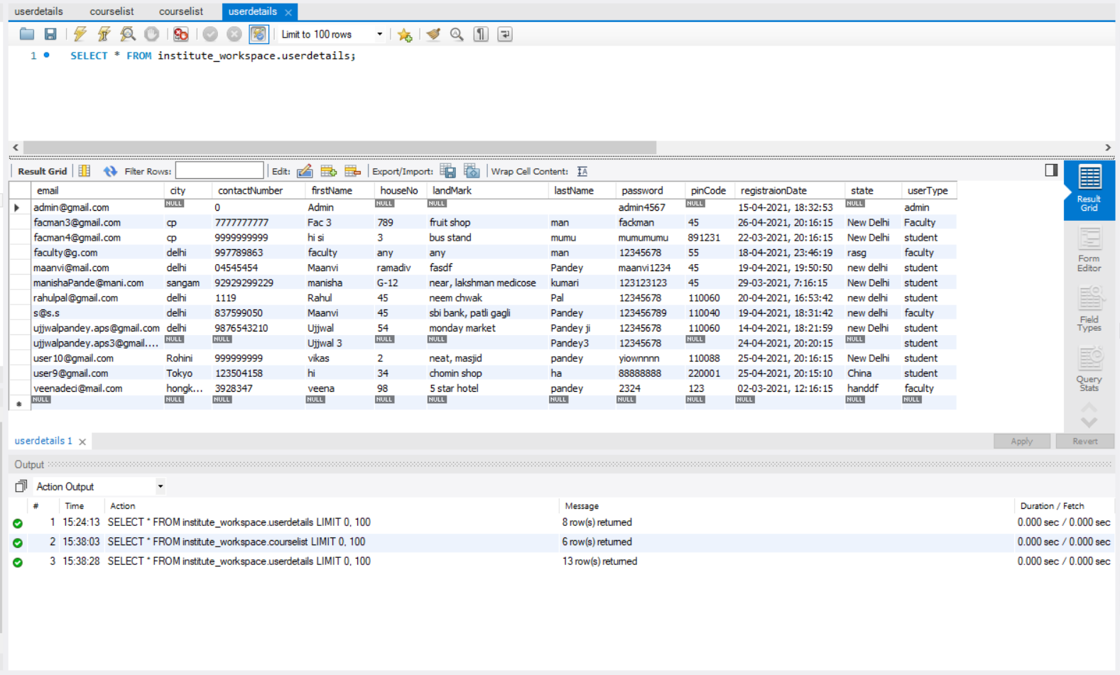

Courselist

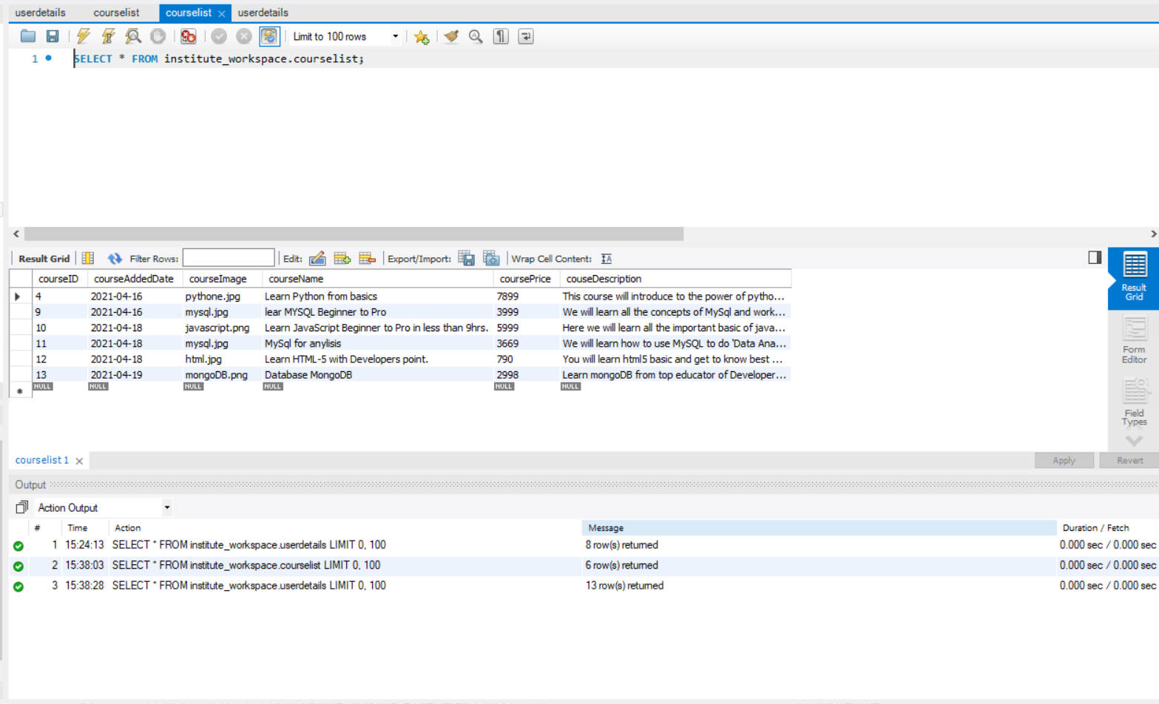

boughtcourses

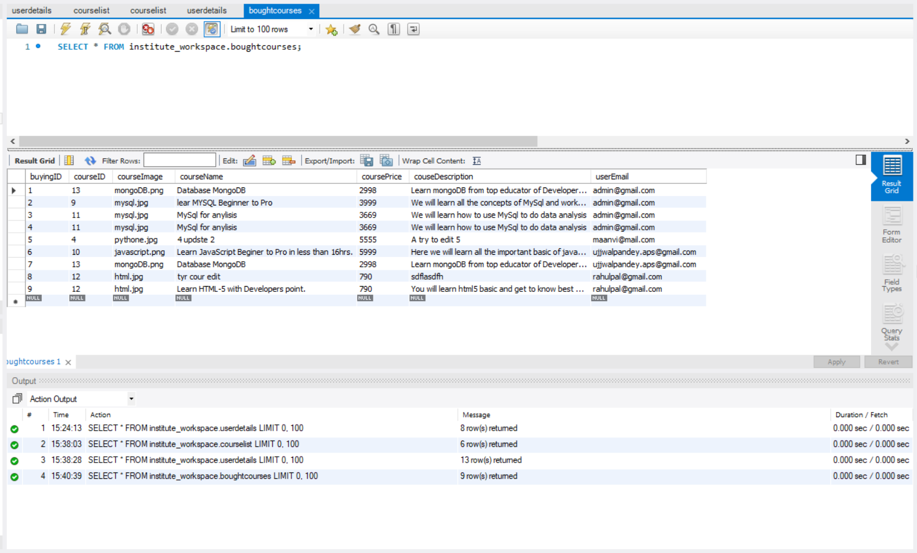

hibernate_sequence

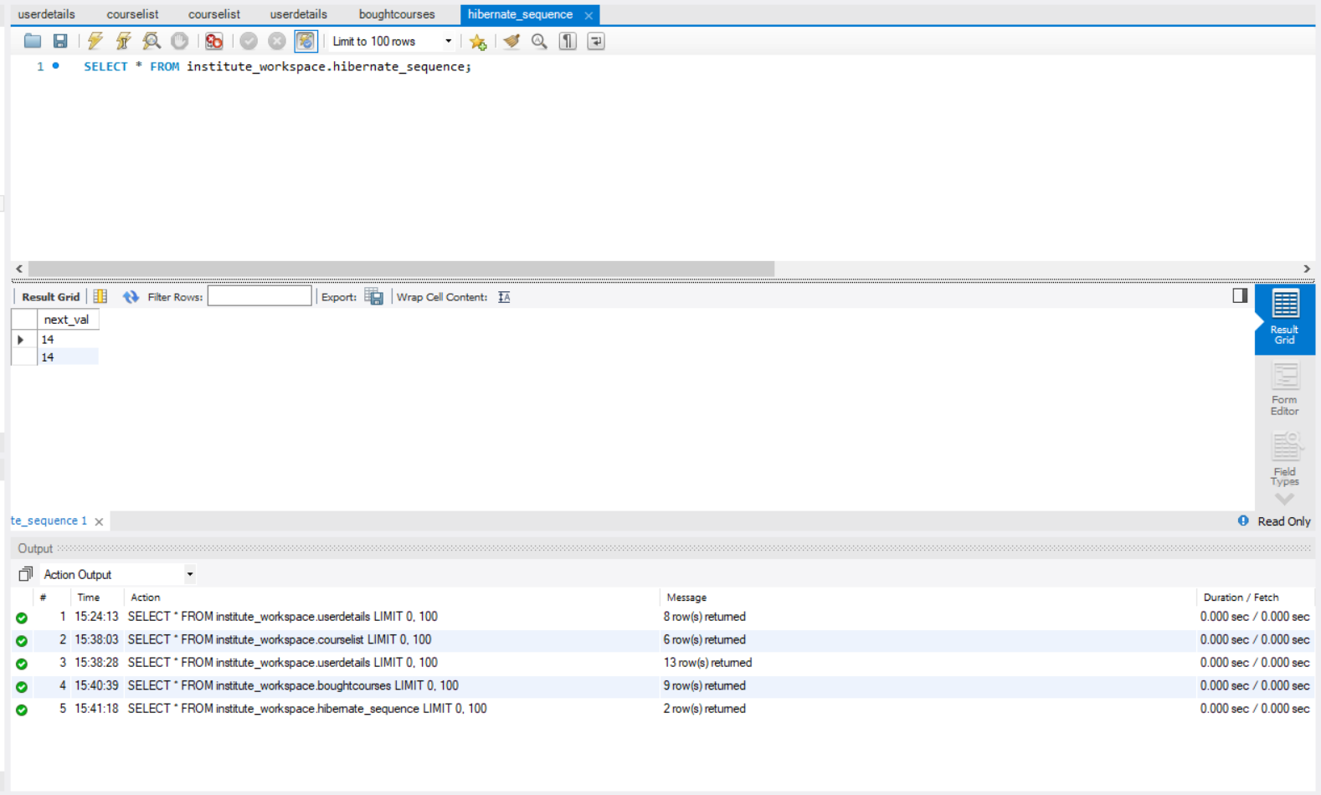

queryfromform

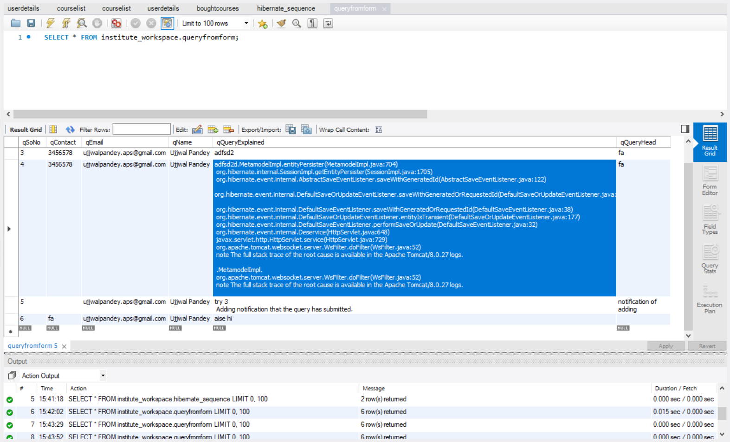

1. **Outputs**

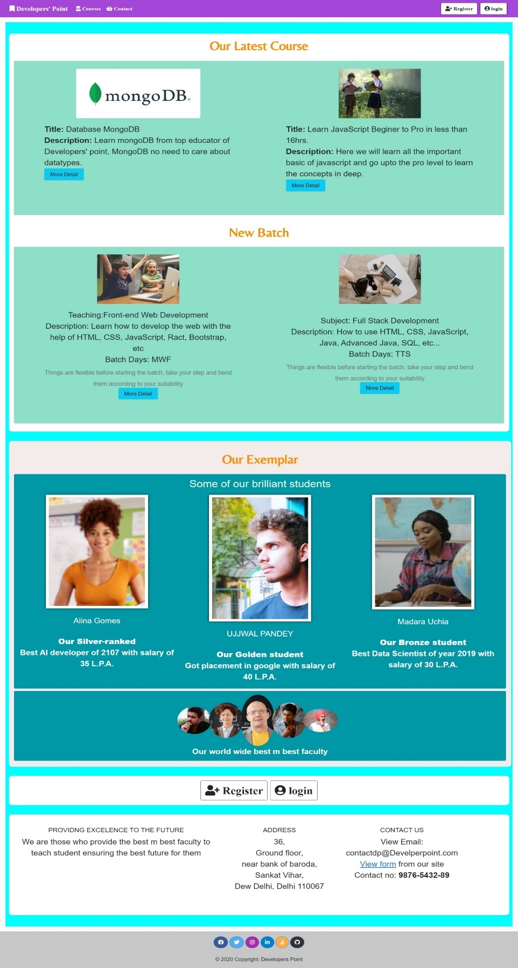

**Index page**

anyone can visit

(No login required)

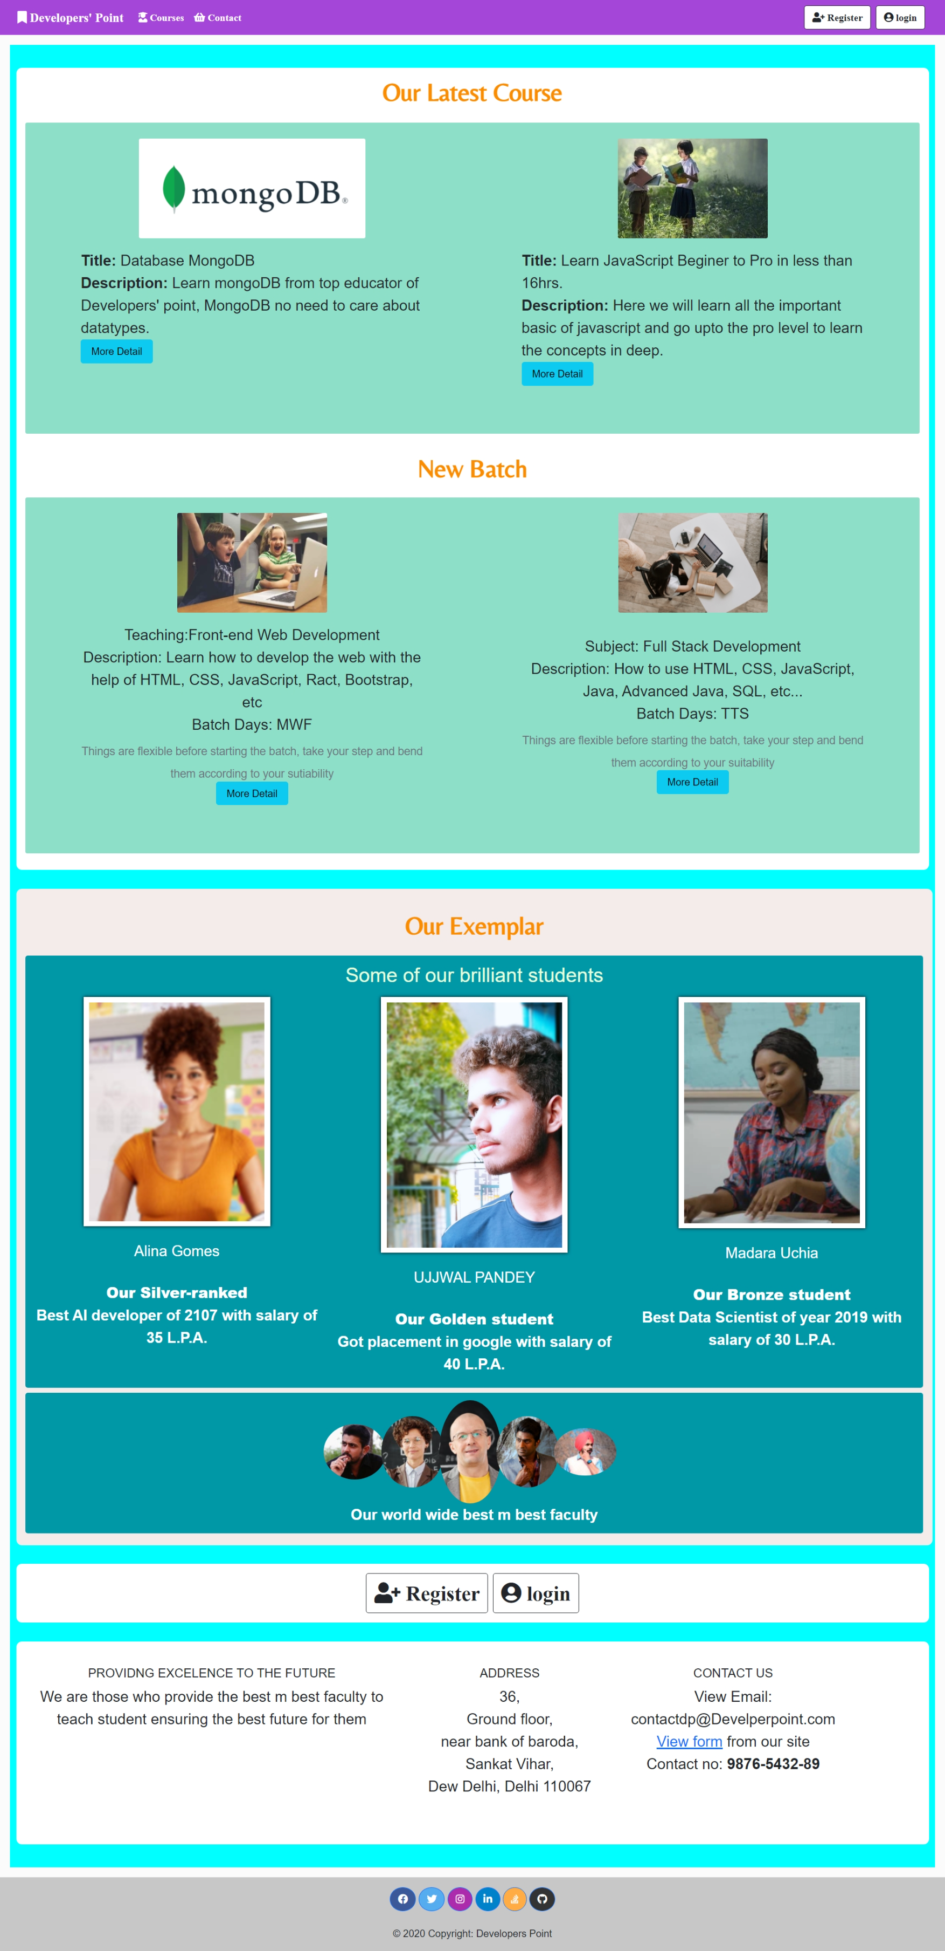

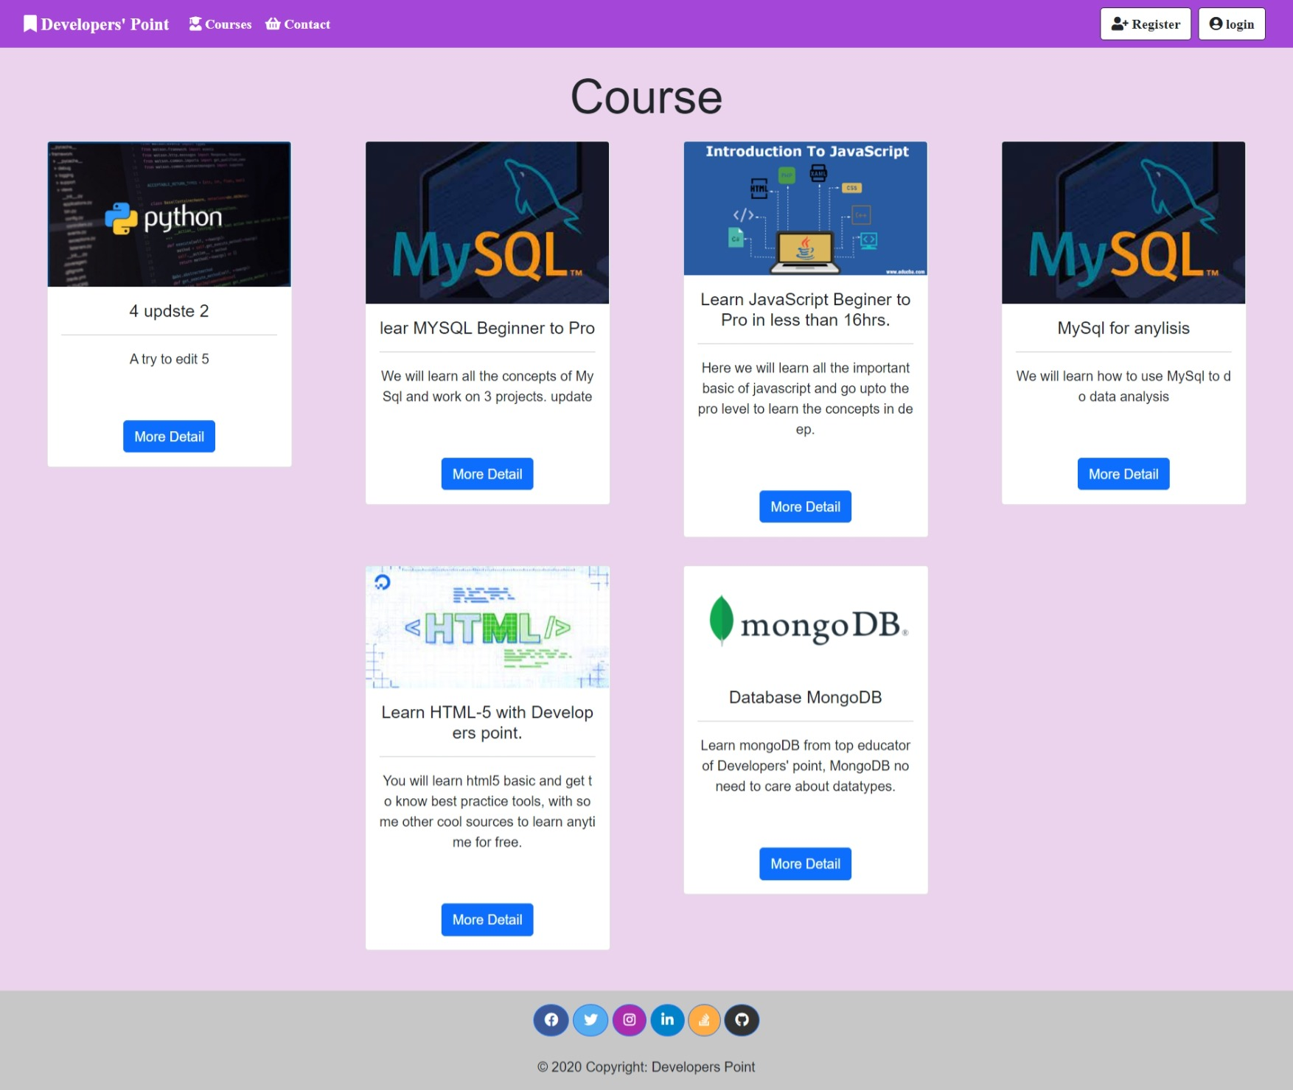

**Courses Page**

Anyone can come and search for courses

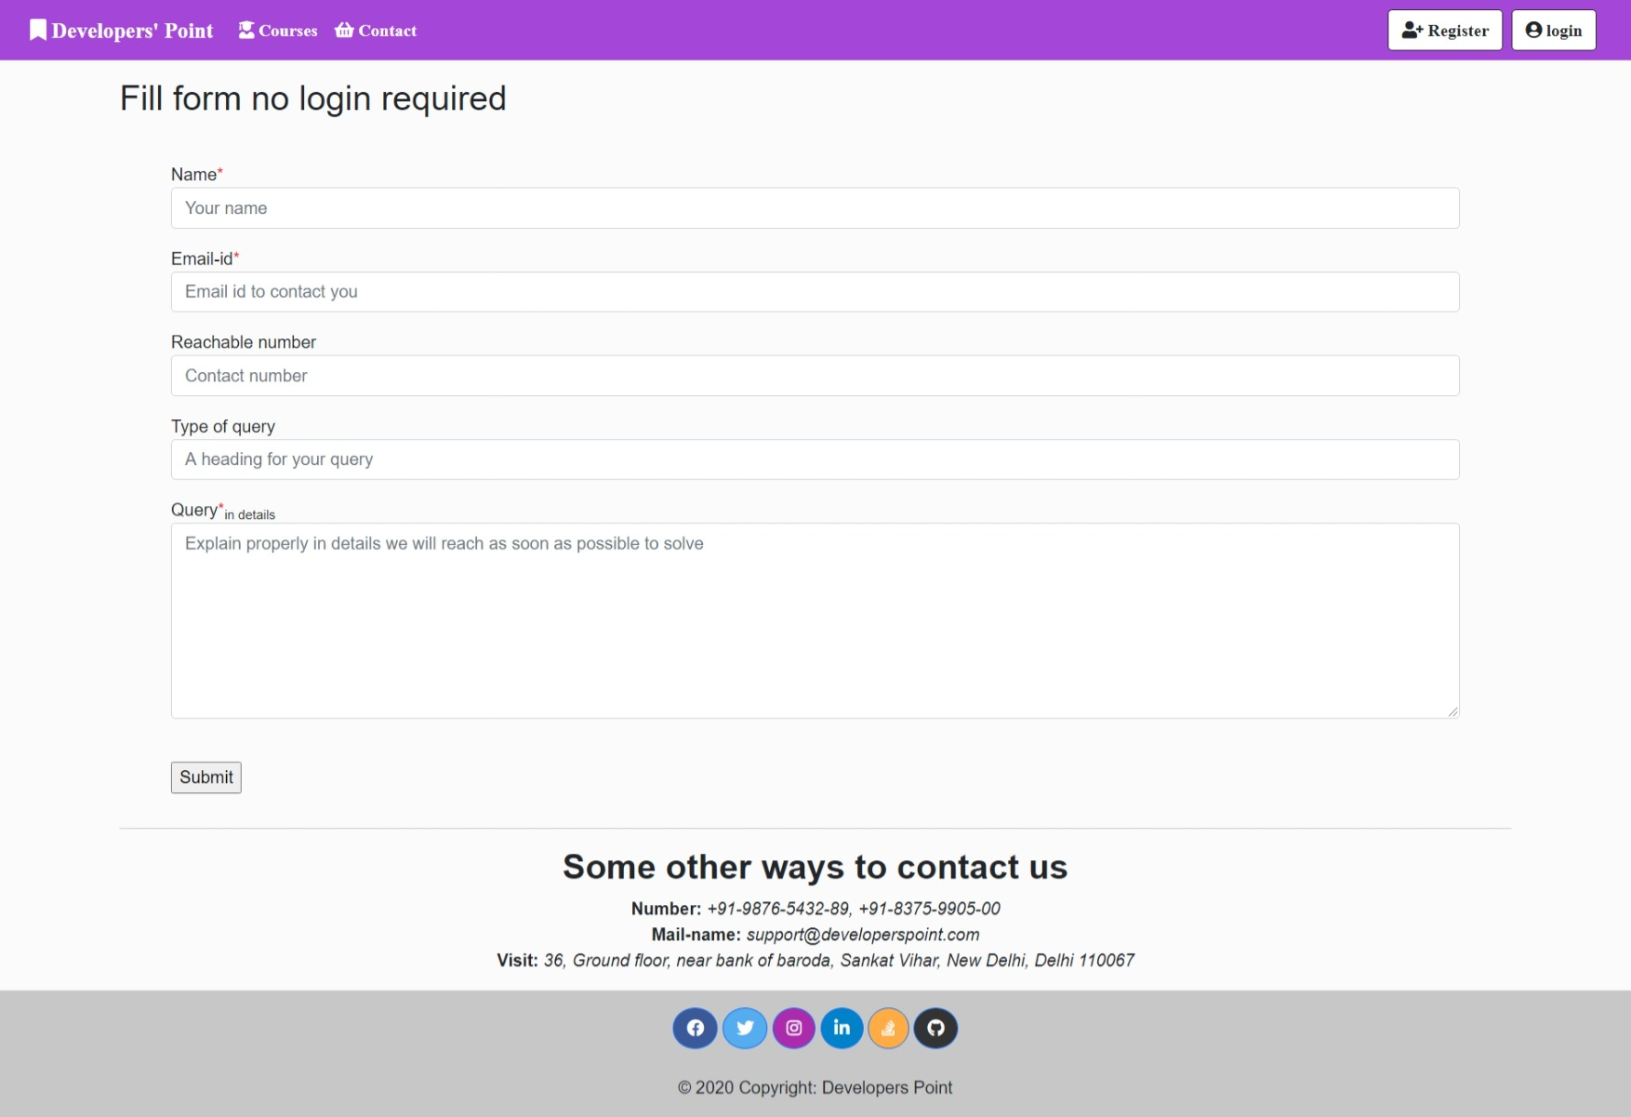

**Contact Page**

Anyone can come and contact institute on any query

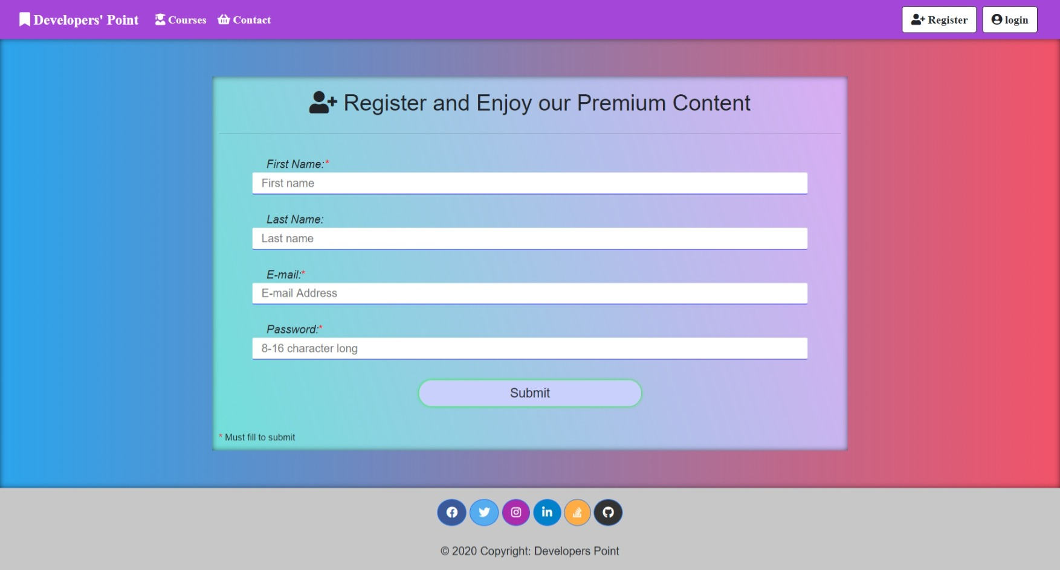

**Registration Page/Form demo**

Registering myself

**Registration Page/Form**

To access main features a person should register once

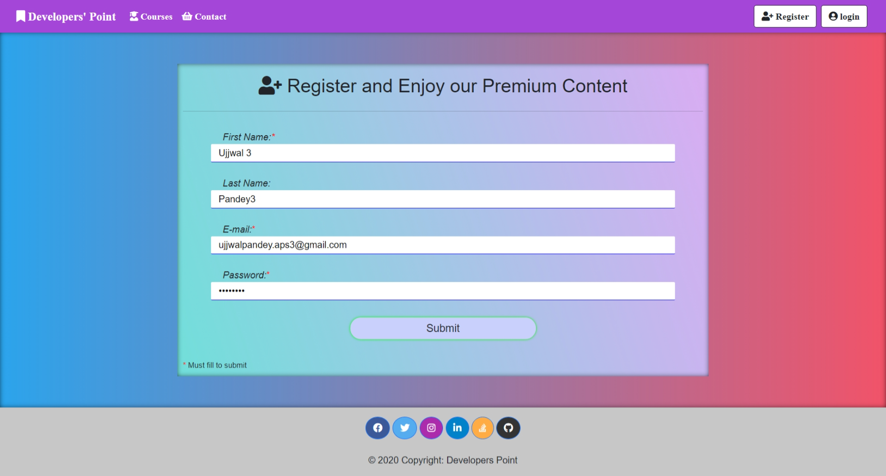

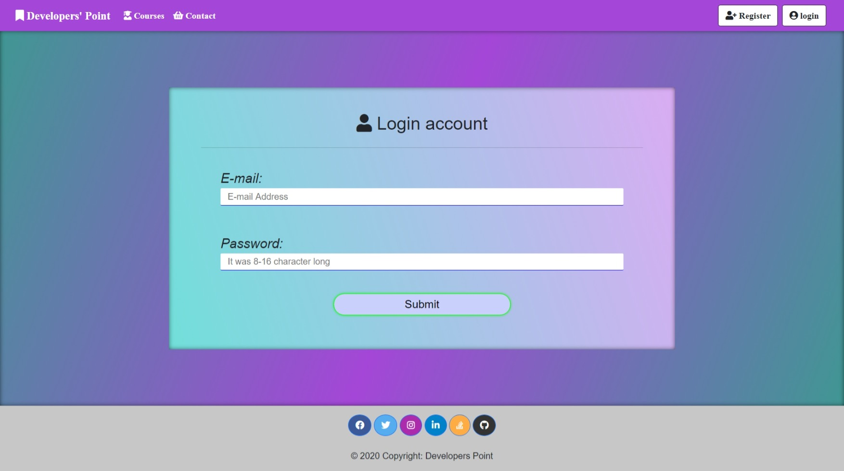

**Login Page/Form demo**

Logging as a student

**Login Page/Form**

To access main features a person should login.

Everyone (Student, faculty and admin)

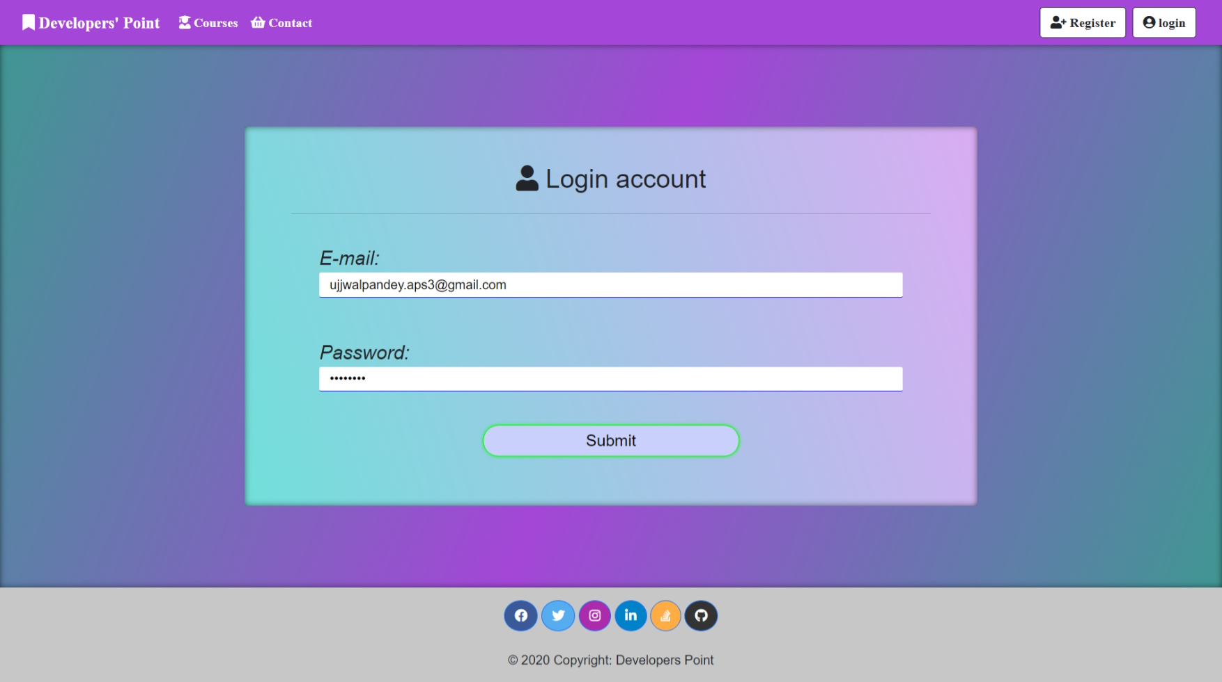

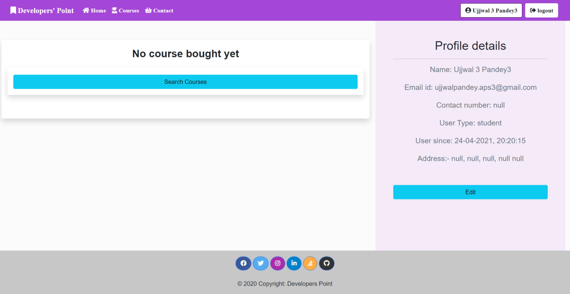

This will appear only when user don’t have a single course bought.

On click refer to the **Courses Page**

**‘Home Page’ of ‘Student’**

Logged in as student

When they haven’t bought ay course

When logged in this button appears

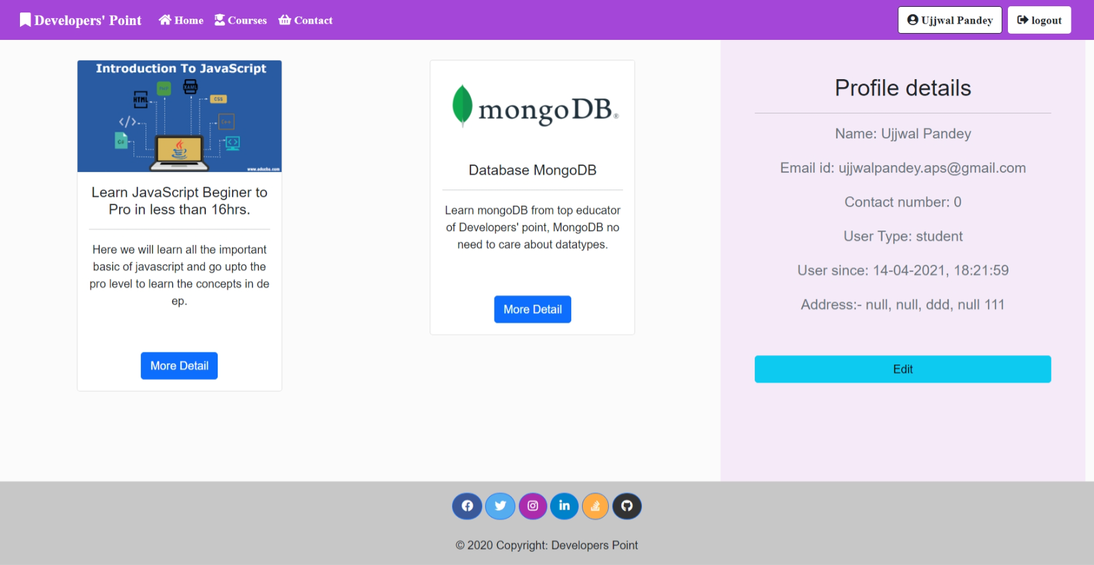

The page after the user (student/faculty) has bought at-least one course

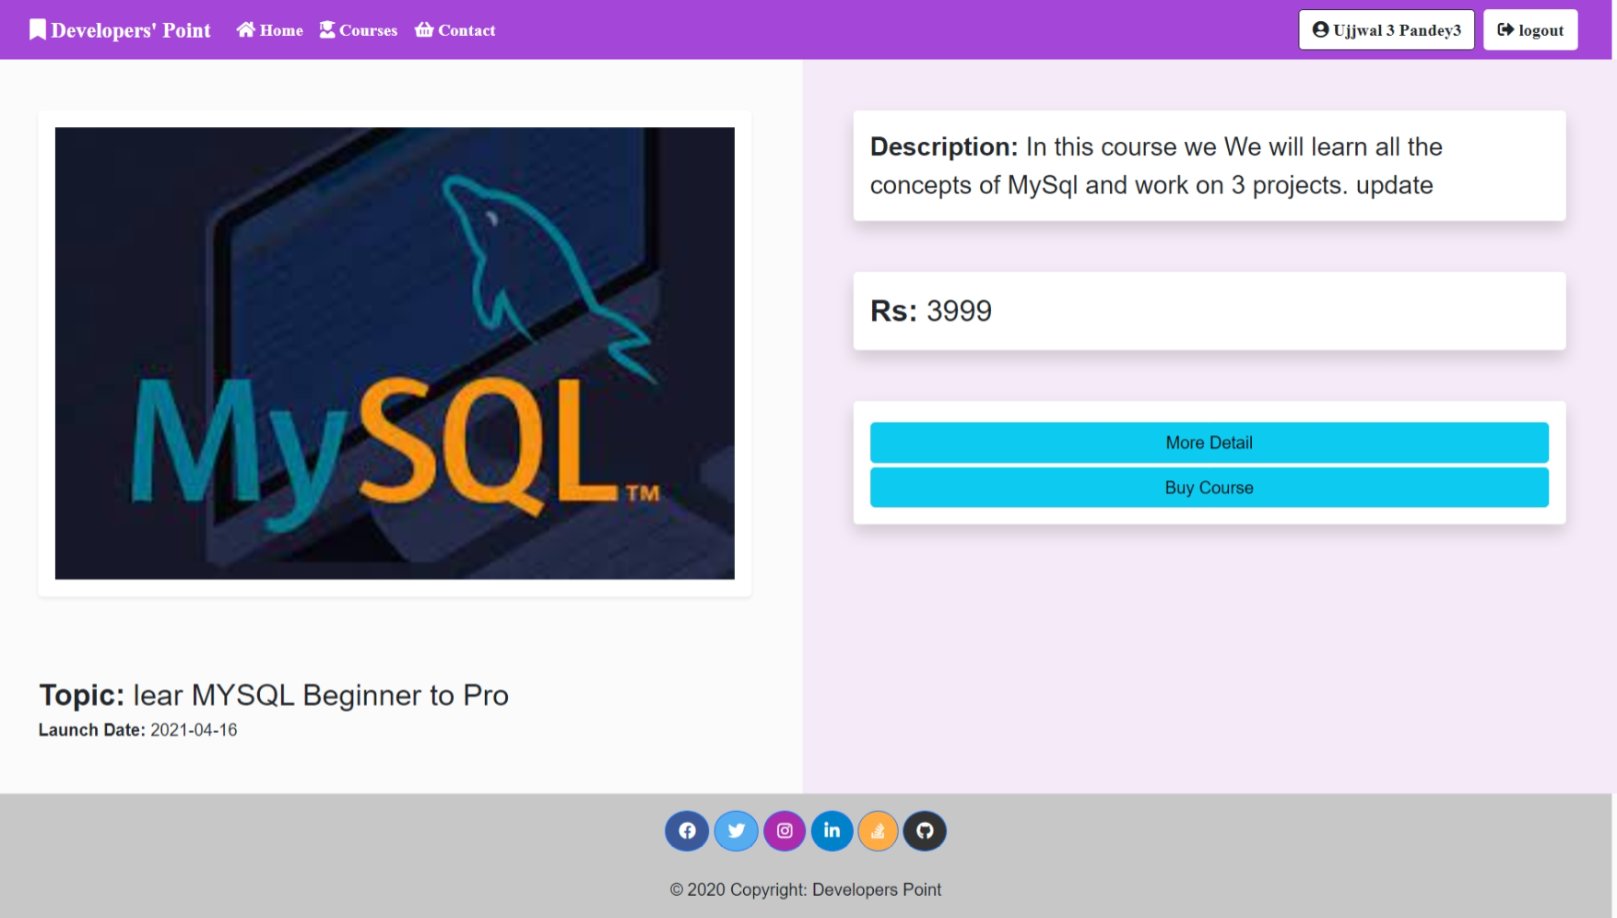

This button will take you to contact form.

From where you can ask for any required detail and institute management team will refer you back

**Course Details**

This page appears when a user clicks on view more details button of a courses card from all courses page

With this button you can buy the course

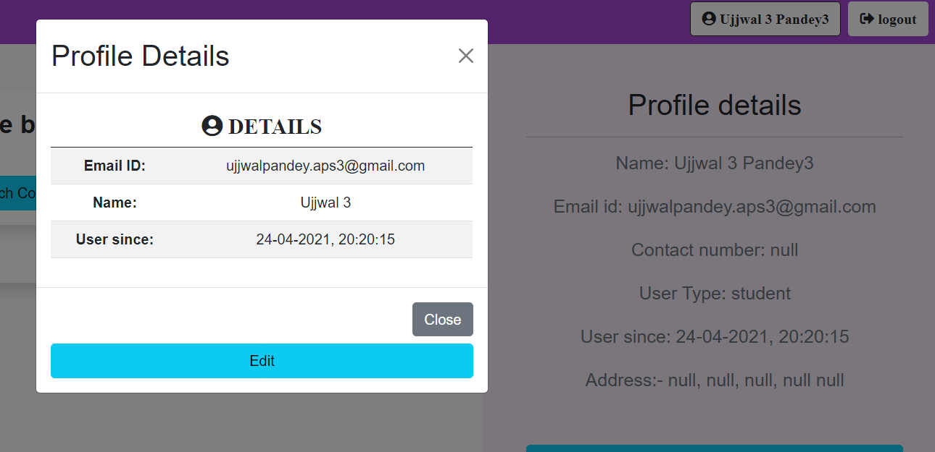

With this button on top-right corner,

On click it will open a model showing basic detail of a user and giving a button to update the profile details

Like the detail which is showing null fill it with real data

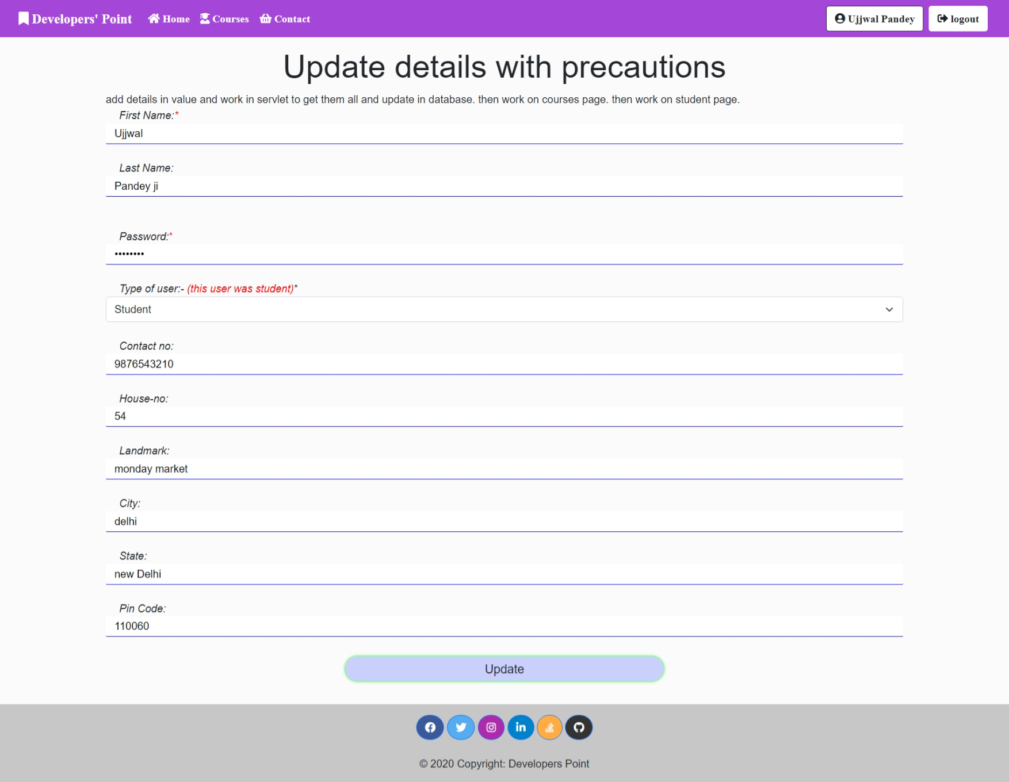

**Updating profile page**

***(Dynamic page)***

User can update its own profile here

It is an example too

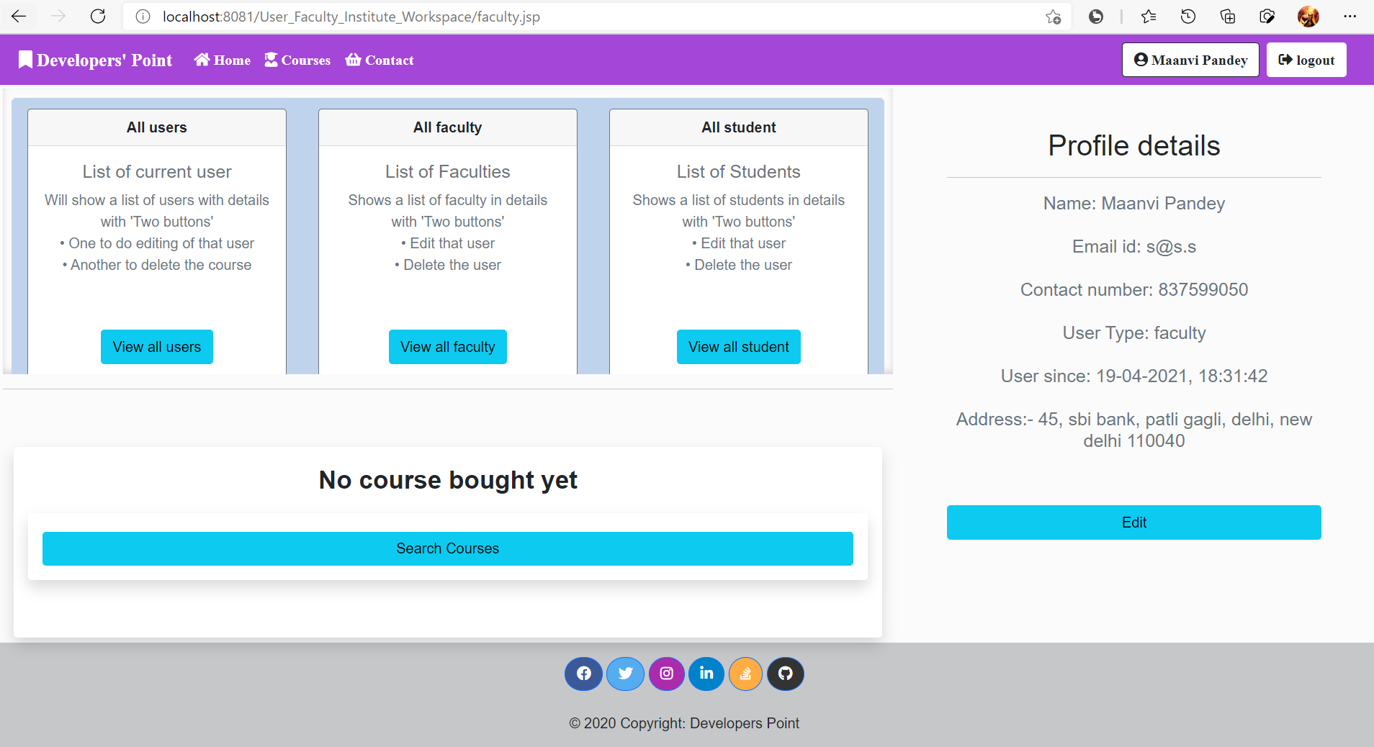

**Faculty Home page**

Logged in as Maanvi pandey

It is same as student page with extra **scrollable frame** of view others details.

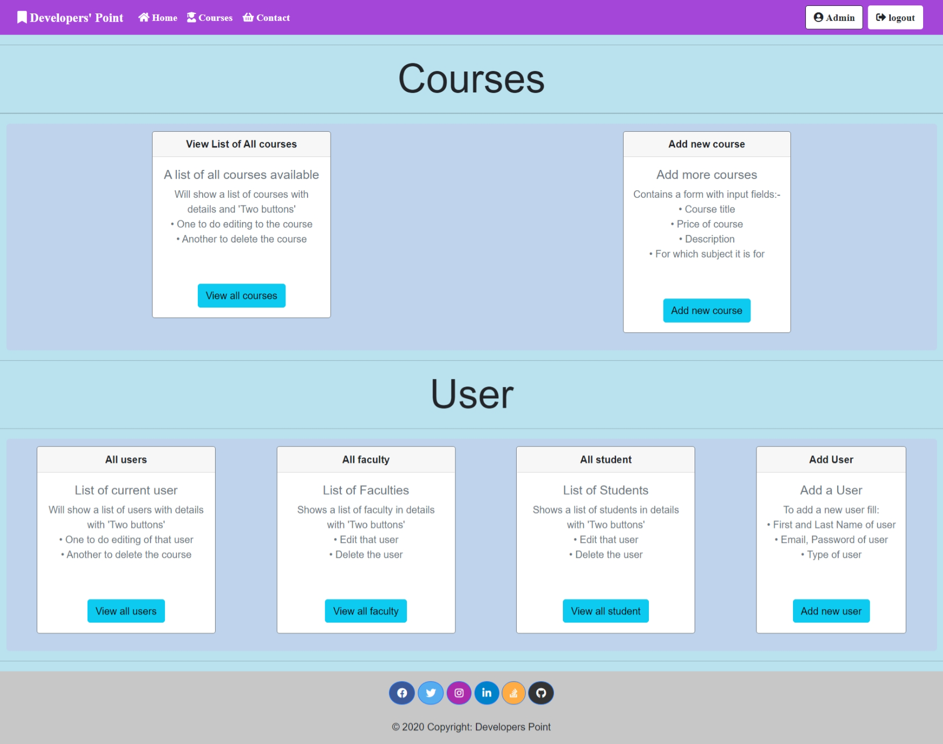

**An admin can do all the things specified in synopsis**

**Admin Home page**

Logged in as Admin

Completely different than

students and faculties

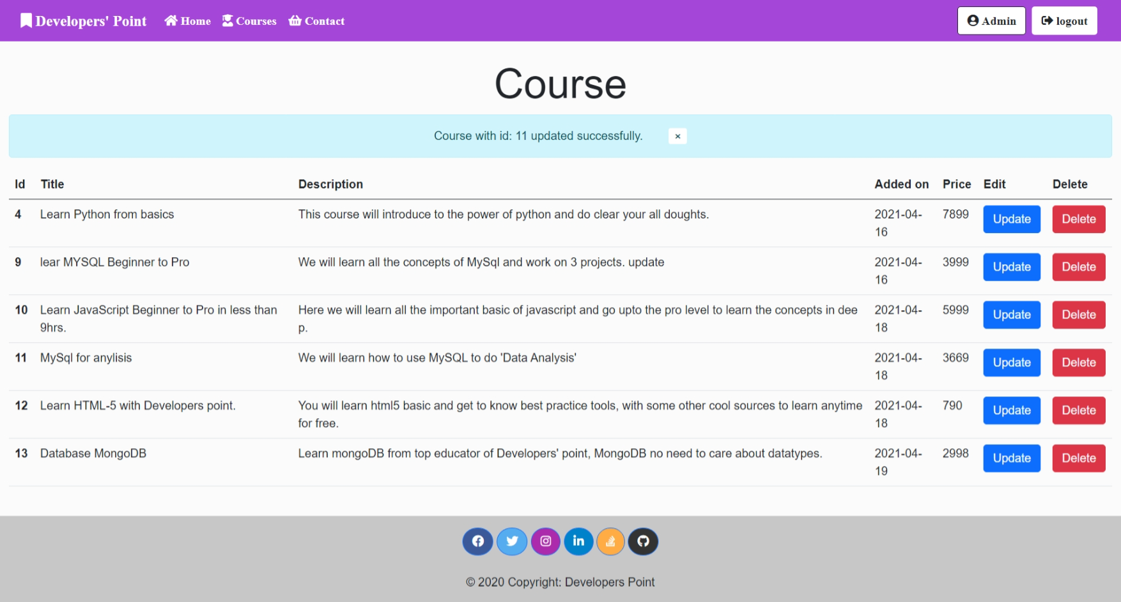

**View all Courses Page**

Admin can View the list of all the courses.

Admin can ‘delete’ and ‘update’ them also.

Blue line under word course will appear when admin has updated any course

Disappear after one time show

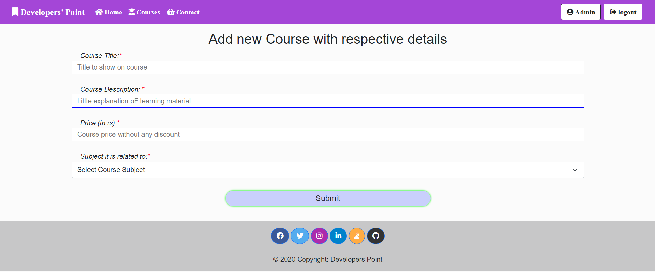

**Add new Course Page**

This page will allow admin to add new course at a time

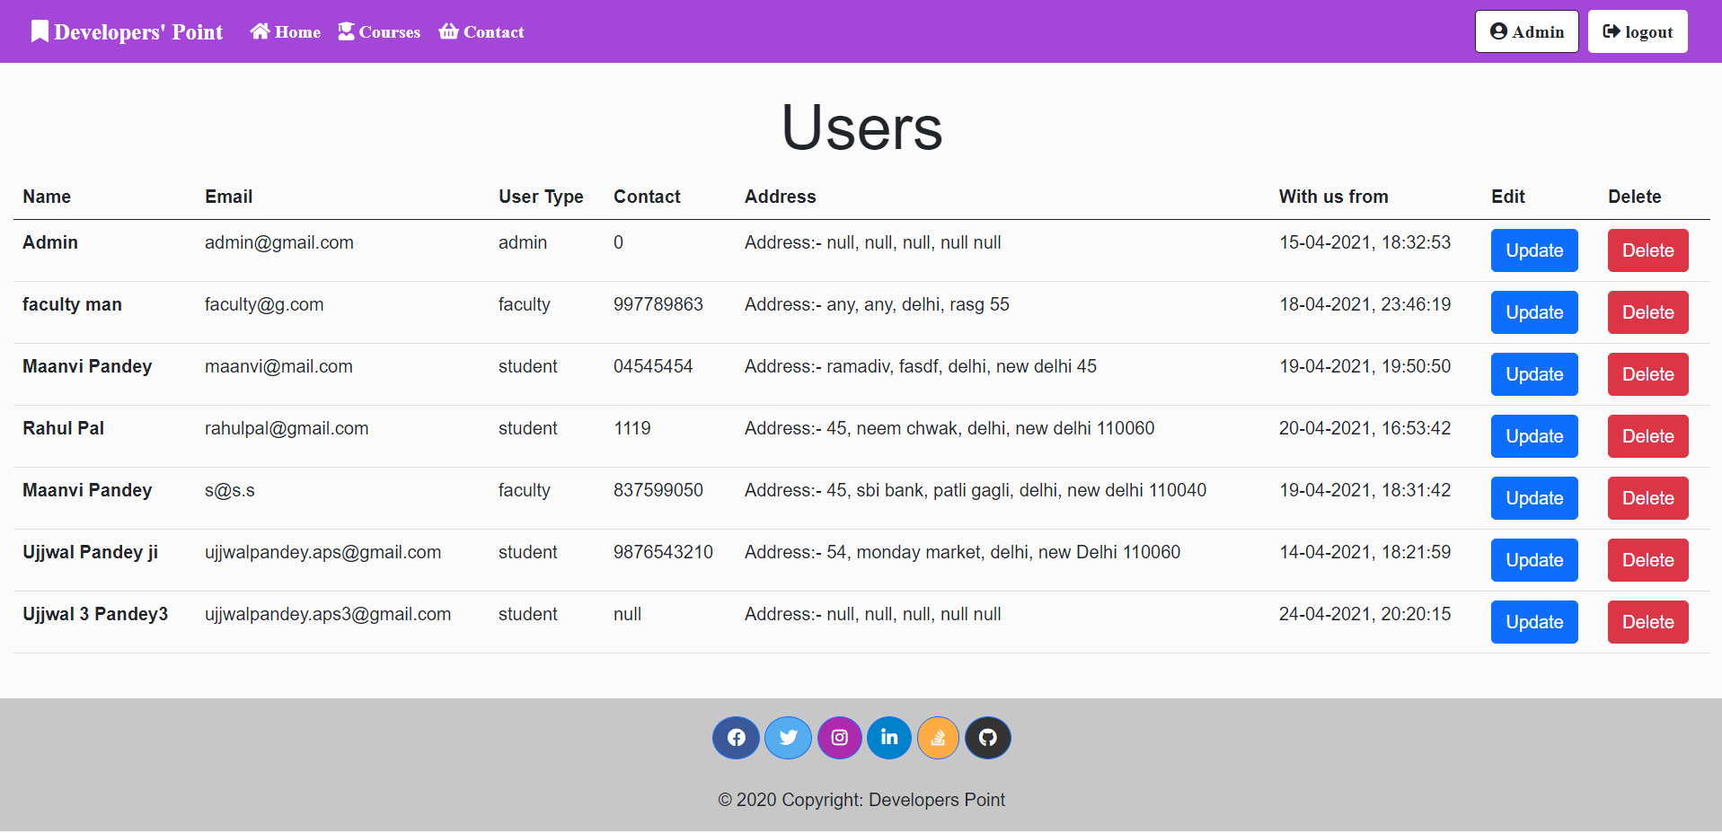

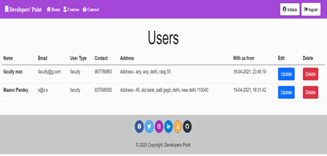

All type of users

**View all Users Page**

This page will allow admin to View, edit and delete any user dynamically

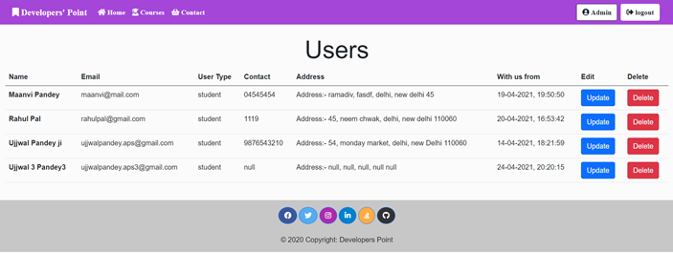

Only faculty

Only students

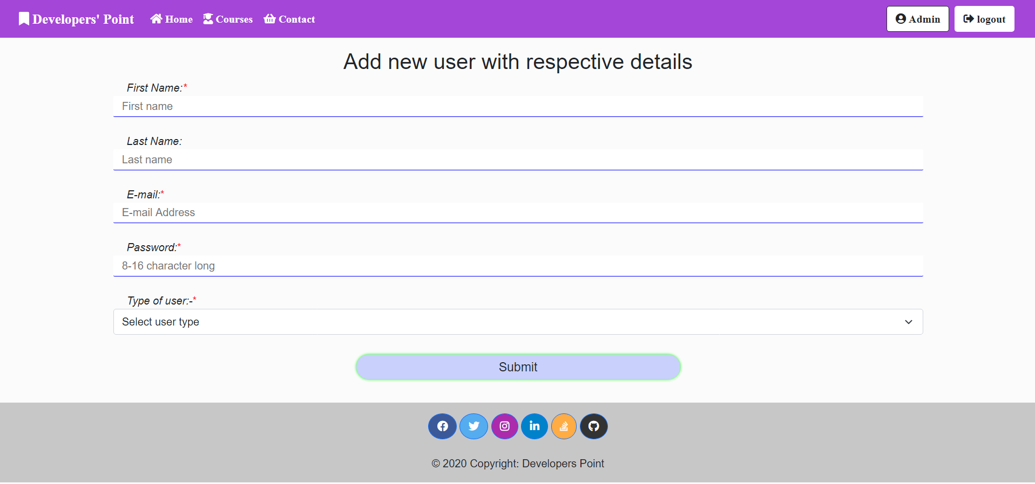

**Add new User (by Admin) Page**

This page will allow admin add new user and assign their role of student, admin or faculty

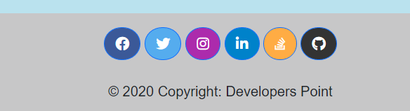

**In Footer**

In footer (available on each and every page) all these icons visible are not only icons they are click and referred to actual my profiles

1. **Testing**

**Unit Testing**

The software units in a system are modules and routines that are assembled and integrated to perform a specific function. Unit testing focuses first on modules, independently of one another, to locate errors. This enables, to detect errors in coding and logic that are contained within each module. This testing includes entering data and ascertaining if the value matches to the type and size supported by java. The various controls are tested to ensure that each performs its action as required**.**

**Integration Testing**

Data can be lost across any interface, one module can have an adverse effect on another, sub functions when combined, may not produce the desired major functions. Integration testing is a systematic testing to discover errors associated within the interface. The objective is to take unit tested modules and build a program structure. All the modules are combined and tested as a whole. Here the Server module and Client module options are integrated and tested. This testing provides the assurance that the application is well integrated functional unit with smooth transition of data.

**System Testing:**

After completion of integration testing. I used system testing to test my system. It is the testing of the system its initial objectives.

**Alpha Testing:**

The alpha testing is conduct at the developer sitein the presence of the customer. The software is used in a natural setting by all the errors and me and usage problems are recorded for maintenance. This test is conduct in a controlled environment to uncover errors.

**Beta Testing:**

The beta test is conduct br the end user of the software. Thereafter the beta test is a live application of the software in an environment that cannot be controlled by the developer. They report all the problems to me. As a result of problems reported during beta test, I made modification leading to completion of my software project.

**Debugging:**

After successful coding successful coding the individual modules, all the modules were crosschecked. The debugging is performed to ensure that no software bugs exited. Debugging is recursively performed until the newly designed system resembles the proposed system. It was ensured that all the modules were logically and syntactically correctly coded.

Debugging occurs as a sequence of successful testing. That is, when a test cases uncovers error, Debugging can add should be orderly process; it is still much an art.

The debugging process will always have one of the two outcomes:

1. The cause will be found, corrected, removed, or

2. The cause will be found.

THE STEPS IN THE SOFTWARE TESTING:

* The steps involved during Unit testing are as follows:
* Preparation of the test cases.
* Preparation of the possible test data with all the validation checks.
* Complete code review of the module.
* Actual testing done manually.
* Modifications done for the errors found during testing.
* Prepared the test result scripts.

THE UNIT TESTING DONE INCLUDED THE TESTING OF THE FOLLOWING ITEMS:

* Functionality of the entire module/forms.
* Validations for user input.
* Checking of the Coding standards to be maintained during coding.
* Testing the module with all the possible test data.
* Testing of the functionality involving all type of calculations etc.
* Commenting standard in the source files.

After completing the Unit testing of all the modules, the whole system is integrated with all its dependencies in that module. While System Integration, we integrated the modules one by one and tested the system at each step. This helped in reduction of errors at the time of the system testing.

* The steps involved during System testing are as follows:
* Integration of all the modules/forms in the system.
* Preparation of the test cases.
* Preparation of the possible test data with all the validation checks.
* Actual testing done manually.
* Recording of all the reproduced errors.
* Modifications done for the errors found during testing.
* Prepared the test result scripts after rectification of the errors.

The System Testing done included the testing of the following items:

* Functionality of the entire system as a whole.
* User Interface of the system.
* Testing the dependent modules together with all the possible test data scripts.
* Verification and Validation testing.
* Testing the reports with all its functionality.

After the completion of system testing, the next following phase was the Acceptance Testing.

Clients at their end did this and accepted the system with appreciation. Thus, we reached the final phase of the project delivery.

1. **Input and Output**

**Input Design for**

The system input design is divided in to 4 sections.

1. The Administration section,
2. The Faculty section,
3. The Student section, and
4. The visitor section.

**Administrator**

Input design is an important part of development process since inaccurate input data are the most common cause of errors in data processing. Erroneous entries can be controlled by input design. It consists of developing specifications and procedures for entering data into a system and must be in simple format. The goal of input data design is to make data entry as easy, logical and free from errors as possible. In input data design, we design the source document that capture the data and then select the media used to enter them into the computer.

There are three major approaches for entering data in to the computer.

They are

* Menus,
* Dialog Boxes, and
* Form.

**Output Design**

Designing computer output should proceed in an organized, well throughout manner; the right output element is designed so that people will find the system whether or executed. When we design an output, we must identify the specific output that is needed to meet the system. The usefulness of the new system is evaluated on the basis of their output.

**Existing System of User-faculty workspace**: In the existing system the admission, retrieval, course buying, updating data and other works are done only manually but in proposed system we have to computerize the processes using this application.

* Lack of security of data.
* Reduce the more man power.
* Reduce the time consumed in process.
* Reduce the consumption of large volume of pare work.
* Remove manual calculations.
* No direct role of the management team in small works.

1. **Implementation of the security for the software development**

System security mechanism, software security has become increasingly important in the age of hackers and virus. This attribute measures a system’s ability to withstand attack on the security. Attack can be made on all three components of the software: Programs, Data and documents.

Creating of user profiles & Access Rights:

This system administration can create the user and delete user. The admin can change the setting user based the requirement of the system. An authorized user cannot log in on the system. This checked during login of every user, before opening a page the web servers check the type of user before referring the user to that page, only the authorized and permitted type of user can access the page not any one, not all type of users to open all type of pages if tried he/she will be redirected to the login page and if they are already logged in, they will be logged out.

1. **Limitations of the Project**

* Excel export has not been developed for course bought.
* The transactions are executed in offline mode, hence online data for course buying and batch admission, and modification is not possible.
* Offline reports of Course bought, Batch Registration, transaction receipt cannot be generated due to offline mode execution.
* Cannot choose batch online, to do that we have to use contact form or other means.

1. **Future Application on the Project**

* We can add printer in future,
* We can give more advance software for App including more facilities,
* We can host online courses on the platform so that users can buy, access and learn online worldwide without coming to any course,
* Integrate multiple load balancers to distribute the loads of the system as the web app goes worldwide,
* Create the master and slave database structure to reduce the overload of the database queries,
* Implement the backup mechanism for taking backup of codebase and database on regular basis on, different servers,
* Implement own transaction system, and so on.

1. **Bibliography**
2. www.w3schools.com
3. tutorialpoint.com
4. DZone.com
5. en.wikipedia.org
6. Youtube.com (Several tutorial channels of YouTube)
7. www.hotscripts.com/category/java/
8. [www.apache.org/](http://www.apache.org/)
9. Java original documentations
10. www.mysql.com/click.php?e=35050
11. [bootstrap.com](http://getbootstrap.com) for CSS(.CSS) and JavaScript(.jsp)
12. mdbBootstrap.com

Thank you

